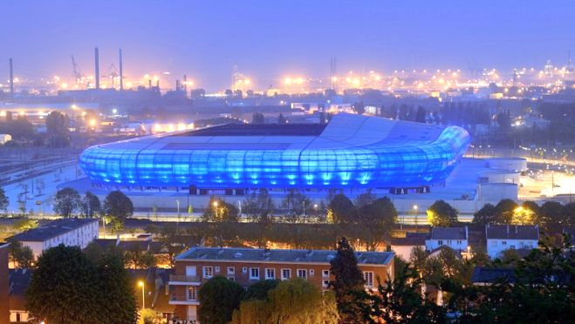
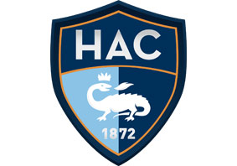
THE GREATEST STADIUM OF THE NORTH OF FRANCE
Where is it ?

The stadium is the first building you see when you come in le havre. This stadium is very big of 25000 seats. This stadium was opened in 2012 therefore it is a modern stadium.

The HAC (havre athletic club) is the older club in France in the second division. This stadium is for football rugby and for concert like star 80 the team of France came play in this stadium.
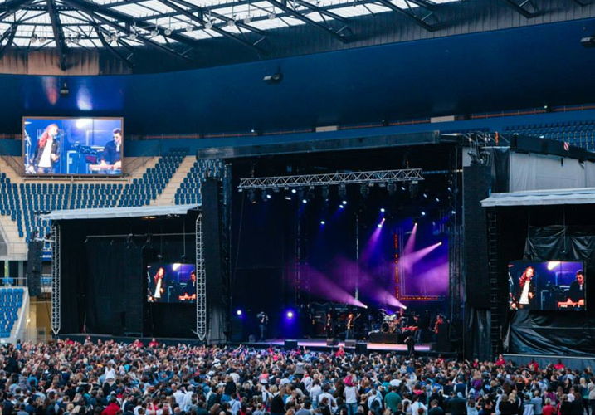
The team of Uruguay and the girl team of Brazil and of France were playing in this stadium.
Are you interested by the modern art ?
Don't miss the opportunity! Go see this beautiful stadium!
When you go in Le Havre go see this stadium.
Why go to this stadium ?
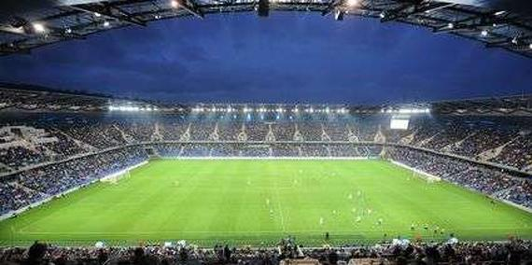
You must go to this stadium because you don't have to pay a lot of for a place. In this stadium there is a very good atmosphere.
This is the back cover when folded.

This is the front cover when folded.

