OUR PRESENTATION

Hello Greek friends,

we are a class with 12 boys and 9 girls.

We have got four teachers: one for Maths, Science, I.T. and

English ; one for Italian, History; Geography and Phisycal

Education; one for Art and Music; one for Religion.

We start school at 8:30 a.m. and we finish at 4:30 p.m.

From 12:30 p.m. to 2:30 p.m. we have a break and the lunch.

Our Primary school is in Cornate D’Adda.

We love each other.

We are happy to know you!
BYE- BYE 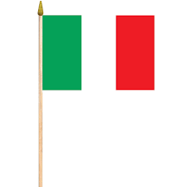

by 3rd grade class A!

