PROJECT GUIDELINES

Who are you?
Our project’s name is FindArt for the app and LMDK tech for the company. We are Denise Laghi, Kevin Suárez, Lucía Martínez, Martina Busiello and Michela Liverani.
What are you planning to make?
Actually, we want to do an app that has a database with a photo collection and it helps you recognise a famous monument, a painting a song, an unknow object. You just take a picture of what you are interested in and the app will describe it for you and give you information about it.
The app would have an auto updating of the info every week.
There would be a comment page where you can leave what you think about the paintings or buildings and if you would recommend our app to other people. And there would also be the signature of the artist and when the painting, building or song was made.
We also thought to the logo. Our project has two logos, one for the company and one for the app
The logos will be
this for the app: and this for the company:
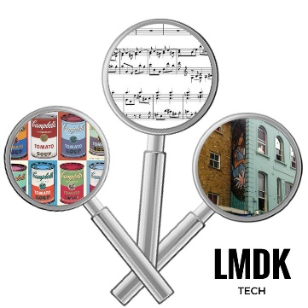
Where did this project come from?
Well, Denise got the idea to do this app. She wanted to do this project because when you travel you never know the name or the meaning of all monuments or paintings or whatever you see. We think that everybody who likes travelling would be interested in this app. In addition, you can use it to recognise a song; so even if you don’t travel, you can use it.
What’s your budget?
Our budget is approximately of 6.000 R depending on the excellent quality, the software which the app refers to, the graphics, the price people will pay to use it and the ways in which people can register on it.
Why do you care?
We want to do this app, because we think that it could be useful to everyone who likes travelling and visiting new places. We are sure that people will love this app because nothing similar exist.

Rewards
When the project is completed, the backers will receive some rewards:
20 RISIS | 50 RISIS | 100 RISIS | 150 RISIS
5 t-shirts | 10 t-shirts | 30 t-shirts | 50 t-shirts
10 stickers | 20 stickers | 30 stickers | 40 stickers
A discount of 5 RISIS for train tickets | A discount of 10 RISIS for train tickets | A discount of 20 RISIS for flight tickets | A discount of 15 RISIS for train tickets
 |  |  | A discount of 15 RISIS for flight tickets

If someone has a restaurant, a hotel, a museum or a taxi these will be the rewards for your advert on our app whenever you are close to the place looked for:
200 RISIS | 400 RISIS | 800 RISIS | 1100 RISIS
2 months | 4 months | 6 months | 8 months

