[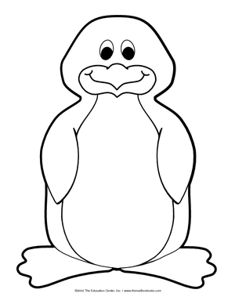](http://www.google.com.cy/url?sa=i&rct=j&q=&esrc=s&source=images&cd=&cad=rja&uact=8&ved=0ahUKEwjhiNqP947SAhUBxRQKHaSKASoQjRwIBw&url=http://www.easyfreepatterns.com/page/8090.html&bvm=bv.146786187,bs.1,d.ZGg&psig=AFQjCNG9qukhs8qkE6oUva0fOWC81Xed8Q&ust=1487139095456459)

Marinos decided to leave from North Pole and traveled to the land of people, so he could make new friends.

In the land of people, Marinos discovered that people had destroyed the environment, and Penguins were threatened by the climate change. The ice of the North Pole was melting.

Marinos gathered all the animals of the planet together. The animals took all humans to the High Court and accused them for destroying the environment. Humans realized their mistake and started cleaning all the garbage from the land and sea. They also closed all the factories and started to use other forms of energy like solar and wind. Marinos returned back to Antarctica. Now he was a hero.

Marinos was a shy and kind penguin. He was living in Antarctica.

Marinos could not swim very quickly like other penguins, so he had no friends. He was always alone.