Introduction

The alarm went off and although he had only slept a couple of hours he jumped out of bed, leaving the pleasant warmth of it to embark on the adventure that awaited him.
He had spent the day before packing. He was going to make the most exciting journey of his life, he would tour Europe visiting some schools and knowing firsthand how some parties were held in those countries.
What clothes had he to wear? The destinations were Spain and Poland during the autumn, Finland and Romania in winter and finally Ireland and Ukraine in spring. He chose not to carry much luggage and buy typical clothes in every place.
He lived in the Rue de Treves at number 81 near the "Classroom of the Future" in Brussels. Indeed, he was Belgian and his native language was French but he could defend himself in all countries because he had a good grasp of the English language and knew that in all the places where he would go, English was studied as a second language.

When he was ready, his friend Marc drove him to the airport and stood there, watching as the plane in which his best friend was now seated in took flight. They were going to be separated for many months but Max had promised to send him many letters describing everything that he saw and experienced in detail. He would also enclose photographs and drawings from the students.

Chapter I. “Chaquetía Day”

In Merida, October 28th, 2016
Dear Marc!
How are you? I hope you are well.
I am already in Merida, at last. It's my first destination and it's been incredible.
Teresa Sanchez, one of the English teachers of the school, came to meet me at the airport and took me directly there because they were going to celebrate "La Chaquetía" that same day. You are probably wondering what Chaquetía is? it is the festivity that they celebrate in Merida coinciding with Halloween.

It's amazing to arrive in the city Marc and see its imposing Roman buildings. We will both have to take a leisurely trip when I finish my travels across Europe and enjoy the architectural wonders of the place. Antigua's school is tiny, no more than 200 students and about 20 teachers, but it's a place where you feel good because it's like a big family where everyone knows each other and cares for each other. And now it's time to go and celebrate "La Chaquetía". The entire educational community and I head towards an esplanade where there is a medieval hermitage called "Ntra. Sra. de la Antigua ", yes, yes, like the school and something curious has happened, the students have adopted it and take care of it with much affection. For example, they share some festivities with her, like this one today.

- I'll tell you how I celebrated the event. La Chaquetía was very funny, Flor, the director had made quince candy and we mixed it in a piece of bread with cheese. She gave me the recipe, I am also sending it to you because it does not seem difficult to make and it tastes delicious. The students sat in groups forming circles, in the shade of the hermitage and shared their "Chaquetía", that is to say, they all ate everything, because it encourages sharing. La Chaquetía is composed of ingredients such as walnuts, almonds, chestnuts, hazelnuts ... and also grenades, figs, mandarins, grapes and quinces.
But they did not just share with each other. A few meters from the hermitage there is a center where the elders of the city meet during the day, and can you guess what is called? Exactly, La Antigua. Many of these elders are the grandparents of the students and it was very emotional. The grandparents had a fire where they were roasting the chestnuts that the children brought but first the professors split them because if they did not do they said that the chestnuts may explode. Then they made small, little packets with paper and put several chestnuts inside them, they were delicious!

I made an incredible discovery Marc. One of the elders told me that The Procession of the Souls was a widespread tradition in Extremadura in the XIX during the night of the dead, on October 31. The souls, who were people dressed in black or white, walked the streets of the village asking for money while going from house to house. And it used to end up in the cemetery. I deduce that Halloween was already celebrated here before the Europeans arrived in America and took with them the Celtic Halloween celebrations. It really shows that in this area there must have been Celtic settlements and its culture still survives.
There is more to tell you. When they finished sharing their "chaquetías" and roasting the chestnuts, they began to play. They were traditional games, from those of yesteryear. Even some grandpas and grandmas participated as well. It was hot, very hot. I have been told that it has been a very hard summer and that there have even been days of 45º C. and it was apparent that autumn had not yet arrived. Luckily there was a very large fountain where we were and we were able to quench our thirst.

After two hours the professors gathered their groups of students and we returned to the school. Some children had kept their packet of roasted chestnuts to share at home with their families. Marc, this celebration has been a real lesson of sharing.
Before leaving I had been given drawings, photos, videos and letters ... For the moment I am sending you this letter, some photos and also some drawings where I will explain to you what they are doing.
When the time for the farewell came, there were hugs and tears. It's funny, the Spaniards love to hug and kiss, I really felt at home.
I am writing to you from the plane that is taking me to Poland. I am loaded with very good memories and with the hope of continuing to enjoy myself while I go through the different European centers that I have been commissioned to visit.

Max

“Dulce de Membrillo" Recipe

Delicious!
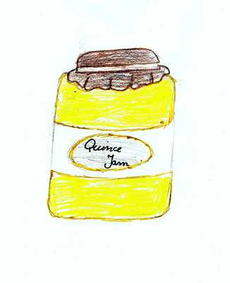
Ingredients:
- Quinces
- sugar

Elaboration
The quinces are washed and covered with water in a pot. They put on the fire the necessary time for the punctures with a fork to be soft.
They are allowed to cool, peel and remove the seeds.
We added the same amount of sugar that we have of fifteen.
Example: For 1 kg of quince 1 kg of sugar.
From here there are two ways to do it.
The traditional one.- You pass through the mixer the fifteen and the sugar and put the pot to the fire, it is spinning (with a wooden spoon) until it acquires the desired texture. We must be careful because it splashes and we can burn.
The modern one.- It is passed through the mixer and placed in a microwave-safe container. At maximum power is put in periods of 5 minutes and meet until it acquires the desired texture.
This is mine. A student from Poland who is a friend of the Spanish students did the drawing and sent it to them.
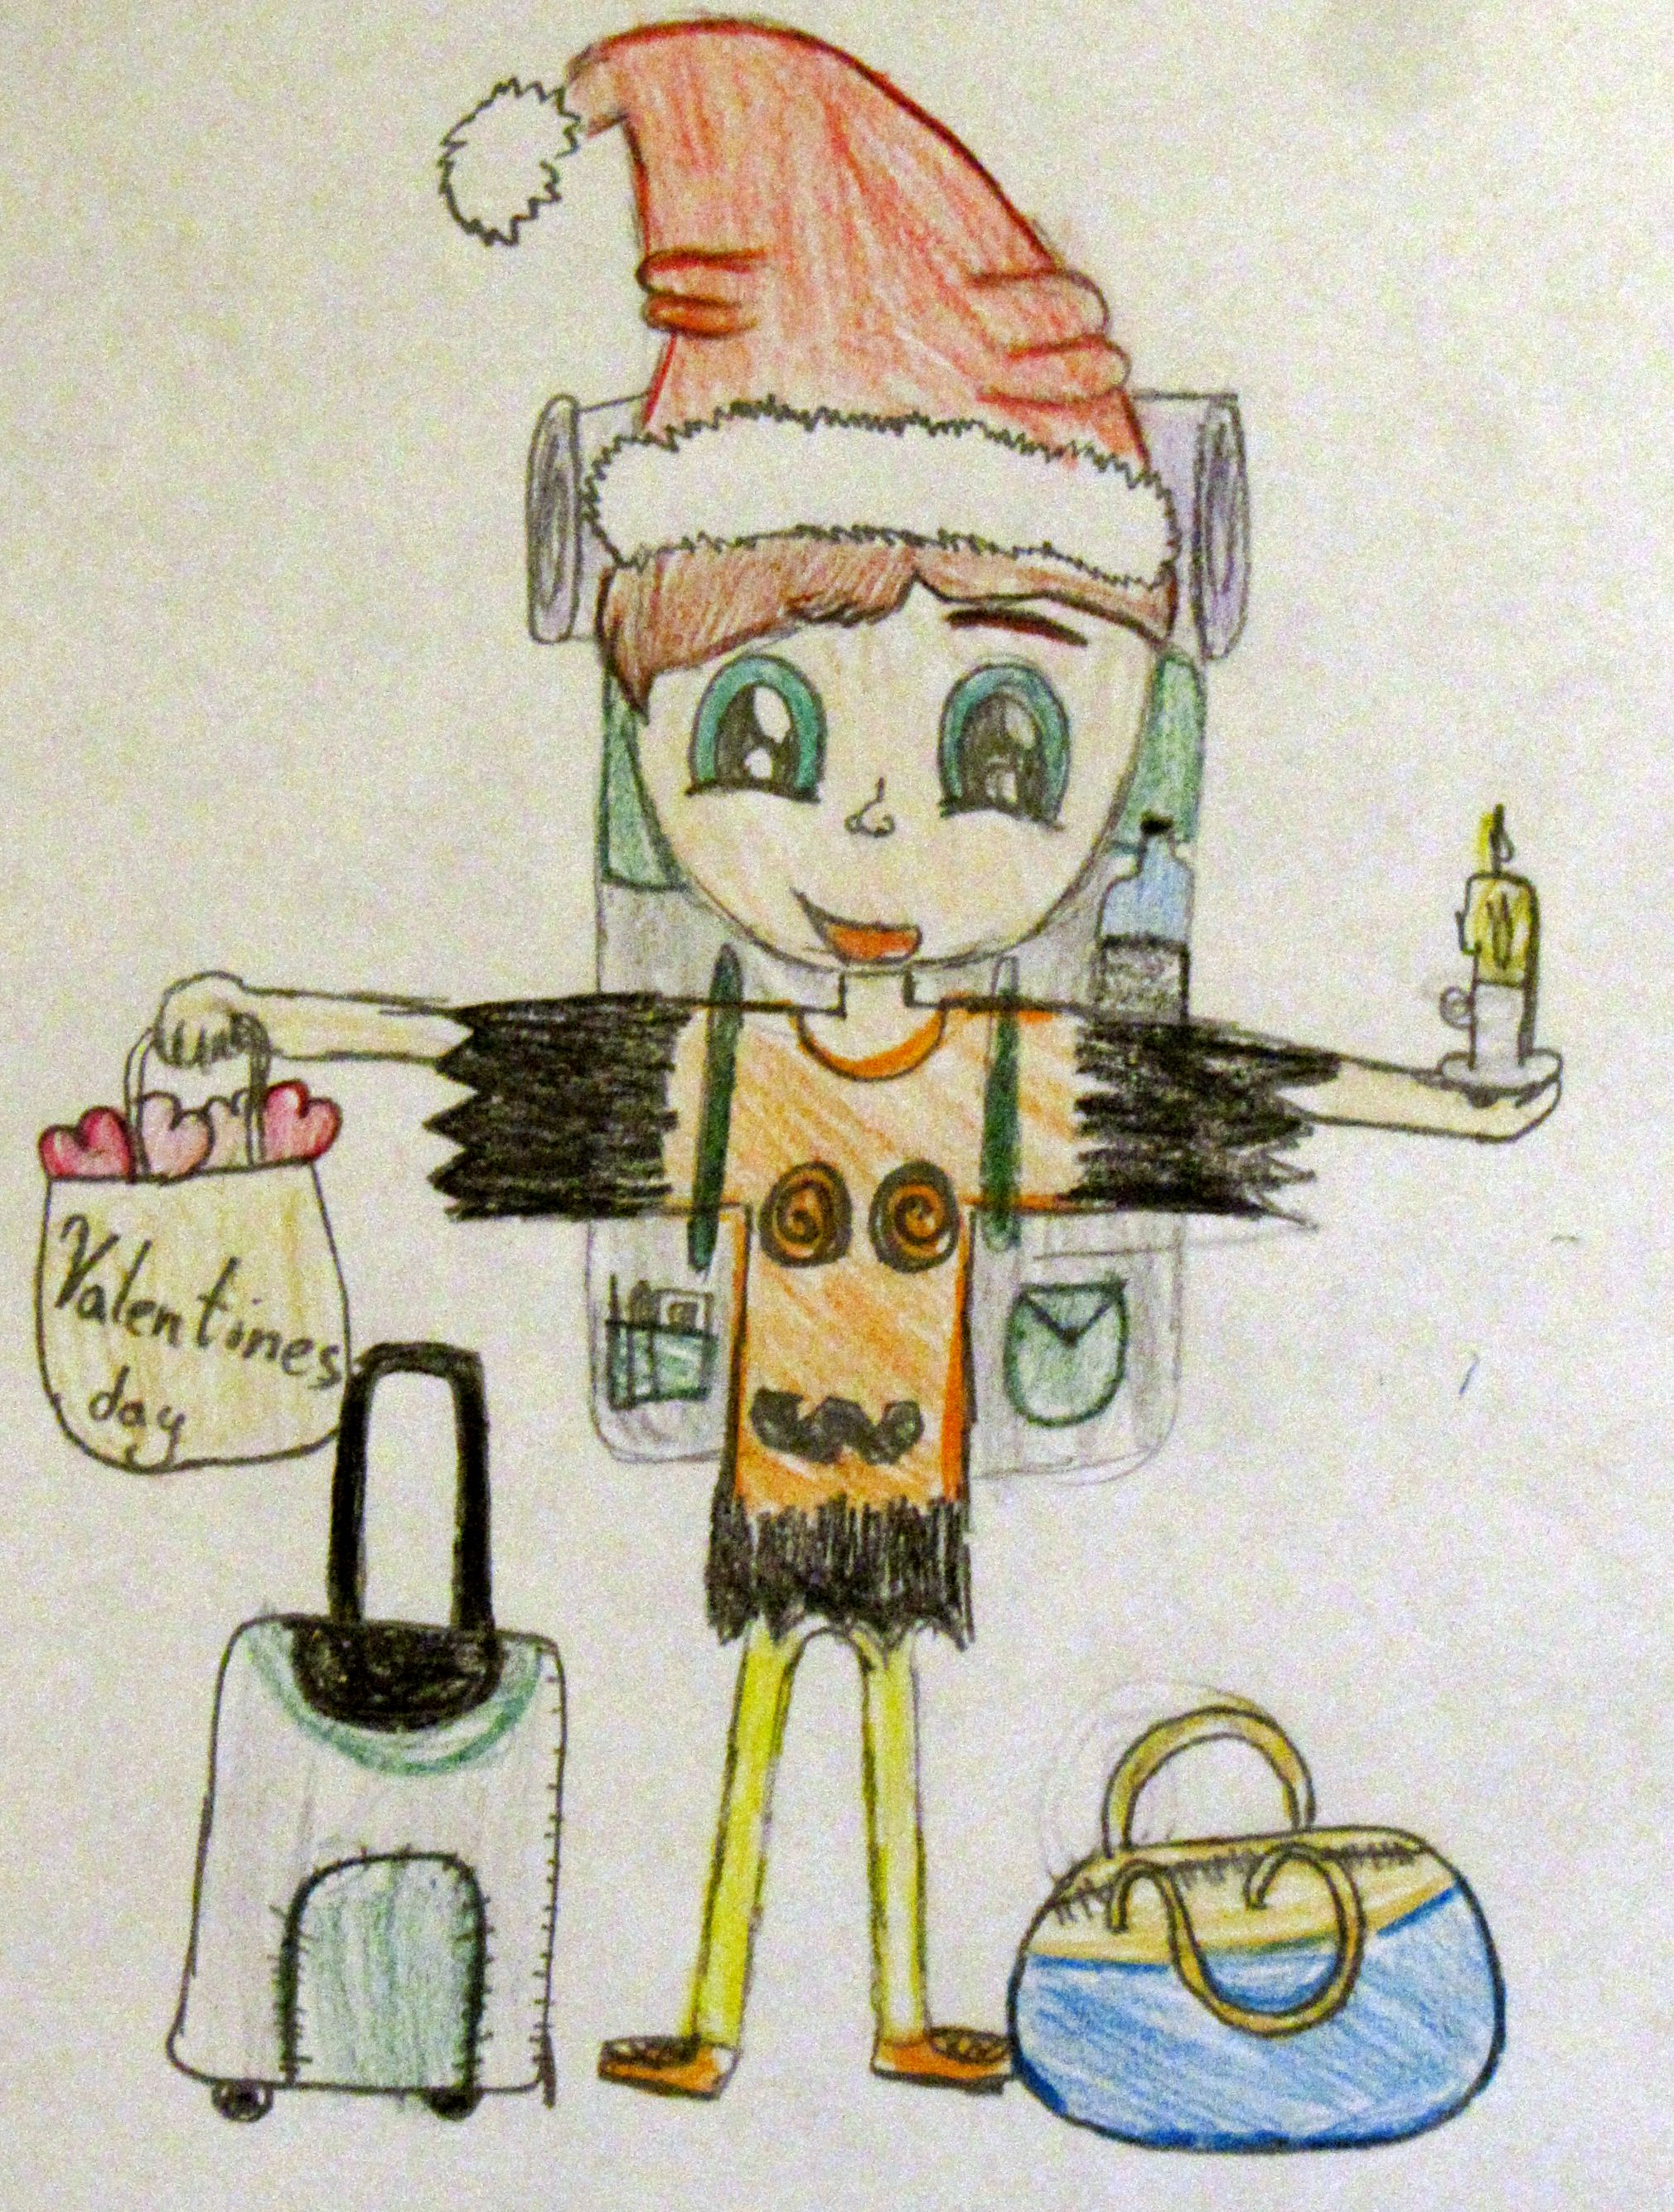
This is mine. A student from Finland who is a friend of the Spanish students did the drawing and sent it to them.
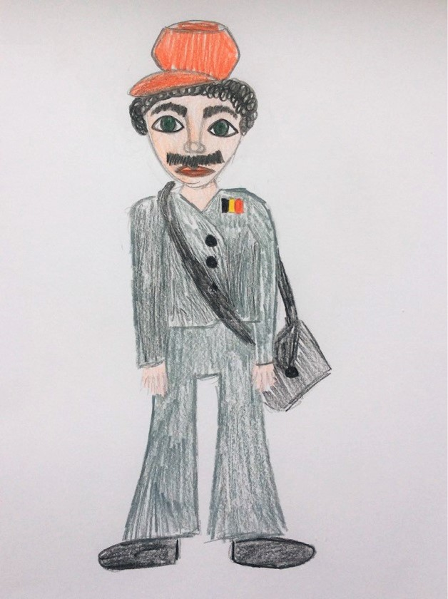

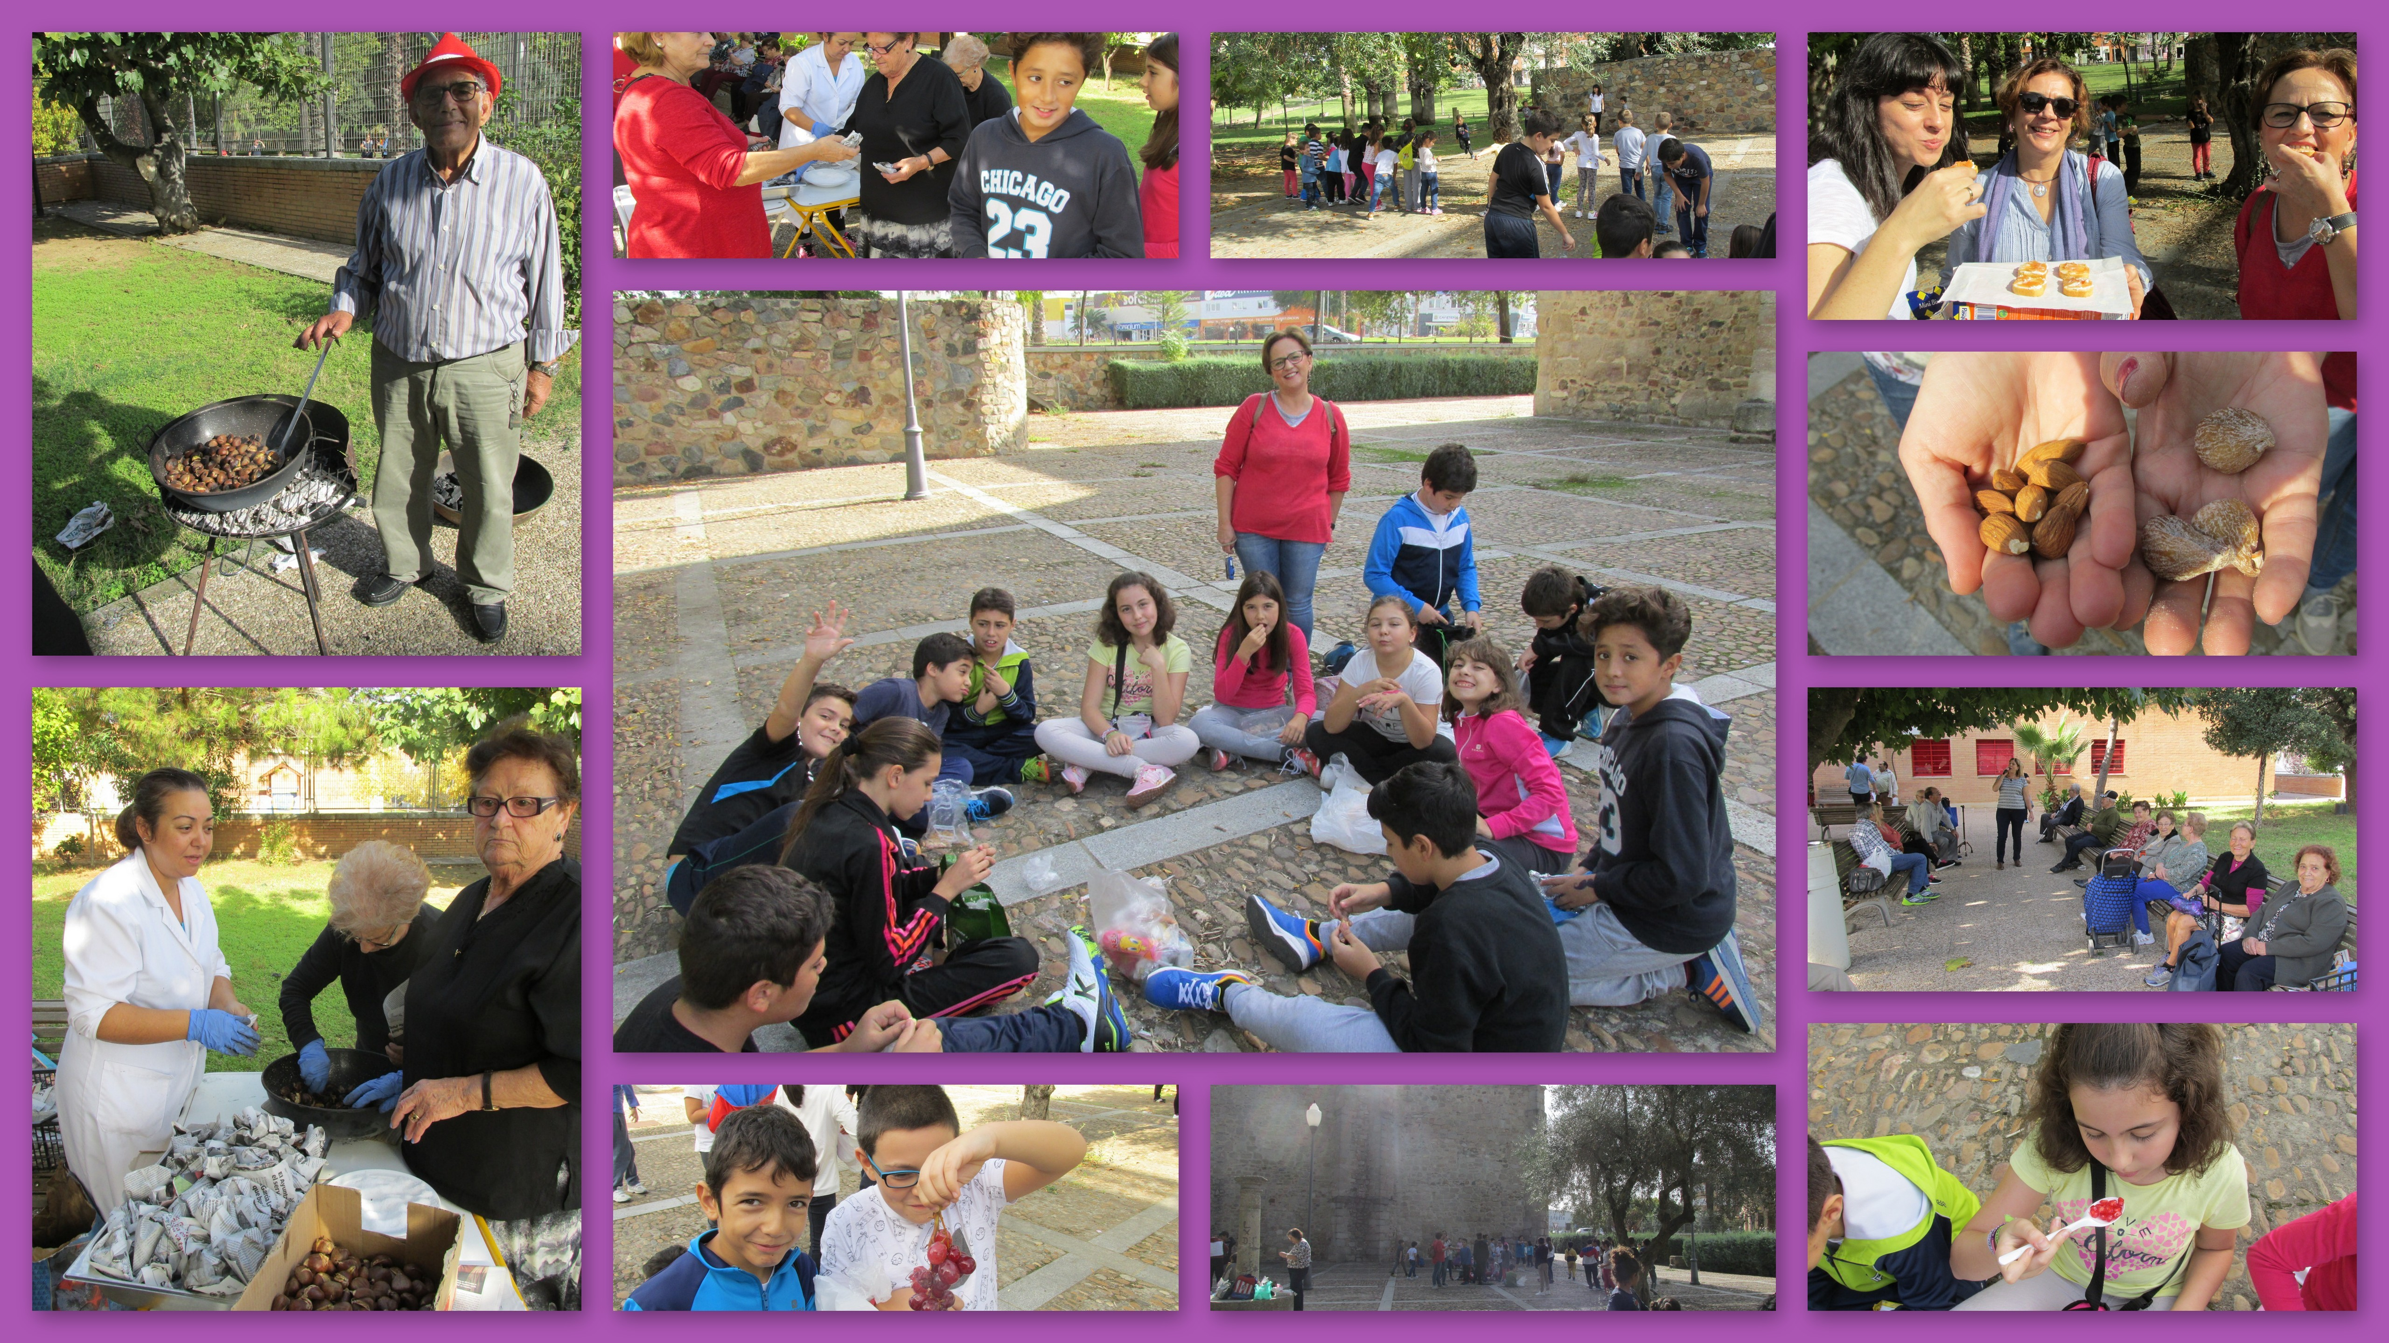
Some photos and drawings of “The Chaquetía Day”
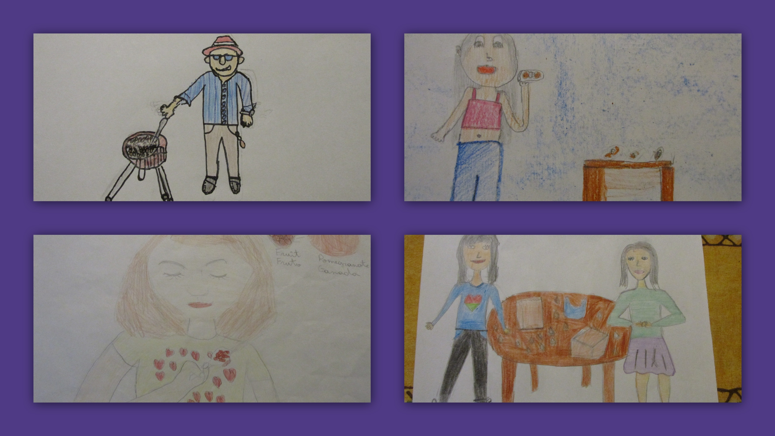

“The Chaquetía day” picture Dictionary
English
Spanish
Gaelic
Ukrainian
Polish
Finnish
Romanian

“THE CHAQUETÍA DAY” PICTURE DICTIONARY

Quince Jelly
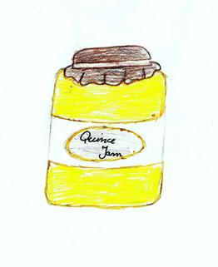
Carne o dulce de membrillo
Glóthach cainche
Айвове желе
Dżem z pigwy
Kvittenihyytelö
Jeleu de gutui

Peanut.
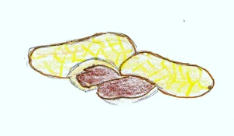
Cacahuete.
pis tálun
Арахіс
Orzech ziemny
Maapähkinä
Arahide

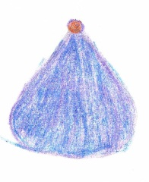
Sweet fig.
Higo dulce.
fige milis
Солодкий рис
Słodka figa
Makea viikuna
Smochine dulci

Delicious!
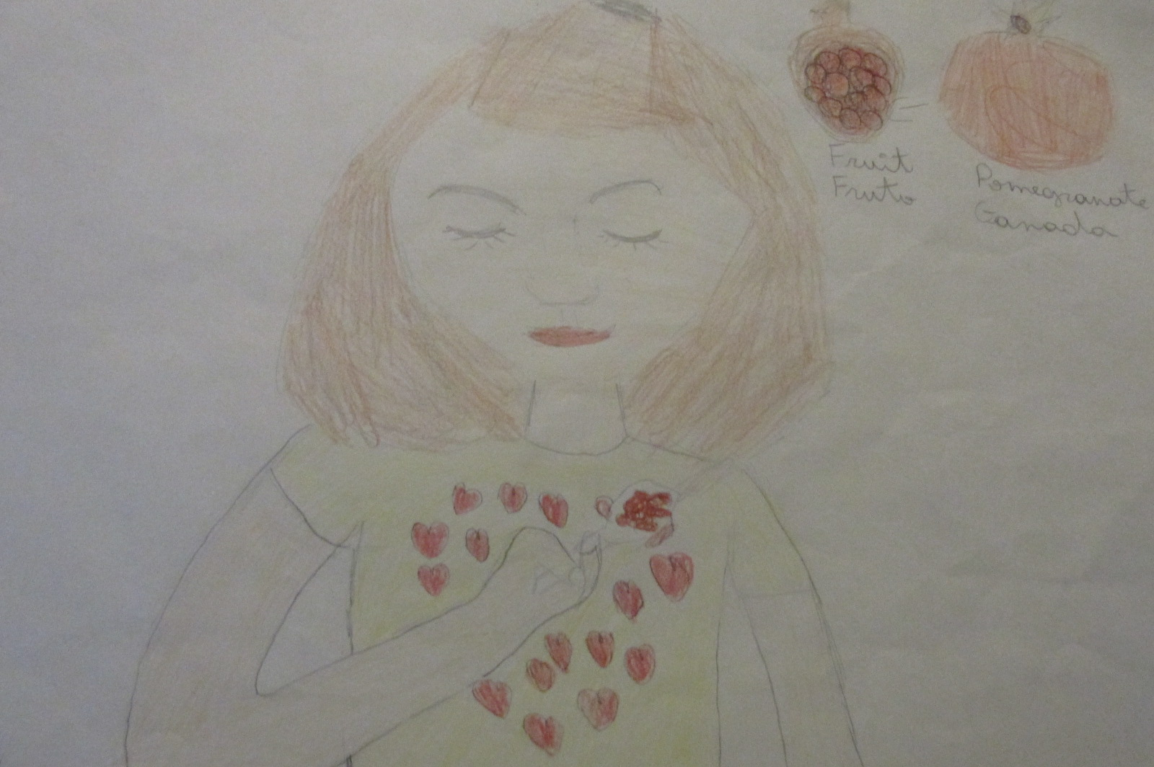
¡Delicioso!
an-bhlasta
Смачно!
Pyszny!
Herkullista!
Delicios!

Almond
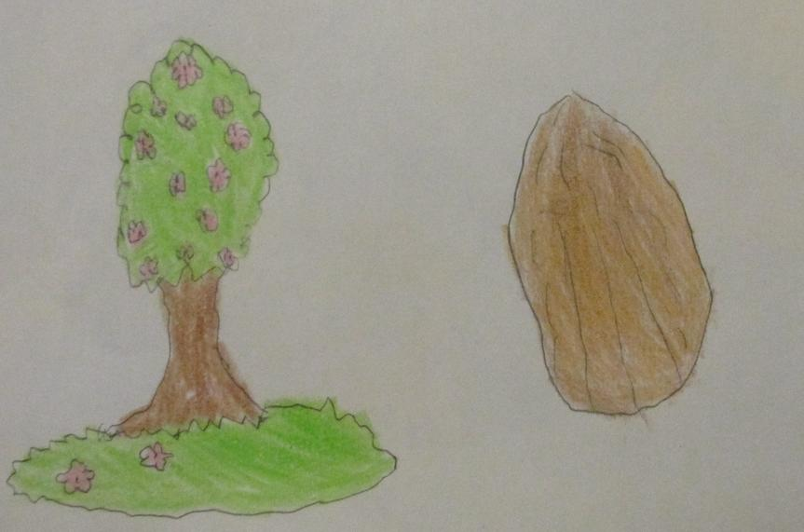
Almendra.
almóinn
Мигдаль
Migdał
Manteli
Migdal

Sharing “La Chaquetía” .
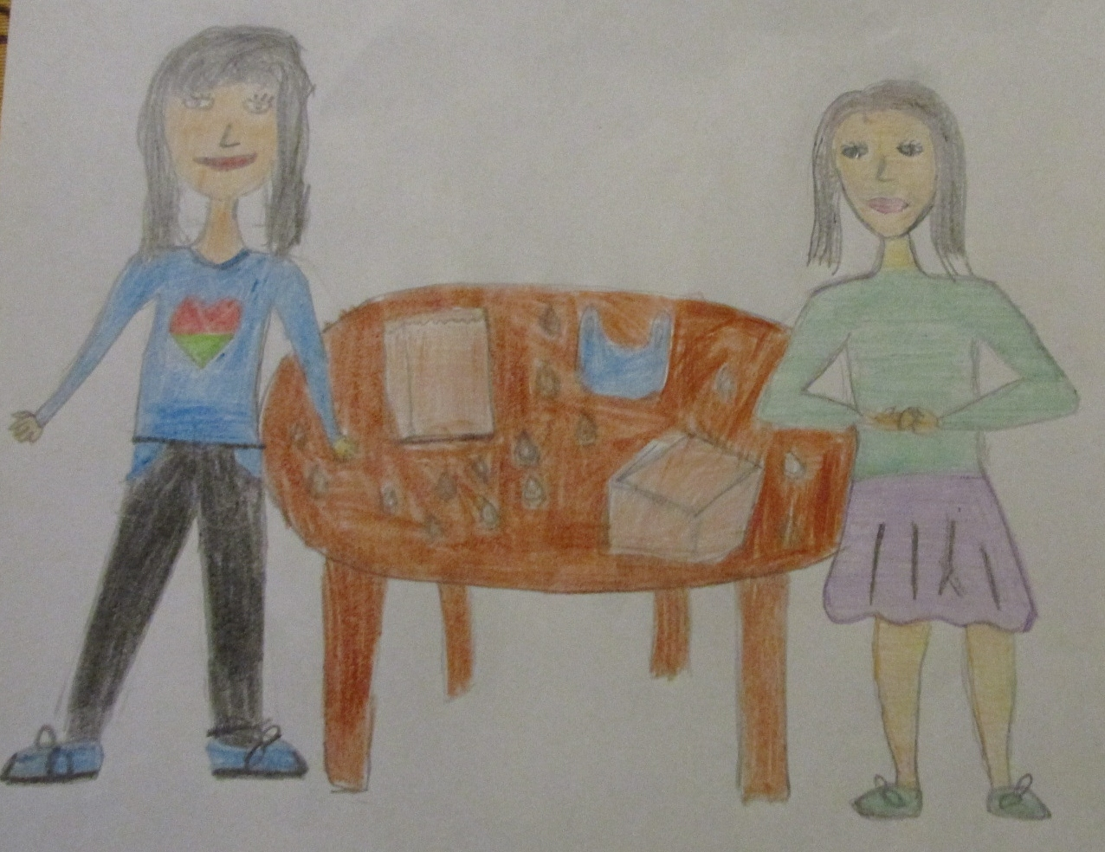
Compartiendo la Chaquetía.
comhroinnt
Використовувати спільно
Dzielenie się "La Chaquetia"
"La Chaquetian" jakaminen
Partajare "La Chaquetía".

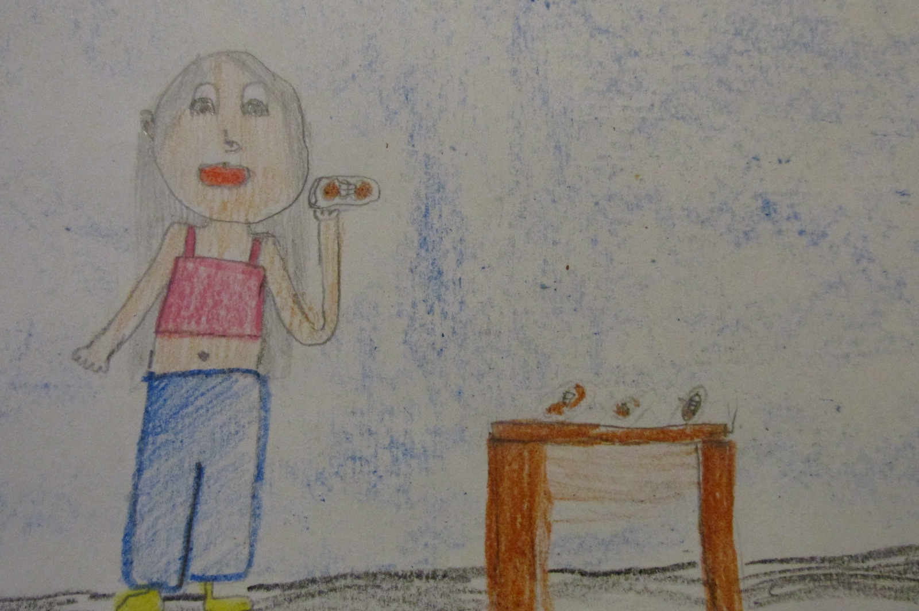
Smearing the quince jelly and the cheese.
Untando la carne de membrillo y el queso.
ag leathadh an Glóthach cainche agus an cáis.
Розмазуючи айвове желе і сир
Rozsmarowywanie dżemu z pigwy i sera.
Kvittenihyytelön ja juuston levittäminen
A murdări cu jeleu de gutui și brânză

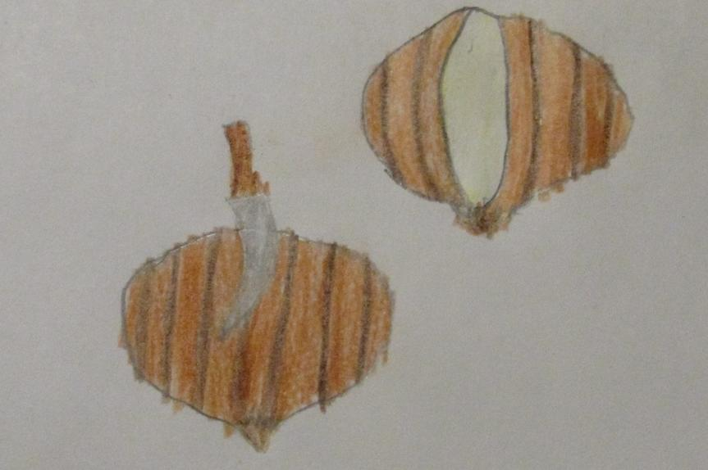
Slitting chestnust.
Rajando las castañas.
an cnó capaill scoilt
розкривати каштани
Rozcinanie kasztana
Kastanjoiden halkaisu
A sparge castane.

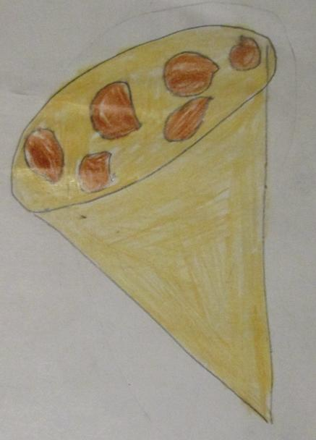

Packing roasted chestnust
Empaquetando castañas asadas.
ag pacáil an cnó capaill rósta
пакунок смажених каштанів
Pakowanie upieczonego kasztana
Paahdettujen kastanjoiden pakkaaminen
A împacheta castane prăjite.

Roasting Chestnust.
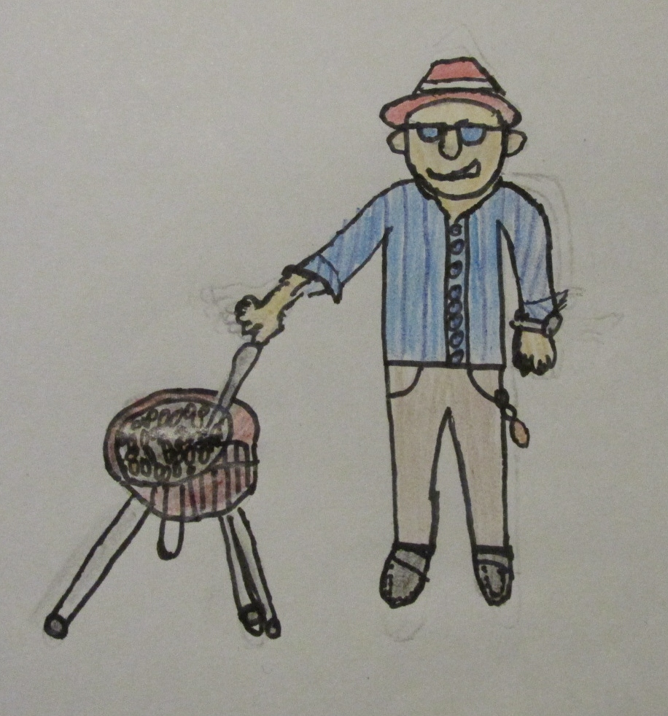
Asando castañas.
an cnó capaill rósta
смажені каштани
Pieczenie kasztana
Kastanjoiden paahtaminen
A prăji castane

Tangerine.
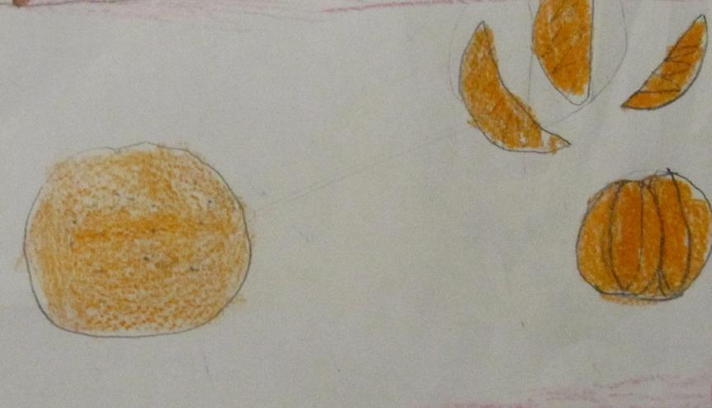
Mandarina
mandairín
мандарин
Mandarynka
Mandariini
Mandarină

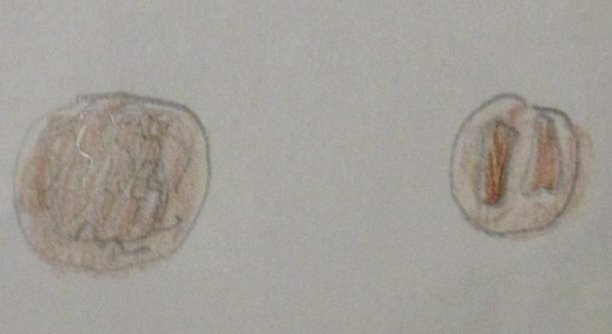
Nuts
Nueces
le cnónna
горіхи
Orzechy
Pähkinät
Nuci

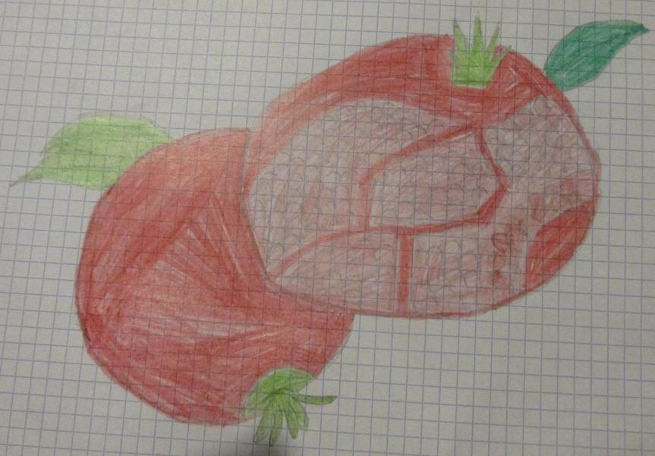
Pomegranate
Granada
pomagránait
гранат
Granat
Granaattiomena
Rodie

