10 good habits – making good choices
During the year we also worked on something we call 10 good habits. The project is about the pupil making good choices - finding habits - which means that they can have as good a daily life as possible and thus be able to perform well in school (and generally in life).

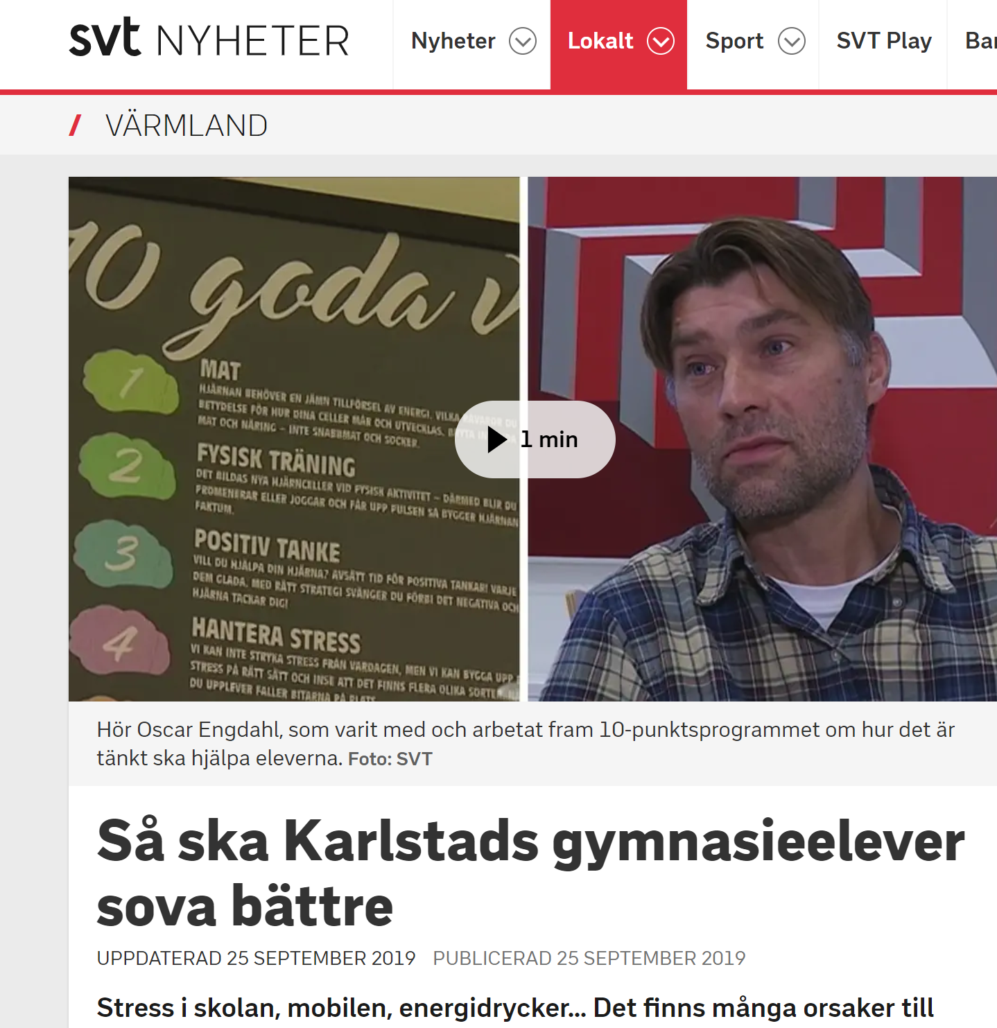
https://www.svt.se/nyheter/lokalt/varmland/sa-ska-karlstads-gymnasieelever-sova-battre

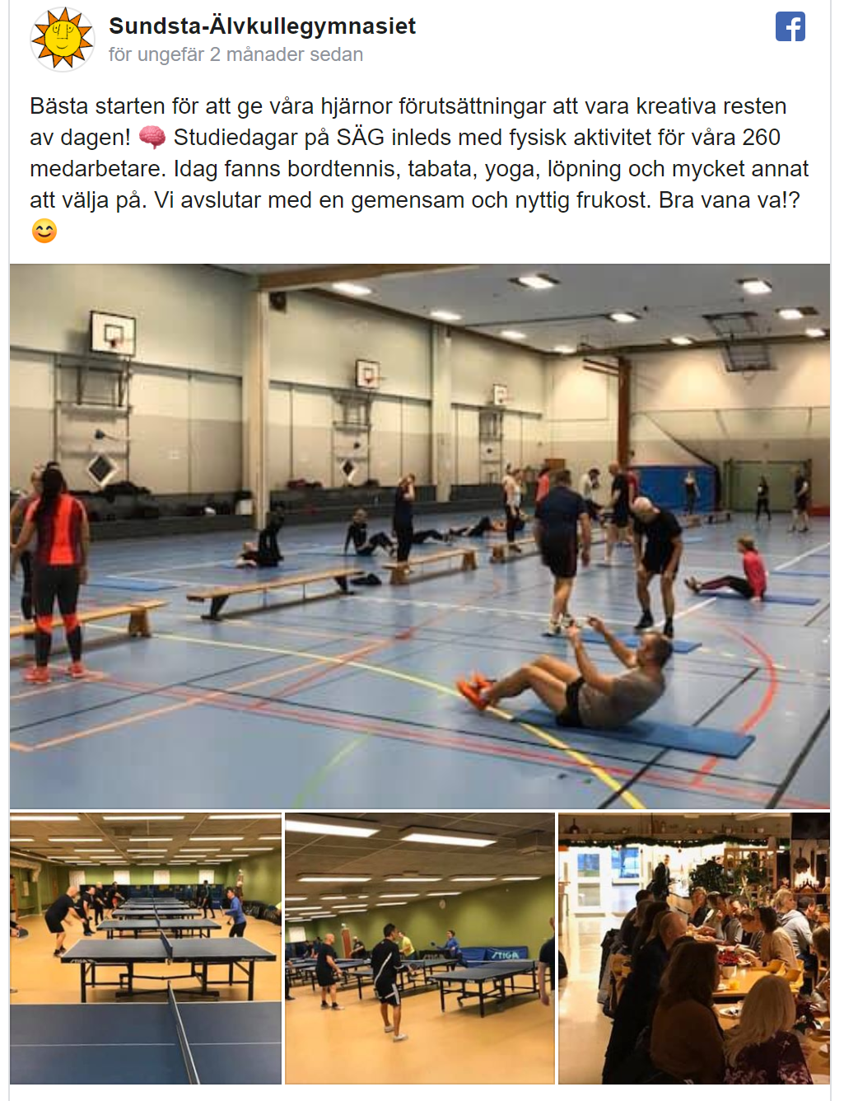

“Best start to give our brains the conditions to be creative for the rest of the day! 🧠 Study days at SÄG start with physical activity for our 260 employees. Today there were table tennis, tabata, yoga, running and much more to choose from. We end with a joint and healthy breakfast. Good habit huh!?”.
https://developers.facebook.com/docs/plugins/embedded-posts/?prefill_href=https%3A%2F%2Fwww.facebook.com%2FSundstaAlvkullegymnasiet%2Fposts%2F2835056749891695&__cft__[0]=AZWraMgKV-yKzN4BoRG3QZMlBhOIuYxCqi22hRL-LOkEJMPPlwFx7gDWOGPrA9dgn-vITR0dqJicdTkq8cViM-DFlAF3ATCKOO1iy7n8_4TmF0xP7geJFjYa9nLmlYO8JmZ09fRUijMEaPHFj5Lg1fcwwHJDll4ydcrbKW3LSOm6bQ&__tn__=p%2CP-R#code-generator

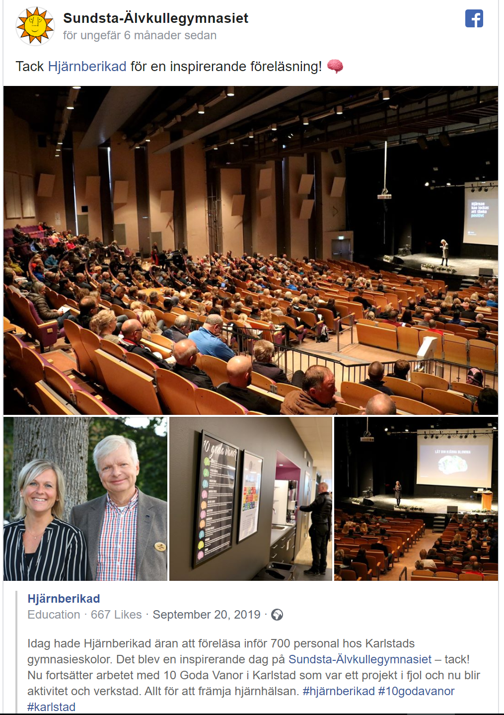

“Today, Brain Enriched had the honor of lecturing to 700 staff at Karlstad high schools. It was an inspiring day at Sundsta-Älvkullegymnasiet - thank you! Now the work continues with 10 Good Habits in Karlstad, which was a project last year and now becomes an activity and workshop. Everything to promote brain health. # brain-enriched # 10godavanor #karlstad”.
https://developers.facebook.com/docs/plugins/embedded-posts/?prefill_href=https%3A%2F%2Fwww.facebook.com%2FSundstaAlvkullegymnasiet%2Fposts%2F2601817289882310&__cft__[0]=AZUDe-UcOGMg6tHhu498w6v2-m8XitSJkL0NV-3l4QlKbfFbyWKEDSsCtvYA_KLgu224cvdFuJZS2Q6oM8rH4Q4H_kAdwOvU9F_qpLJdWsXshKh_DZgGF-qXZFIjnhJcZa1NeVhCttjl0YWciYRH1Y145sSJS51RV3BB6w1zITF1GDP-GgZOcxad1br7XEdPULpiqFsyEM87fBdqLJ09K9lePcJwm2bzU9MsK7wAY4l2Lmv_IoKBn3TS386HsXokAVI&__tn__=p%2CP-R#code-generator

Conclusion (so far)
Positive: that all mentors have the same structure, focus on the good habits of the month, that the material is solid and well-worked and has a good scientific basis, it is also comprehensive, many classes find it interesting and fun.
Negative: is that many times it becomes something that the mentors only check off, that the mentoring is not particularly engaging in the arrangement and that the students do not see it as something that affects them. Several mentors also see it as something further that must be done and the daily work becomes suffering. Only a few of the mentors write memos to It´s learning about 10 good habits.

