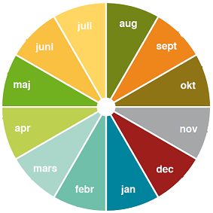

Handle stress

Variety

Repetition

Friends

**Year Wheel - 10 good habits**

Positive thought

Learn new things

Food

Sleep

Physical activity

Make your own decisions