ITALY-VITERBO LEARNING TEACHING TRAINING ACTIVITIES
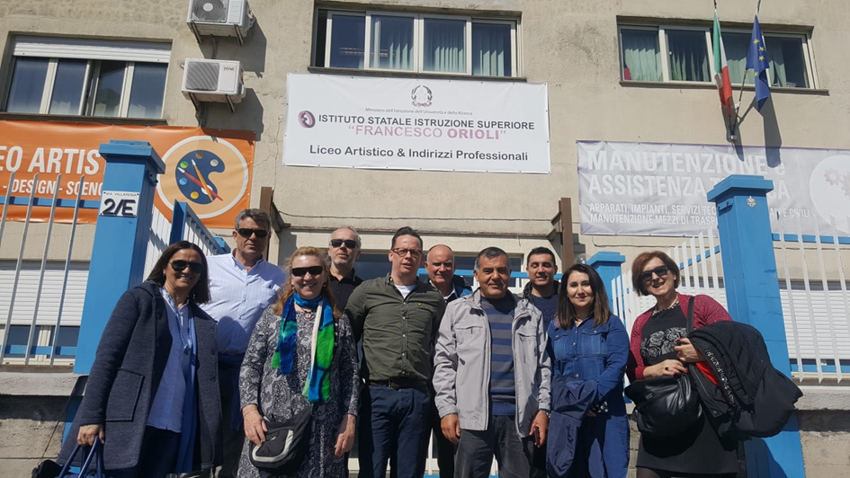
The project contact person Patrizia Falesiedi and the Guidance Teacher Alba Stella Paioletti from the IIS Francesco Orioli vocational school in Viterbo, Italy, and other relevant teachers and administrators participated in the project activities. The project activities were carried out with the project participants consisting of 8 teachers and managers from partner institutions outside Italy.
The participants:
SPAIN TURKEY
(IES Punta Del Verde) (Antalya Mesleki ve Teknik Anadolu Lisesi)
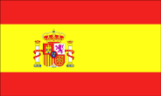
1- Adolfo Salto Sánchez del Corral 1- Mustafa Tahtabaş
2- Jesús Hernández Sánchez 2- Meltem Ökte Çıkan
3- María Ángeles Oliva Jiménez 3- Atilla Konuk
SWEDEN ITALIAN HOST INSTITUTION
(Karlstads Kommun Nobelgymnasiet)
1-Jan Johansson
2-Jan Wasikkaoja

The project teams of the partner institutions came to Viterbo on Monday, March 18, 2019 and settled in the hotels where they would stay. The project team from each partner institution stayed in different hotels because the host institution could not find a place in the same hotel even though they had booked in advance. As a Turkish project team, we stayed at the B & B ”L’Incontro” Residenza Medievale Hotel in the old city of Viterbo (San Pellegrino), surrounded by walls. This building in the old town is a 13th-century building that has been restored and used as a hotel today. For information, hotel prices are around € 50 per day.
LEARNING TEACHING TRAINING ACTIVITIES (19-22 March 2019)
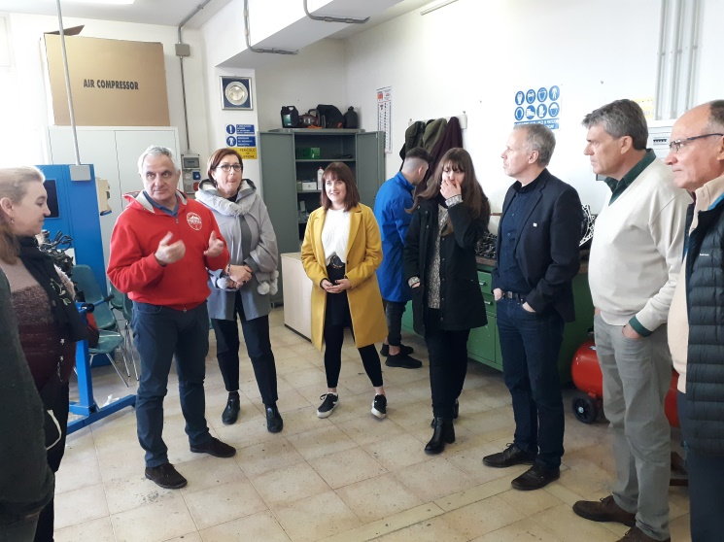
The mathematics teacher Andrea Celestini and the guidance teacher Alba Stella Paioletti from the host school project team took the participants to the school in the morning. The project team at the school organized meetings and department visits to introduce the school. At the school, we visited the informatics, graphic design, fashion design, electrical electronics, machinery and motor departments and talked to the teachers and students. In the corridors of the school, examples of graphic design made by the students took our attention.

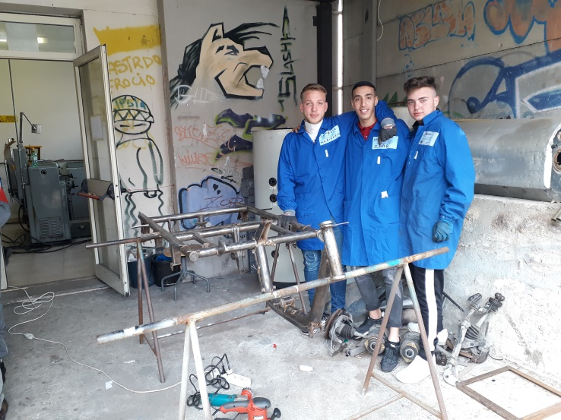
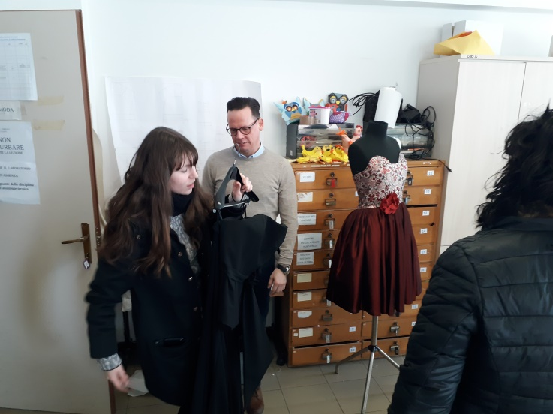They showed special clothes made in the Fashion Design department. These clothes made for special occasions are exhibited as an example. It was stated that exhibiting the products made by the students increased the professional motivation of the students.
We also visited the electrical, electronics, machinery, plumbering and IT departments of IIS Francesco Orioli. The school's workshops are usually small in volume and few students practice at the same time. There is also a desk chair environment to handle theoretical lessons in some workshops.
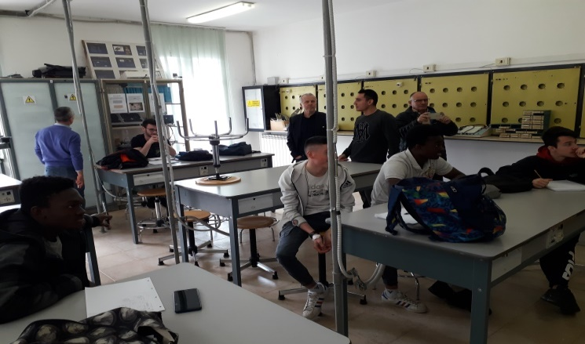
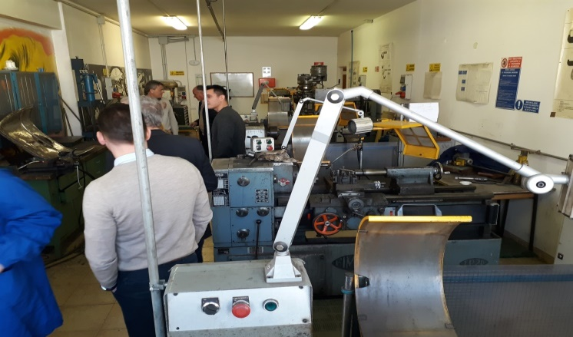
Students wear work aprons while practicing in workshops. There are some immigrant students coming from African countries. The noise in the school corridors during the break time seems to schools in Turkey. The teachers’ room and the school environment is also similar to Turkey. In a general point of, we can say that lifestyle and eating habits in southern European countries have a lot in common.
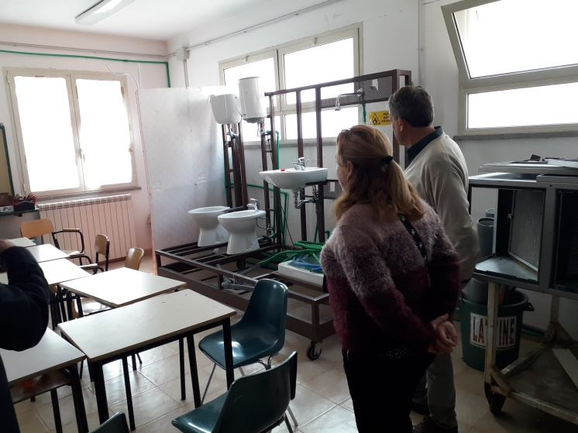
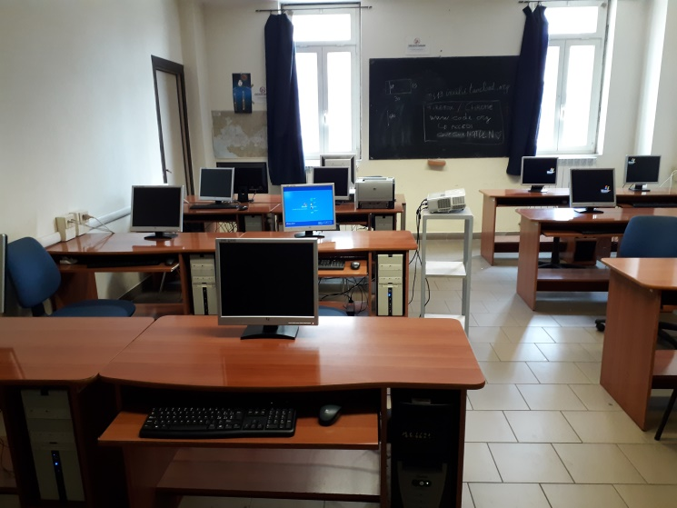
Teachers working for the school guidance service introduced the work and operations of the service. Guidance services for students, support services for students requiring special education and support services especially for disabled students were introduced.
Students in need of special education were assigned a teacher for two students in a small workshop and had them do the work they could do. Two of the students were separating the hundreds of tiny cubes of three different colors according to their colors and stick them on the cartons. In the second example, hundreds of keys removed from old keyboards were glued neatly onto a plastic mannequin. This kind of work improves the hand and mental skills of special education students with long-term patience with economic materials. We have observed that students do these things fondly.
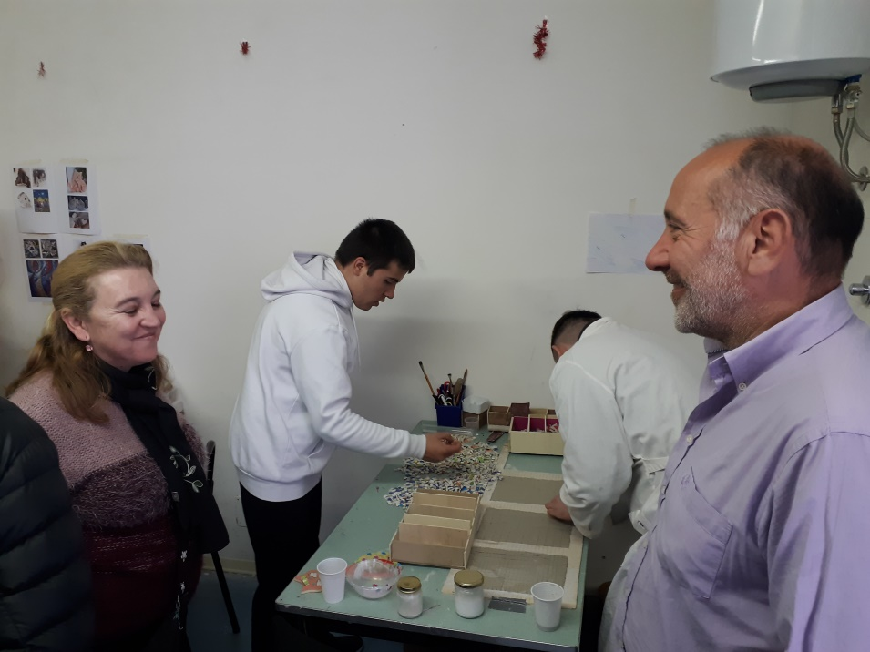
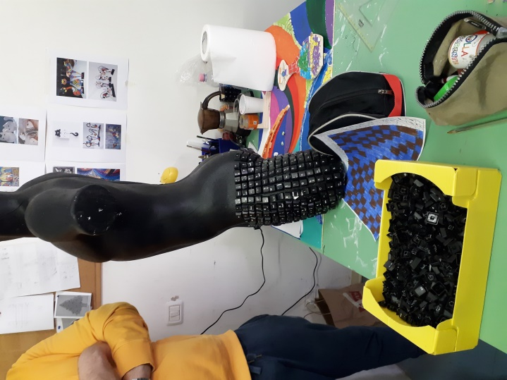
Counselor Mauro Spezzi, in his presentation, focused on the students' motivation and the factors affecting them. First of all, two types of motivation, internal motivation and external motivation were mentioned, depending on the adaptation and reference point of the students. Factors affecting internal motivation were summarized as interest, curiosity and the need to make money to meet our needs. Factors affecting external motivation were explained by recalling some theories of psychology. In addition, the concept of social motivation and the social recognition of the students by their friends and the feeling of meeting the expectations of the family were emphasized.
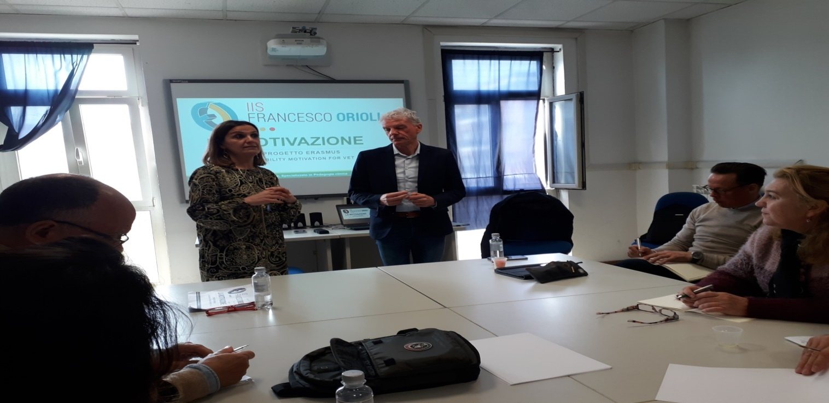
The following topics were also discussed about the students' motivation: A combination of balanced knowledge, effectiveness, and social relationships will enable the student to prepare to face the challenges of life. To teach students well, all aspects of students’ characteristics should be considered. Sociograms can be used to personally identify students' problems. In order to free low motivated students from their current situation, we should pay attention to collaborative learning, and we can develop short and easy lessons.

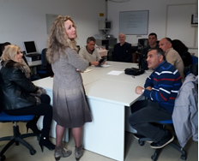
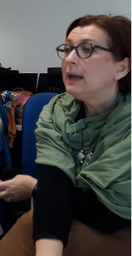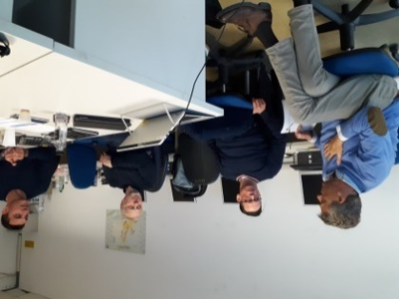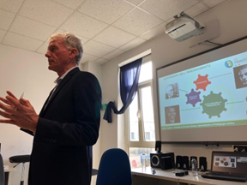
Another topic affecting motivation was also included in the guidance teacher's presentation. Human typing in psychology was explained with a cartoon image. (Do you know these people?) These human types were given as examples from real life and the participants were discussed on the subject.
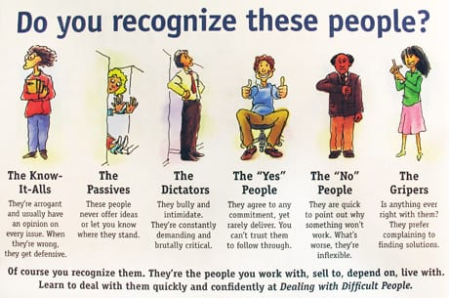

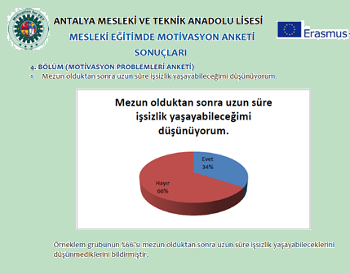
Each partner school explained the result of the questionnaire (Motivation in Vocational Education) which was created and carried out by all partners as one of the main activities of the project. http://vetforall.org.tr/anket
An example of this 54-item questionnaire is shown. At the project meeting, each institution interpreted their survey results considering their school and country. Then the results from the four partner institutions were combined on a bar graph, as in the example below for each question. The results in each item were evaluated and interpreted. All survey results and evaluation report can be viewed in the PDF file of our Projects / 2018-2019 Erasmus + KA229 / Motivation Survey Results from the menu at the top of our school (Antalya Vocational and Technical Anatolian High School) website.
http://antalyaeml.meb.k12.tr/meb_iys_dosyalar/07/19/970149/dosyalar/2019_04/11223702_TR-IT-SE-ES_Anket_KarYYlaYtYrma.pdf?CHK=678a825950e019102795956295d41d2d
The results can be found in the website announcements of our project on 8 April 2019.
http://vetforall.org.tr/cms/
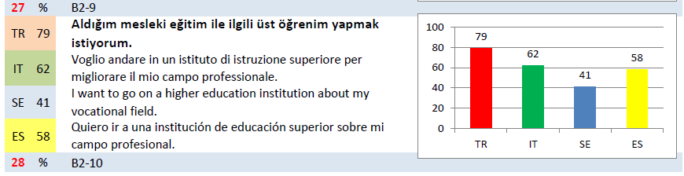 The results can also be found on the 9 April 2019 news on the facebook page of our project.
https://www.facebook.com/groups/1388915668102665/?ref=bookmarks
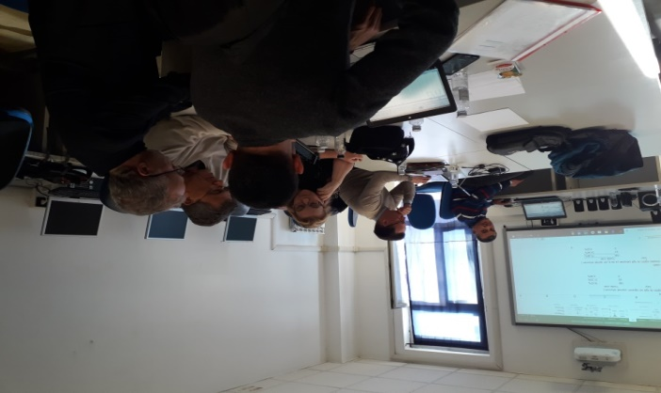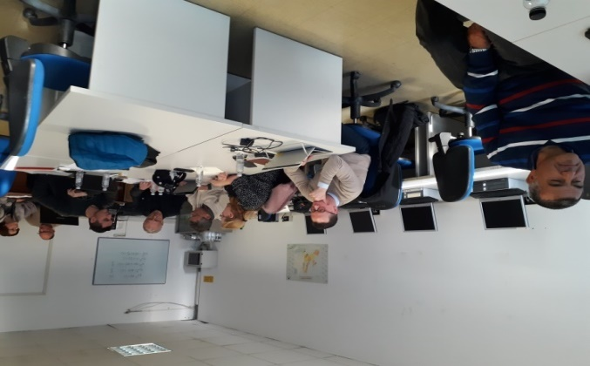
In the results of the survey, we found various areas where countries received similar answers, as well as areas with large differences. We tried to find the reasons for focusing on differences and creating activities that could strengthen the motivation of vocational education work in each country.
During the project meeting activities, María Ángeles Oliva Jiménez, Spain's partner institution guide teacher, made a presentation titled "Psychosocial Education and Intelligence in Vocational Education". In order for the education process to be effective, María Ángles underlined the need for teachers and explained the following: Motivation, healing, toxicity and caring for their families in good relationships. As for the students, he said that education and experience are essential elements for a competitive professional profile. But the most important for achieving true personal and professional success is psycho-emotional skills: all the skills, strategies and resources we demonstrate in our daily lives are both personal and social and professional. We see this dimension of the personal and professional development of both teachers and students as key.
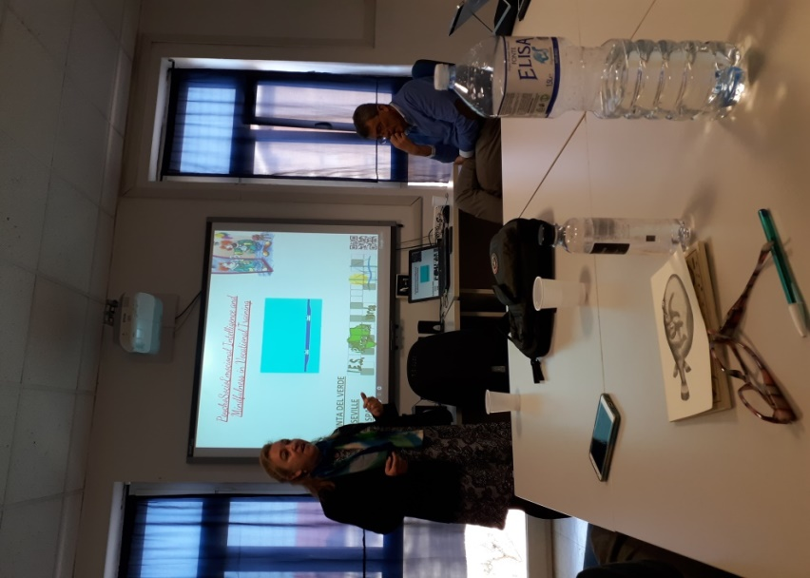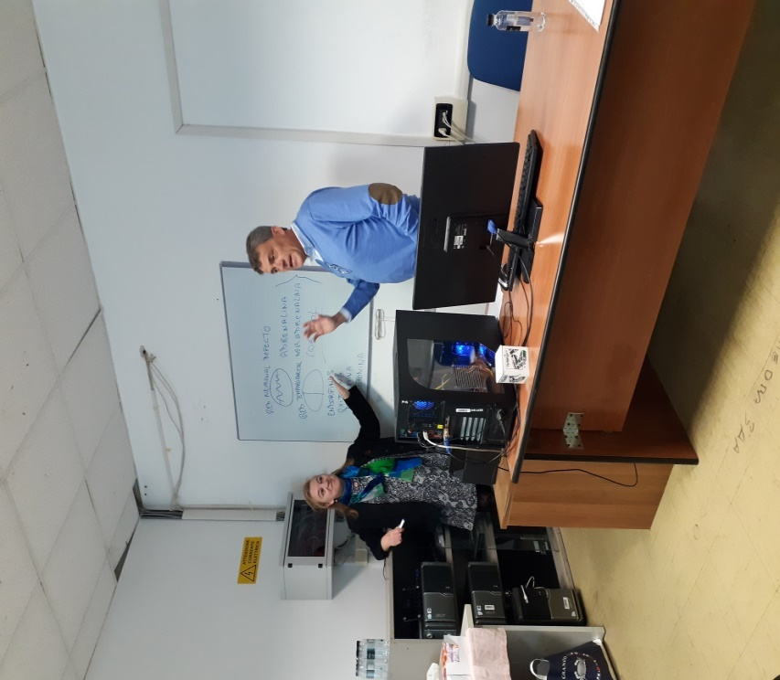
Undoubtedly, the motivation of our students and teachers develops with the knowledge and application of the techniques described in this workshop. The aim is to encourage schools to incorporate guidance mechanisms into curriculum mechanisms to acquire skills that develop skills such as self-awareness, self-control, empathy and social skills.
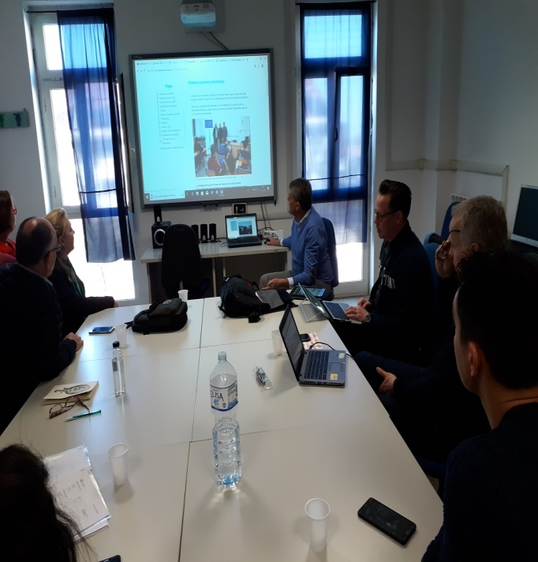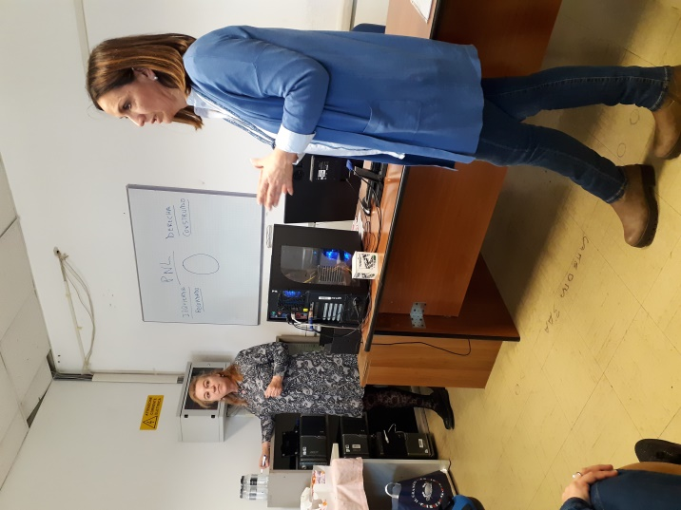
On the last day of the project activities, the project activities were evaluated. Until the next meeting, each partner institution will evaluate the positive and negative situations in its own survey results at their school. According to the reasons that reduce motivation, activities will be done to increase motivation. These activities will be announced at the Swedish meeting in May 2019, the results will be evaluated and good practices will be exchanged.
The host institution presented the Europass and Participation Certificates for each participant with a farewell dinner.
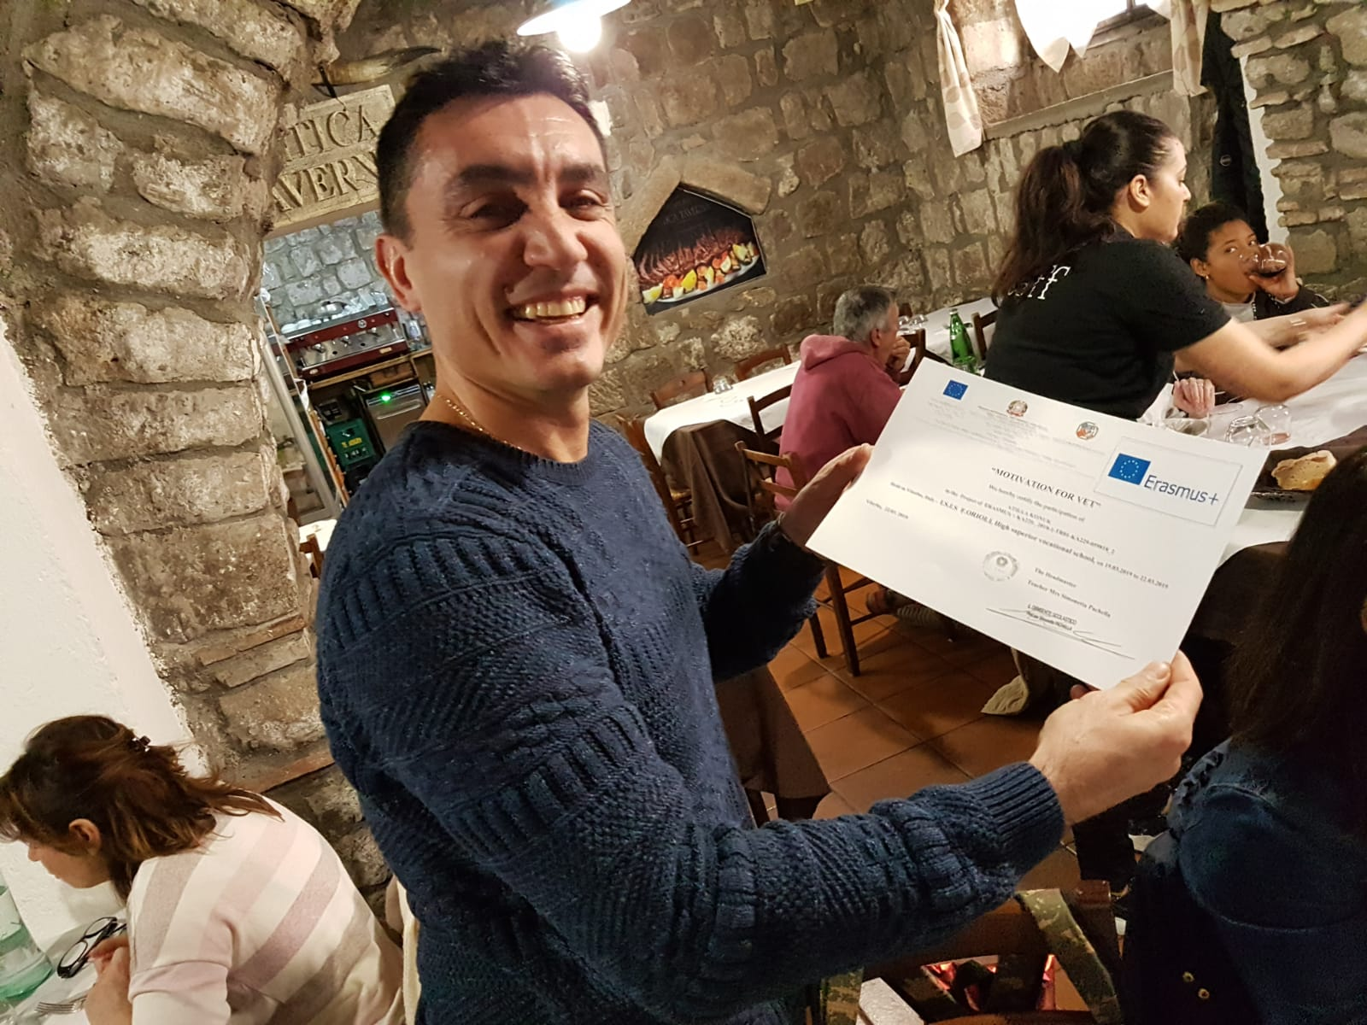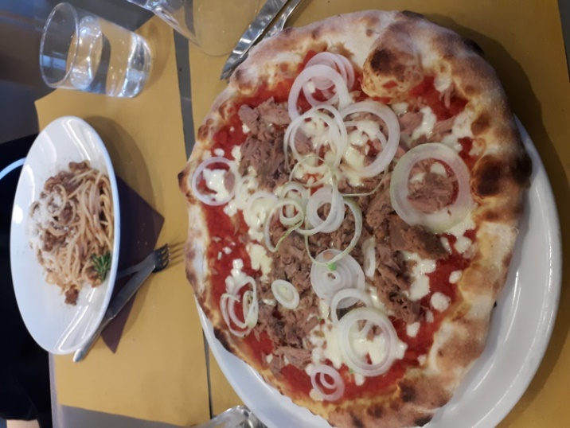
We tasted meals belong to Italian food culture. Usually there were different kinds of pasta and pizza in the menus. As a Turkish group, we preferred menus without pork. Let's introduce here the most varied food we eat in Italy. You can find these dishes everywhere, but they are served in different tastes in every restaurant.
