ABOUT ME…..
Hi !! My name is Ana Tomé, I´m fourteen years old and I´m in 9th grade.
I live in Vale de Óbidos with my parents, that is near of Rio Maior.
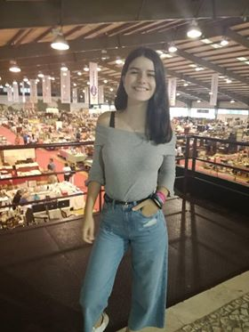
I was born in Santarém. I don’t have brothers and sisters.
I pass my days listening music and watching series and I love being with my friends.
I came to European club because I love English and I want travel to meet news countries and news people´s.

ABOUT ME….
HII!!!! My name is Alice Costa,I´m thirteen years old. I live with my parents and my brother in Casal Ventoso. I was born in Santarém.
I´ve got blue and grey eyes and blond hair.
I love dancing, drawing, swimming and listening to music.
I came to European club because I love English and I want travel to meet news countries and news people´s.
