Halloween at Ceip Vadorrey, Zaragoza, Spain
Edit page
Halloween at Ceip Vadorrey, Zaragoza , Spain:
In the morning, we decorated our doors:
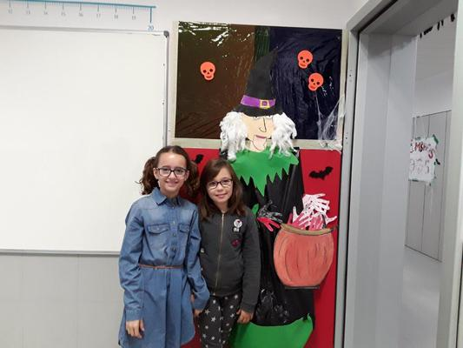
We listened to some spooky stories about legends at Halloween night:
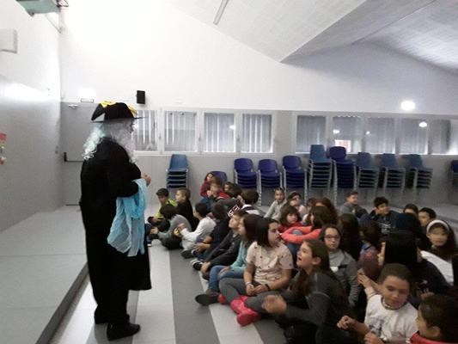
We made beautiful Halloween hand puppets:
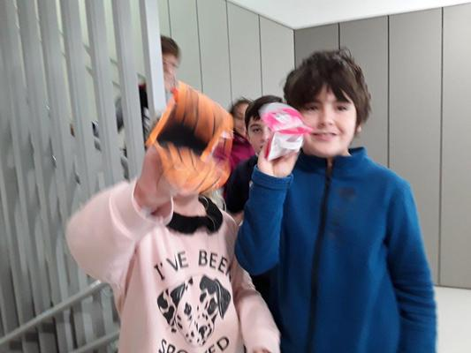

In the afternoon we all celebrated Halloween dancing songs and wearing our favourite scary costumes:
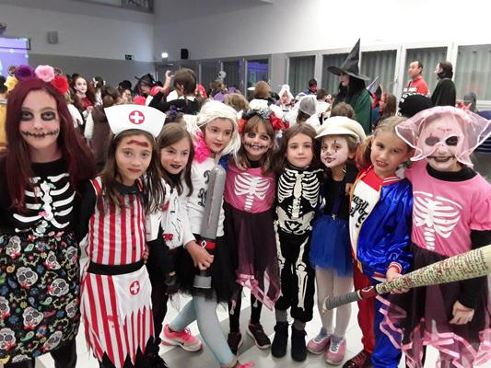
Even our teachers wore them too!
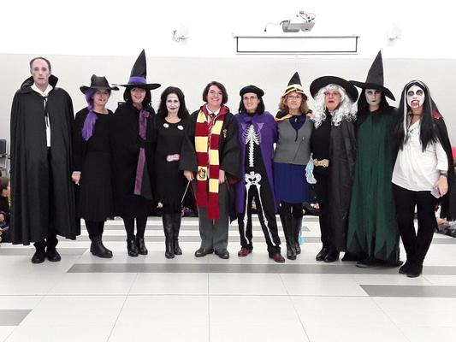

Happy Halloween!

