Anatomy of skin
Lesson Plan

WORKSHOP- „Anatomy of skin“ prepared for the LTTA part of Creative teaching and Learning, Erasmus+ Project with agreement №2016-1-BG01-KA219-023692, funded by the European commission.
TEACHER: Valya Radeva, Biology teacher, SU Ekzarh Antim I, Kazanlak, Bulgaria
AUDIENCE: teachers and students
TIME AND PLACE: Escola Secundaria Maria Amália Vaz de Carvalho, Lisbon, Portugal, April 2017 г.
LESSON TITLE: Anatomy of skin
PARTICIPANTS: Students, ages 15-18, participating in LTTA , Creative Teaching and Learning project in Lisbon, Portugal, April 2017. The students worked in international teams.
LANGUAGE: English
TIME: 40-45 min
GOAL: Students learn structure of skin by making a model.
MATERIALS: balloons, cotton, sheets of paper, shoelaces, markers, glue, candies with different color, napkins
ACTIVITIES PLANNED:
- The first step is explanation of skin by the teacher.- 10 min
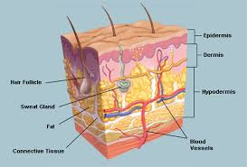

- The students are divided into groups by choosing candies with different color.- 2-5 min

- Each group has to create a model of skin using only balloons, cotton, sheets of paper, shoelaces, markers, napkins, glue and using their knowledge about the anatomy of skin and their own creativity and imagination.- 20 min

- At the end of the task each group has to represent its model and to explain the different parts of skin.- 10 min

FEEDBACK: Students are having a great fun and being in competition they memorize structure of skin without difficulty.
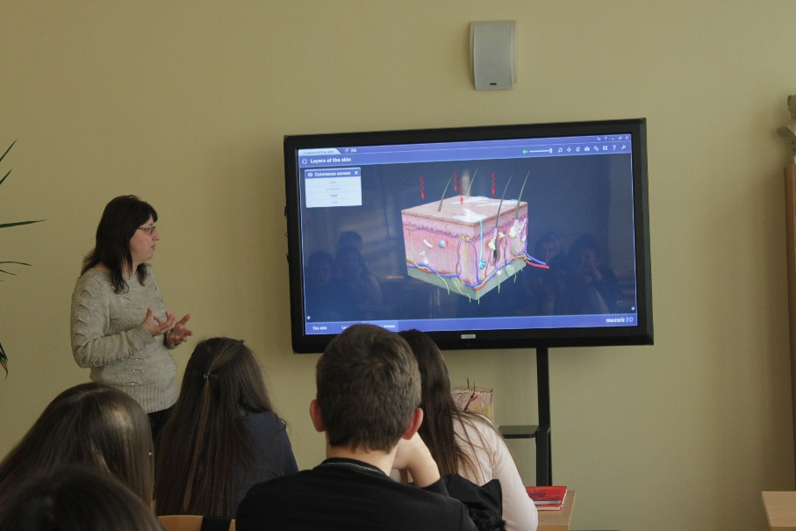
Valya Radeva, SU Ekzarh Antim I, Kazanlak, Bulgaria

