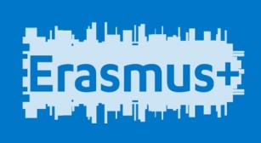 | 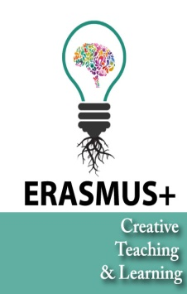 | 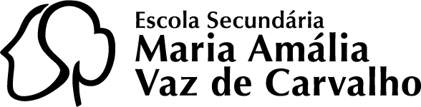

ABSTRACT - workshop on Thursday 28 / 04, 12, 12pm (~15 min)
Teacher: Nektarios Rodosthenous, American Academy Larnaca

Sampling: A teacher’s guide to Soundplant
This workshop offers an explication on the educational purposes and the sampling environment of Soundplant, a cross-platform (Windows and Mac) freeware (free software). The participants will experiment with the creative tools of the software, as well as its more technical functions. In order to get a real sense of the potential and the capabilities of Soundplant, they will be able to custom-control any parameter of the software. Questions of sound design will be explored; as the name suggests, this is a process dealing with the notion of sculpting in sound, hence enabling and enhancing the creative impulses which are embedded in the process of sampling. Soundplant is very simple in its fundamentals and its details; yet, even though technology advances it remains effortlessly engaging to its users, influencing and getting influenced by the students.
In the end of the workshop, time will be given for exchange of ideas from a music technology standpoint between the participants. Additionally, this workshop opens up the critical discussion of adaptation of music tech tools in the didactic systems and presents ways of embedding music technology in the educational sphere, shifting the focus and promoting a student-centric approach to e-learning.

