Introduction to War Poetry
By Mr Rioch O'Gorman
Deputy Director of English , Astor College for the Arts, Dover, England
L/O: Use your imagination to create a soldier.

Who is this man?
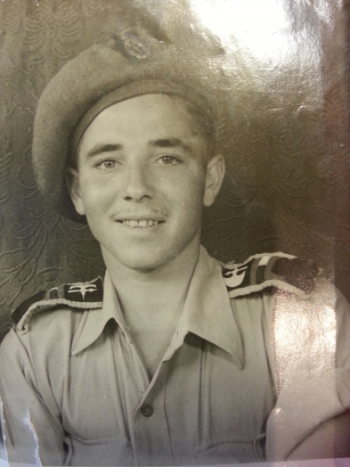

What is his name?
Where does he live?
What is his favourite food?
What is his favourite drink?
What is his favourite sports team?
What is his best friend called?
Who is his favourite relative?
What is his favourite subject at school?
What is his special talent?
What is the name of his girlfriend?
What is his dream job?
Where would he like to live in his old age?

1) Corporal Task :
Write three lines you would say to your parents about going off to fight for your country.
2) Sergeant Task:
Write down three private feelings about being sent into a war zone. How do you feel?
3) Major Task:
Think of three positive sights and sounds and three negative sights and sounds of being at war.
Choose your task
4) General Task:
Using all of your sentences, write an imaginative diary entry about being at war.
*Remember that the main point of this is to think about how war would have affected the individuals*
2018 marks 100 years since the First World War ended…
… so let’s jump into the present day!
Under your work, I’d like you to write a social media style message on what you’ve learnt today. You can start with: ‘’Today in English, I learnt…’’

