Lesson Plan
WORKSHOP – PRESENTATION for ERASMUS + Project: 2016-1-BG01-KA219-023692_2
TEACHER: Elen Sotiropoulou, English Language Teacher at 17 Lyceum of Athens
Date: 29.4.2017
AUDIENCE: Teachers, (Students?) - School: Lisbon, Portugal ‘

LESSON TITLE : STRESS
STUDENTS: Senior High School, ages 15-18, participating in ERASMUS+ Project ‘Creative Learning & Teaching’, 2016-2017. Lisbon, PORTUGAL, April 2017.
LANGUAGE - LEVEL: ENGLISH, Advanced Level English Language Skills
TIME: ~40 MIN

SKILLS: ALL (LISTENING – SPEAKING – READING – WRITING)
AIM/GOAL: HOLISTIC LEARNING THROUGH CREATIVITY, LEARNING THE NEW USING THE FAMILIAR- MASTERING AND IMPLEMENTING RELEVANT KNOWLEDGE AND SKILLS VIA INTERDISCIPLINARY APPROACH: English Language, Biology, Drama, Art, ICT, PBL,
OBJECTIVES: VOCABULARY AND GRAMMAR PRACTICE, ORAL SKILLS DEVELOPMENT, COGNITIVE, METACOGNITIVE, SOCIAL, EMOTIONAL, COMMUNICATIVE DEVELOPMENT, CRITICAL THINKING

OUTLINE:
ACTIVITIES PLANNED + TIME ALLOCATED FOR EACH ONE:
Use English language and all four learning skills. Practice using conditionals.
1’ – Introduction to topic via realistic shock tactic
1’ – split students into groups of 3-4 (each one from a different country so they
get to use English only, to communicate)
1’ – Introduction to activity – requirements, objectives, outcome – give
handouts
1’ – Students allocate roles (two doctors, one cameraman, one patient-if there
is a fourth person in the group, time keeper) – use journal-list
10’ - Read (skim), choose and use ideas from: text, vocabulary list of
expressions, alternative medicine handout, body charts (both controlled
and freer practice) - use journal-list
10’ – Act – Role Play improvising and record on video each group’s attempt.
Students – Teacher can use mobile phone camera. Video should not be
more than 1-2 min. in length – use journal-list
10’ – Watch videos silently - use journal-list
5’ – Students gather in groups of common roles , e.g. all alternative doctors
together. They give feedback and share their notes - use journal-list.
They allocate a speaker for their group to report to class.
5’- Feedback to whole class from all groups.. What went well, what they
enjoyed, realized and/or learned, what they would do differently.
Evaluation of self, others, activity.
1’ – Show our English language WIKI page on ‘Stress’ and Play song(s)
while wrapping up with positive outcomes, e.g. realizing there are ways
out of stress and the best way is to communicate with others.
Talking helps identify and solve underlying issues causing stress.
Solutions to stress will be offered in next meeting through a special
Mindfulness Activity.

MATERIAL/FACILITIES / REQUIREMENTS: Projector, PC, WIFI, Internet, Mobile phone camera, HD cable, Doctor’s robes (if possible), Handouts (text from coursebook, alternative medicine, body chart, journal-list, …)

RESOURCES/REFERENCES/LINKS:
QSE ADVANCED LEVEL by Andrew Betsis, unit 19, p.87
STRESS https://www.psychologytoday.com/basics/stress
Alternative medicine http://altmedworld.net/alternative.htm
https://www.verywell.com/holistic-health-4014763
Body chart http://www.mindbodygreen.com/0-18426/diy-foot-reflexology-7-pressure-points-to-reduce-stress-boost-metabolism.html
http://www.newhealthguide.org/Reflexology-Foot-Chart.html
Expressing opinion vocabulary - handout
Songs Don’t worry be Happy , Bob Marley
https://www.youtube.com/watch?v=L3HQMbQAWRc
all you need is love, Beatles
https://www.youtube.com/watch?v=dsxtImDVMig
Perfect, Fairground attraction
https://www.youtube.com/watch?v=txapREGWHp0
Journal-list - handout
Wiki http://17lyka.wikispaces.com/health
Evaluation sheet - handout
Quiz STRESS QUIZ - Enjoy
https://quizlet.com/36437382/flashcards
http://www.webmd.com/balance/rm-quiz-health-benefits-music
http://www.webmd.com/balance/rm-quiz-happiness
https://quizlet.com/36437382/stress-managment-flash-cards/
http://study.com/academy/practice/quiz-worksheet-characteristics-of-general-adaptation-syndrome.html -GAS
http://study.com/academy/practice/quiz-worksheet-chronic-stress-related-health-risks.html - CHRONIC STRESS
http://study.com/academy/practice/quiz-worksheet-ways-to-reduce-stress.html - COPING
LESSON PLAN : https://v.gd/9OhBsb
http://learningdesigner.org/

EVALUATION: Self, Others, Activity
TAKE HOME TASKS/ASSIGNMENT: - Create a video with captions, title,
project info etc and upload on our wiki Erasmus page to share with all
-Write a list of ideas to help students overcome exams stress and
present in a PPT with visuals and music. Upload on our Erasmus wiki
and share. A discussion may follow on which PPT was most
helpful/inspiring.

NOTES:

USEFUL REFERENCES FOR TEACHERS
- LESSON PLANNING WITH BLOOM : http://learningdesigner.org/

- STATE LEARNING STANDARDS
Five Components of Comprehensive Social and Emotional Learning
• Self-Awareness (identifying emotions, self-confidence, self-efficacy)
• Self-Management (impulse control, stress management, self-discipline,
motivation, goal setting, organizational skills)
• Social-Awareness (perspective taking, empathy, appreciating diversity,
respect for others)
• Relationship Skills (communication, social engagement, relationships,
cooperation, resolving conflicts, seeking help or helping)
• Responsible Decision Making (problem solving skills, ethical
responsibility)
UIC, UNI OF ILLINOIS CHICAGO
https://www.casel.org/wp-content/uploads/2016/01/state-learning-standards-to-advance-social-and-emotional-learning.pdf
- GOALS, OBJECTIVES AND LEARNING OUTCOMES
http://schools.aucegypt.edu/academics/eli/IEG/Pages/Goals,%20Objectives,%20and%20Learning%20Outcomes.aspx

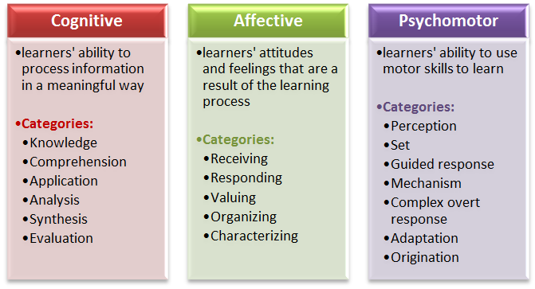

- MY WIKI LINKS
http://17lyka.wikispaces.com/BLOOM
http://17lyka.wikispaces.com/ERASMUS++KA2
http://storybird.com/books/dreaming-of-happiness-or-living-it/
http://17lyka.wikispaces.com/happiness
http://17lyka.wikispaces.com/health (Scroll down to ‘STRESS’)

- STRESS QUIZ - Enjoy
https://quizlet.com/36437382/flashcards

