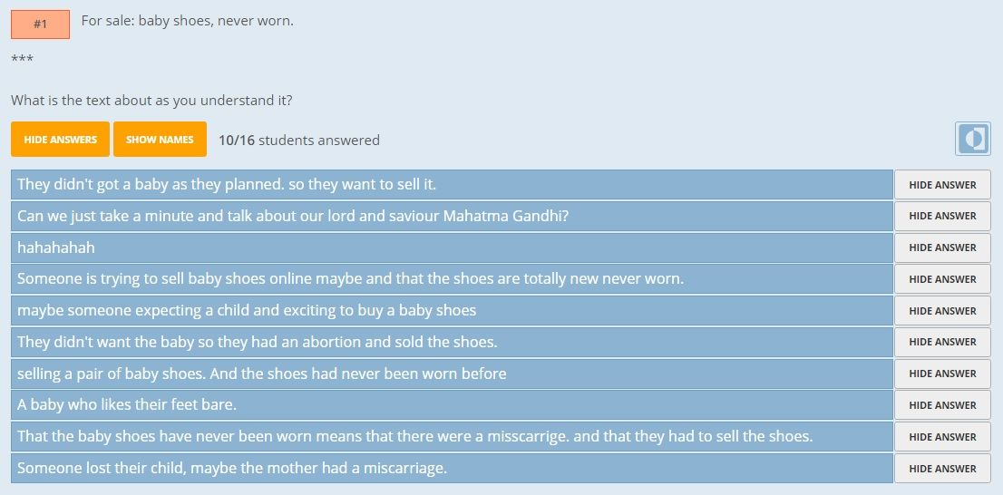

Website: www.socrative.com
The main purpose of using Socrative is to let all students participate, even the students who are a bit shy and normally don’t draw attention to themselves, will here maybe spark and feed the class discussion. The fact that the comments are published anonymously by the students can encourage them to then participate in an open class discussion as realize that their ideas are possibly quite similar to others’ way of thinking. It is important that the teacher examines the comments before publication to avoid inappropriate language and comments publically.

