STRESS
http://themaximmovement.com/blogs/three-phases-of-the-stress-response/
Three Phases of the Stress Response
Written by Andrea Maxim, Naturopathic Doctor
There are THREE phases of the stress response: Alarm – Resistance – Exhaustion
ALARM: this is your “fight or flight” ACUTE response. Hormones like adrenaline are secreted here which allows us to run away from predators. What happens here is all the blood and energy rushes to our heart and lungs allowing us to run. In turn, this takes energy away from all other organs and systems, like the digestive system
RESISTANCE: this phase is our response to CONTINUED stress. Now, our adrenal glands start to secrete cortisol to combat the stress. Cortisol is a good hormone to have as a short term solution to stress. Long term secretion can cause the adrenal glands to become fatigued. When this happens, the body uses other organs as a resource ultimately leading to a total depletion of the body. Other symptoms at this phase include increased heart rate, increased blood pressure, retention of water and huge carbohydrate cravings (energy source).
EXHAUSTION: this is when partial or total collapse of the organs occurs. The adrenals are completely exhausted and all other organs are stressed beyond their means. When people exhaust themselves in such an extreme way, autoimmune disease, cancer, diabetes, headaches, migraines, menstrual irregularities and serious digestive disturbances occur.
HOW CAN YOU MEASURE YOUR STRESS RESPONSE?
All phases are mediated by our main stress hormone cortisol, produced by the adrenal glands. Measuring cortisol levels, through serum or saliva, is the best way to determine adrenal gland function. The most accurate method of testing cortisol is through Salivary Hormone Testing – either early morning salivary cortisol or a 4-point cortisol test. The 4-point cortisol test will measure your cortisol at four different times during the day, which is the best way to see how your body responds to stress on a daily basis. Ask Dr. Maxim how you can get your adrenal gland function tested to prevent Burn Out.
Do not hesitate to contact Dr. Maxim today to start MAXIMizing on your Hormones and MAXIMizing on your Health!
Andrea Maxim, ND – Creator of the MAXIM MOVEMENT
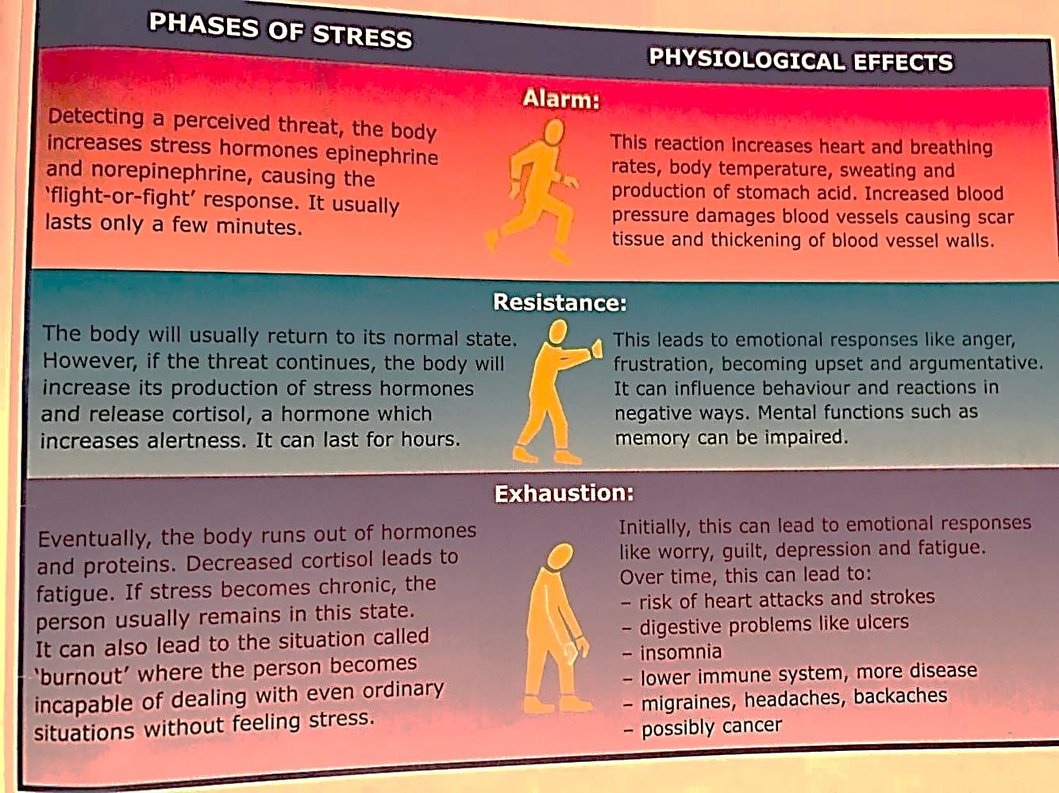
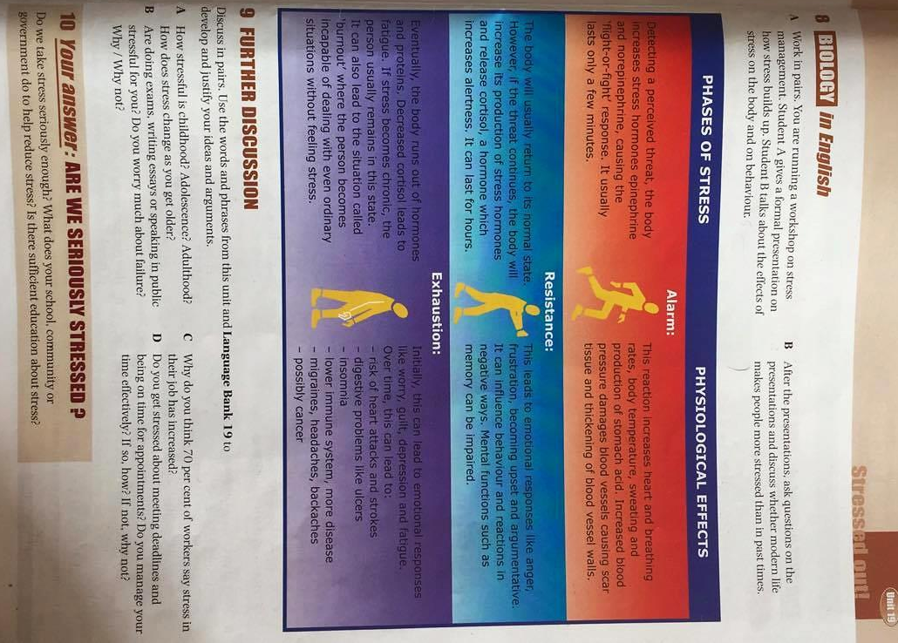
ORIGINAL TEXT IN COURSE BOOK ‘QSE’, ADVANCED, by MAURICE FORGET, ANDREW BETSIS ELT PUBLICATIONS
UNIT 19. P.87

