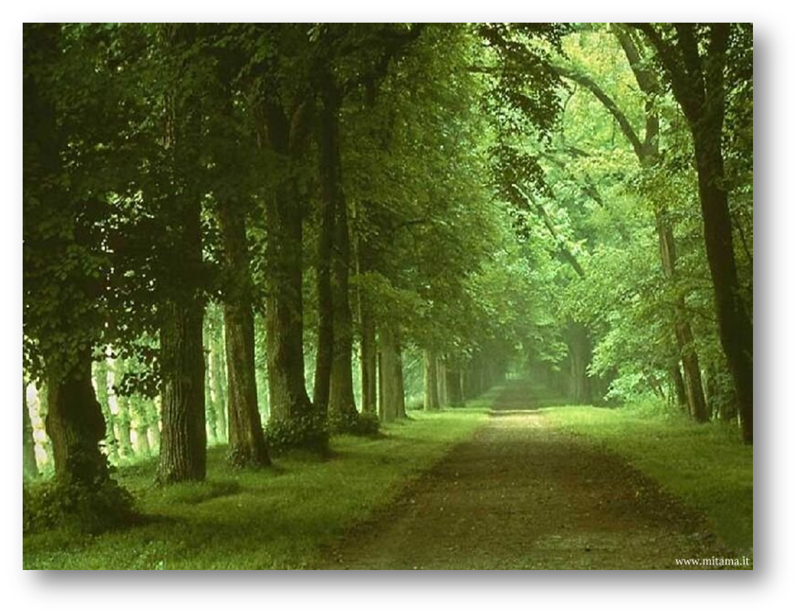

IN MY LIFE…

I HAVE SEEN FANTASTIC SKIES.

I HAVE HEARD THE BIRDS SINGING.

I HAVE TOUCHED AMAZING ANIMALS.

I HAVE SMELLED THE THRILL OF THE WIND.

I HAVE TASTED THE TASTE OF DEFEAT.

I HAVE DONE EVERYTHING FOR MY FRIENDS.

***IN MY LIFE…***

***I HAVE SEEN FANTASTIC SKIES.***

***I HAVE HEARD THE BIRD SINGING.***

***I HAVE TOUCHED AMAZING ANIMALS.***

***I HAVE SMELLED THE THRILL OF THE WIND.***

***I HAVE TASTED THE TASTE OF DEFEAT.***

***I HAVE DONE EVERYTHING FOR MY BESTFRIENDS.***