Erasmus project ''FULLY AVOID BULLY''IT02-KA229-079166

THE PROJECT LOGO CHOSEN BY STUDENTS AND TEACHERS

In the period October-November 2020 in our school was announced a school competition for choosing a logo for the Erasmus + 229 project "Fully Avoid Bully". You can watch the competition on the following link. https://www.25maj.edu.mk/mk/aktivnosti/671.
There were 16 logos submitted to the project organizers in the school. The logos which were encrypted, and then by voting of students and teachers from the primary school "25 Maj", Gazi Baba, three logos were selected representing the Republic of Northern Macedonia and the primary school "25 Maj" '. Authors of the selected logos of the school competition are:

1. Logo created by Erina Alija, class 6-2

2. Logo created by Fisnik Aliju, class 6-1

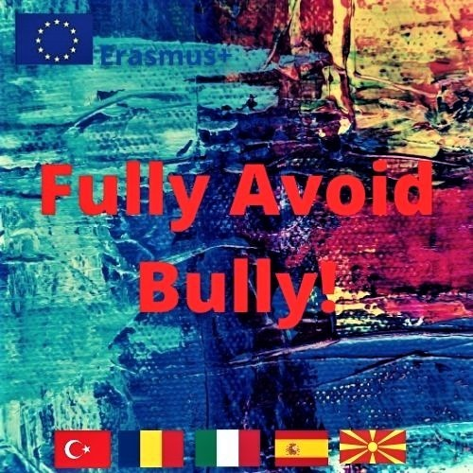 3. Logo created by Andi Kastrati , class 4-5

The international voting and selection of the project logo took place in the period from 06.11.2020-13.11.2020,. The international voting consisted of a selection of 15 logos (3 logos from each project partner school). The international commission consisted of representatives from each school partner in the project. The information about the logo contest was published on the school website of OOU “25 Maj”. The article gives detailed information first about the school contest for the project logo (time of the school contest, the rules of the contest as well as information about the best 3 logos chosen for the school).
You can find more information about the international logo contest in the following link https://twinspace.etwinning.net/121039/pages/page/1047515. At the end of the international voting, the logo number 3 created by Andi Kastrati, student in the Municipal primary school ,,25 Maj'' is selected as the winning logo for the project Fully Avoid Bully IT02-KA229-079166 with the highest number of votes, respectively with 1981 votes out of the 2651 total votes of the logos. The selected logo, in addition to being published on the project website, will be printed on T-shirts that will be delivered during the first mobility, and the author of the winning logo will be awarded.
You can read more about the logo contest on the following link https://www.25maj.edu.mk/mk/aktivnosti/671

