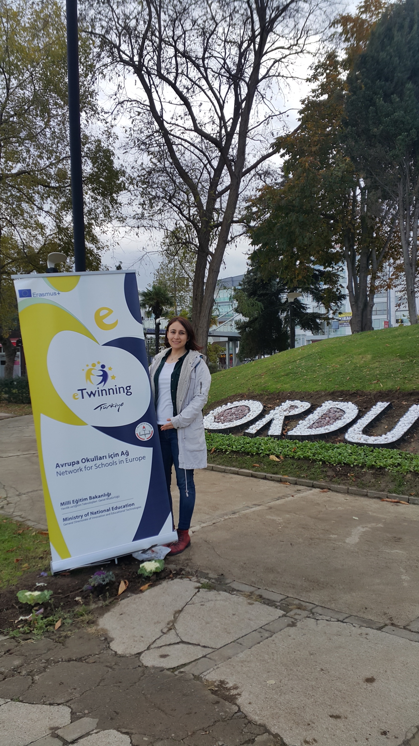

Hello, I am English Language Teacher for ten years in secondary school. I am interested in e twinning projects since 2013. I like reading and reading activities with my students. So I am glad to be in this project with you.

