Be Internet Smart

- Match the information below to the proper column.

What you CAN do in a social network | What you MUSTN’T do in a social network | What you SHOULD do in a social network
_____________________________  _____________________________  _____________________________  _____________________________  _____________________________  _____________________________  _____________________________  _____________________________ | _____________________________  _____________________________  _____________________________  _____________________________  _____________________________  _____________________________  _____________________________  _____________________________ | _____________________________  _____________________________  _____________________________  _____________________________  _____________________________  _____________________________  _____________________________  _____________________________

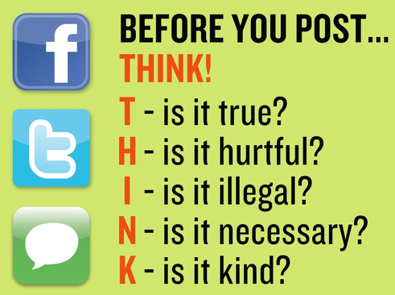
- connect to people,
- tell people when you are going on vacation,
- share your photos,
- share information with people you don’t know online,
- listen to favourite songs,
- tell jokes,
- post info that may compromise your reputation,
- set some limits on using social networks,
- see what your friends are up to,
- post personal information,
- post information you wouldn’t like to see in news or in newspapers,
- be picky in choosing your online friends,
- let your online life get the better of your real life.

Source: https://en.islcollective.com/

