WE CREATE GAME:
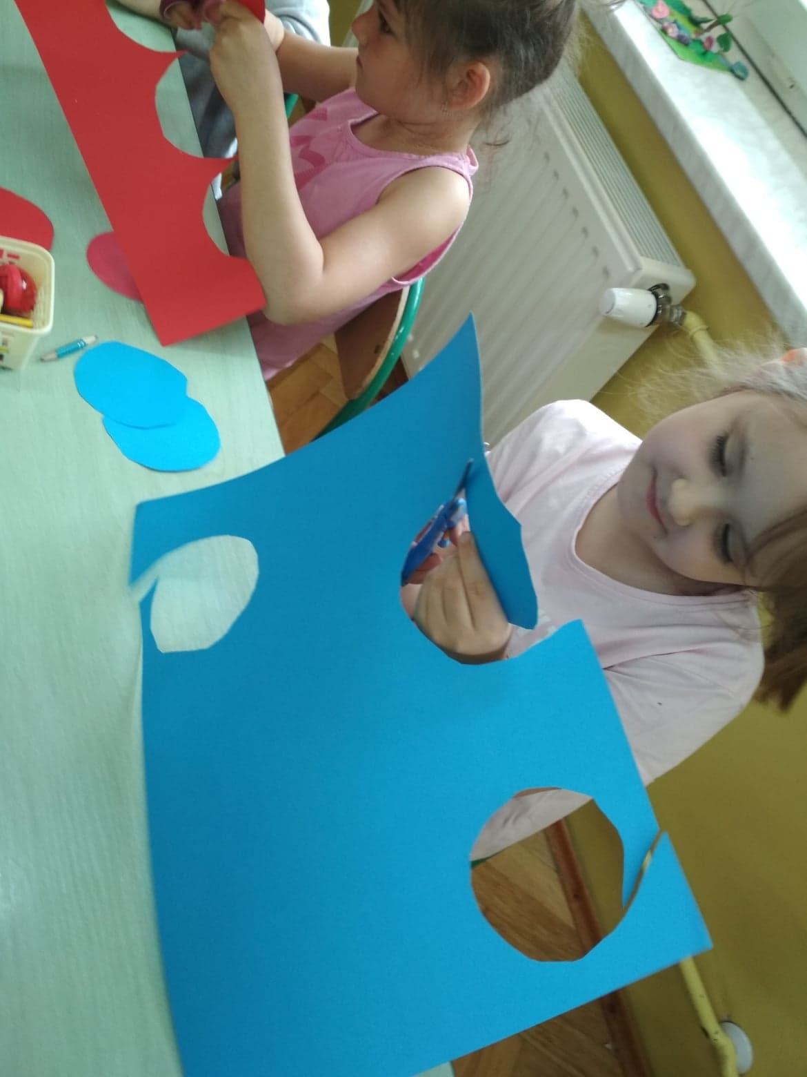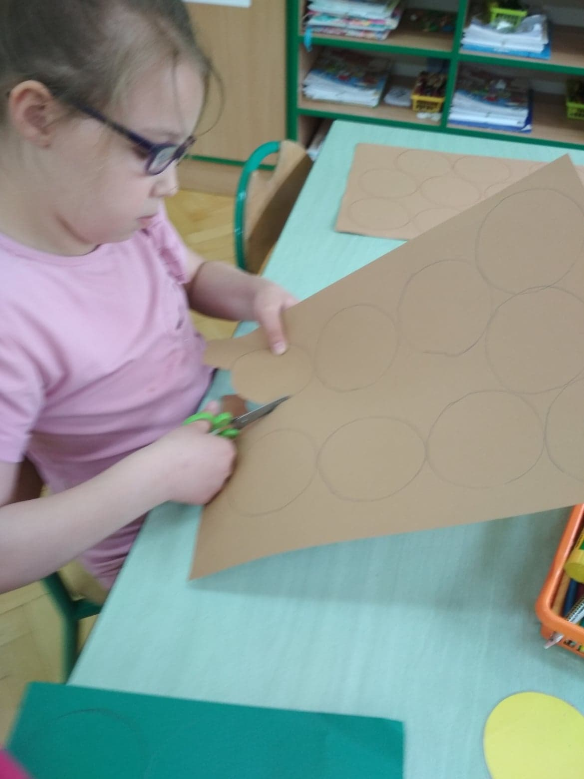

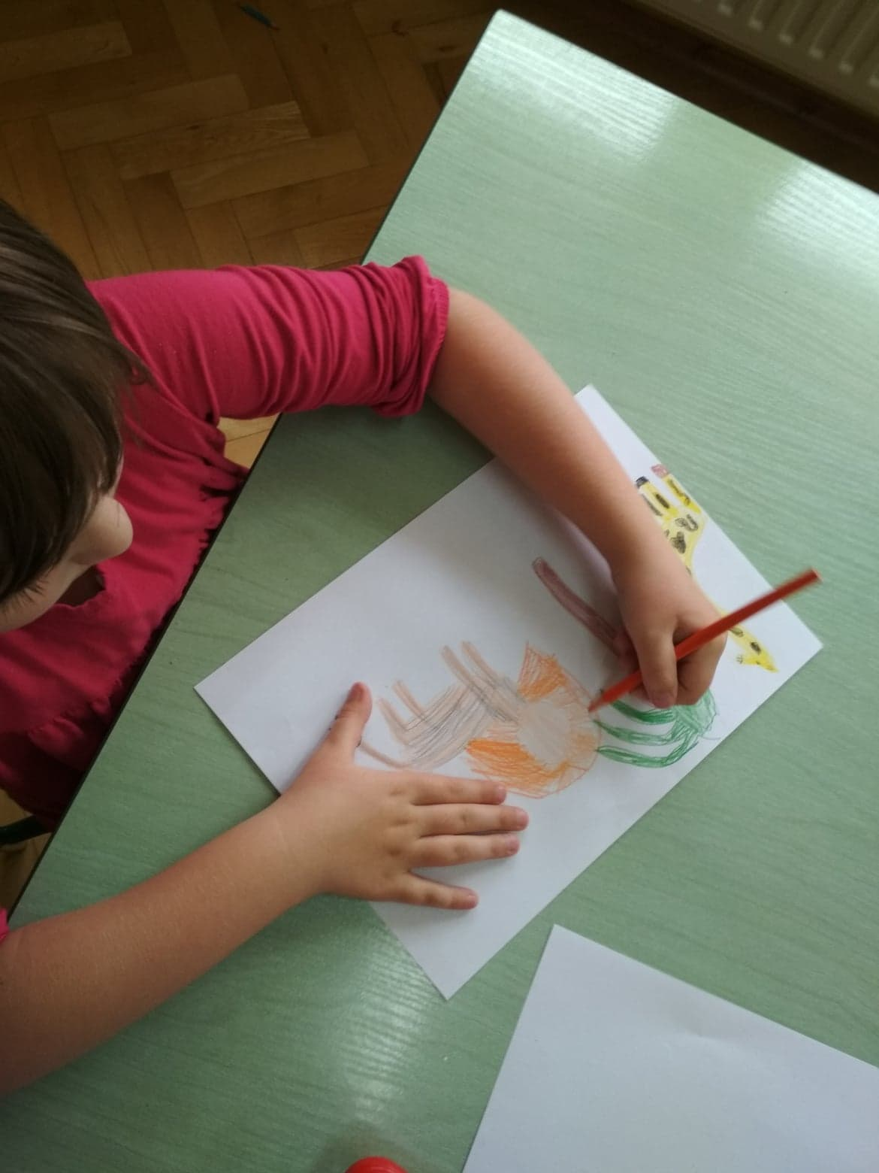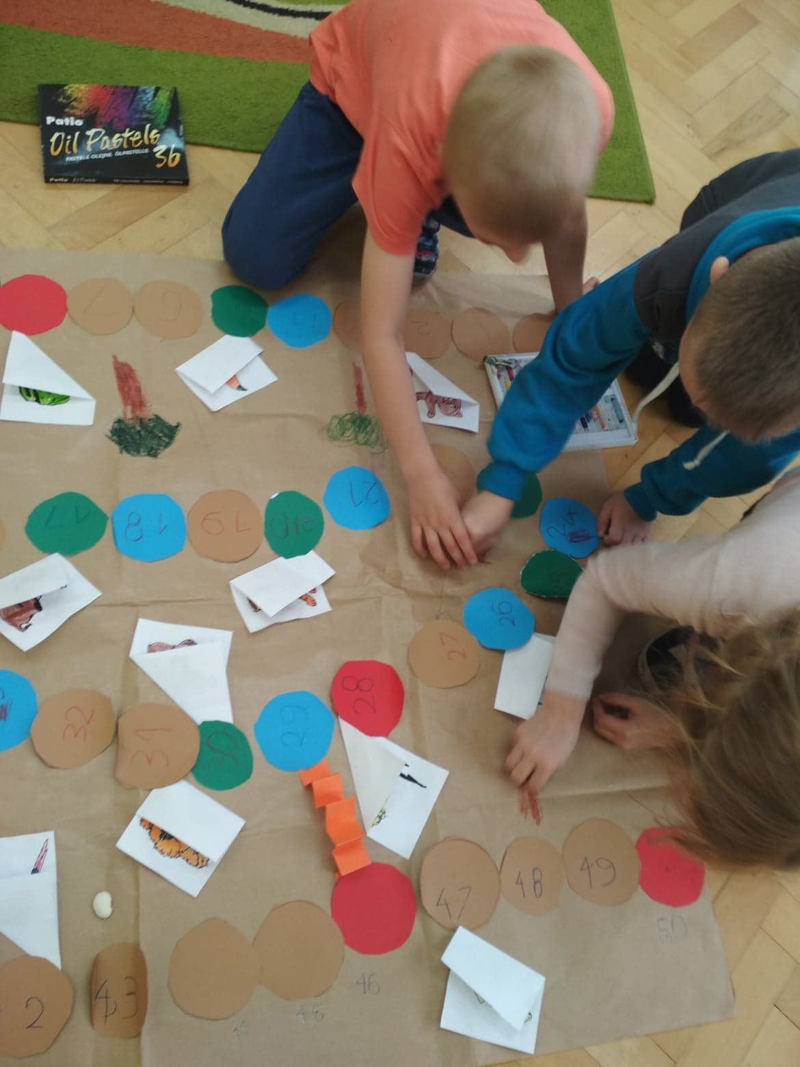

WE PLAY THE GAME „ ANIMALS RACE”
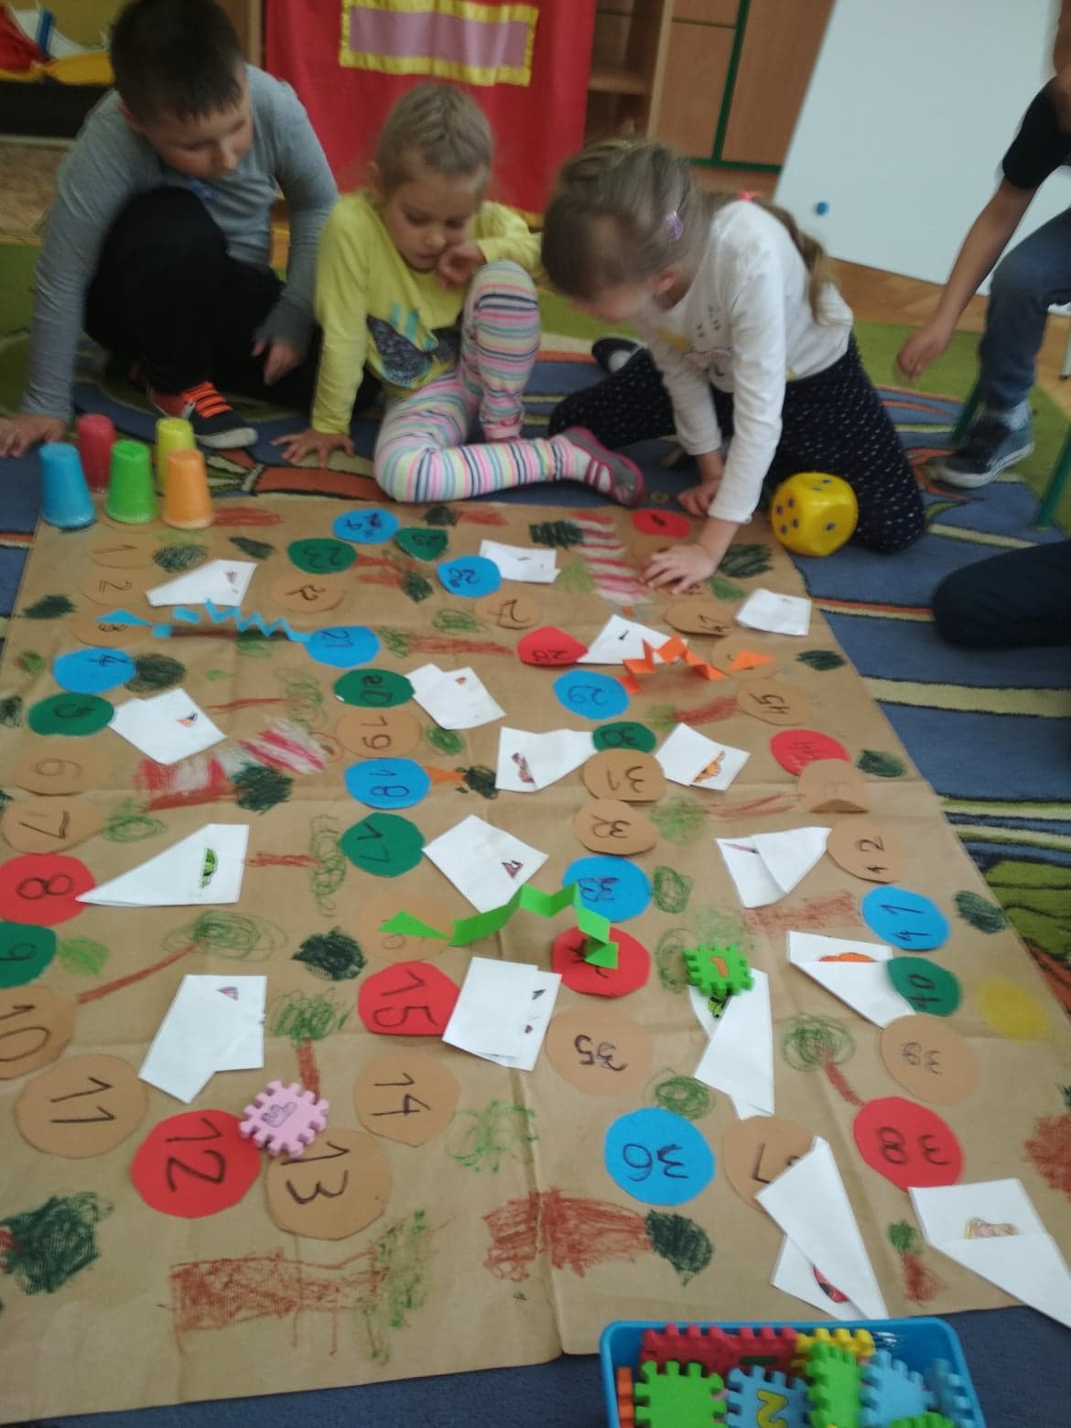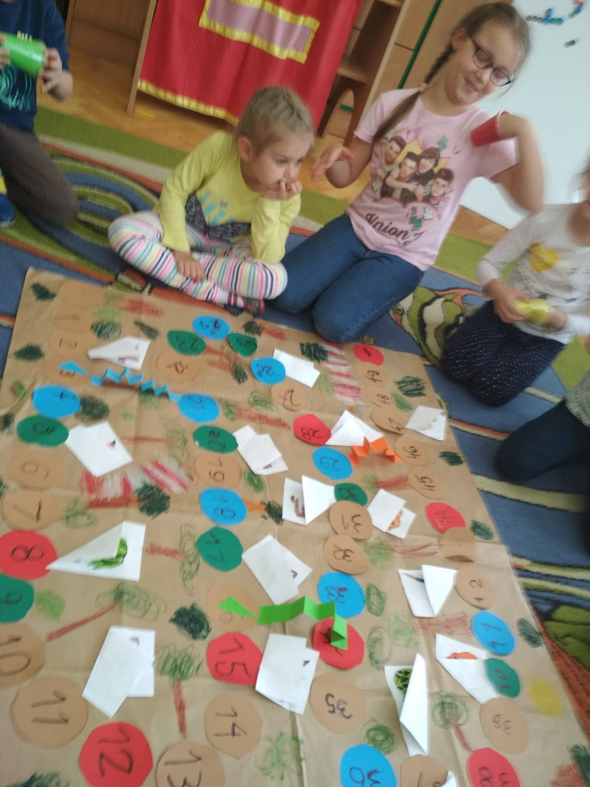
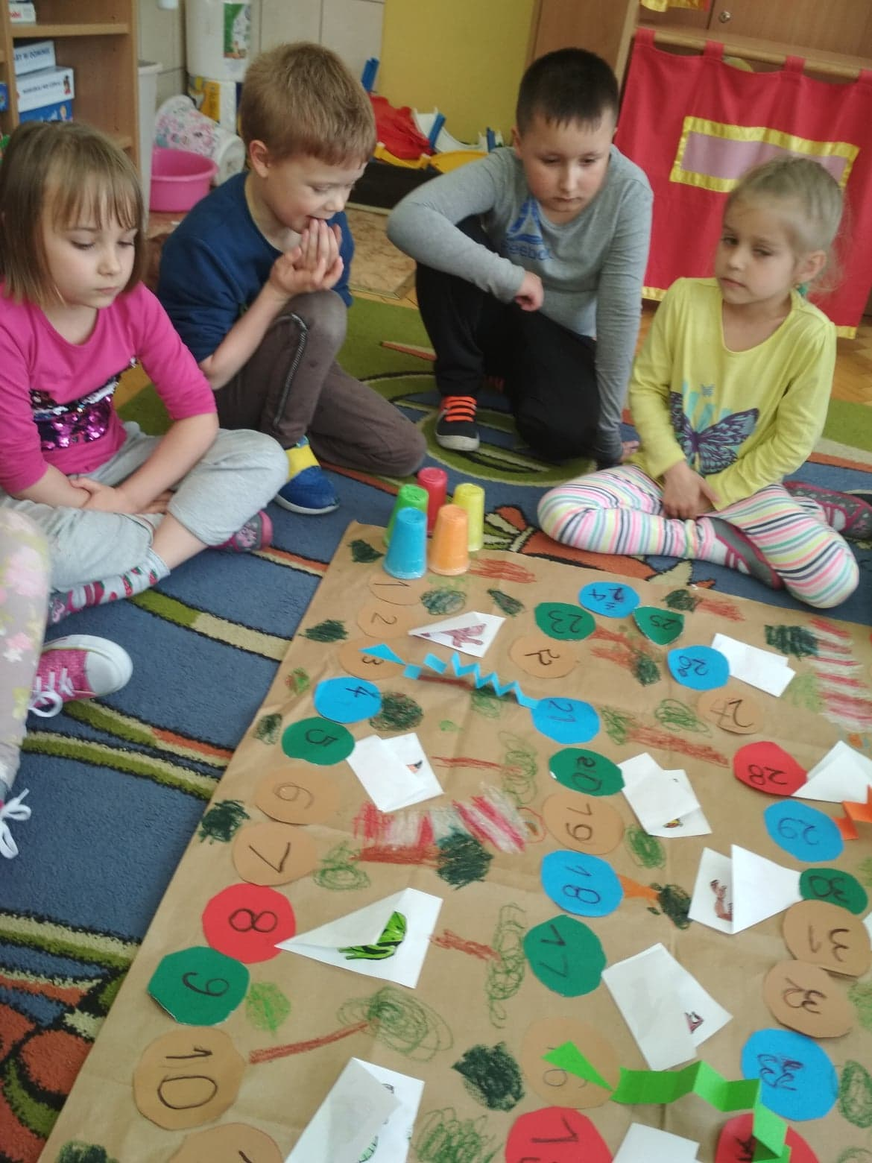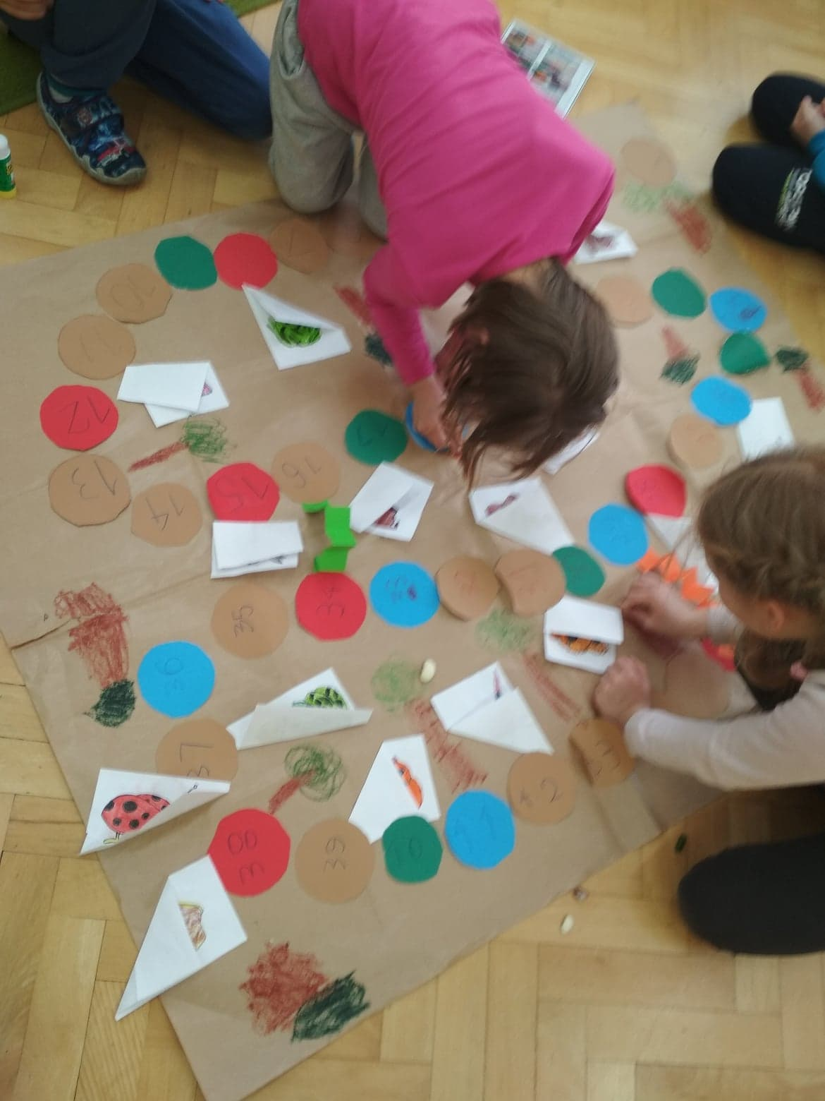

YOU NEED TO MAKE A GAME:
PICTURE OF ANIMALS
COLORFUL CIRCLES
PAPER
CRAYONS
1: FIRST STEP: Children with teacher prepare the game. They colour pictures of animals, cut the circles and stick them in the paper. Then they fold the card with animals and stick it in the paper, too.
You need counters and dice.
RULES:
The children throw a dice and move counters on the board. We can plan different tasks in each field( for example, an extra dice roll or go forward / back ). In addition, they guess which animal is hidden in the field and they earn points if they guess "What is this?". The winner is the person who first reaches the finish line or the person who has the most points. These are two versions and it depends on children. They decide about it at the beginning of the game.
Have a fun

