The Oldest One “Yek”: An Ancient Vampire/Demon From Turkish Culture
Supernatural beings like vampires or demons attract a great deal of our attention. So how do we define these beings? Of course, there are many studies on this . As you can guess, as a Turkish researcher, I pursued the possibility of the existence of such vampiric beings in Turkish culture. Thus, my main aim in this artictle is to study the oldest vampire/demon concept in Turkish culture. I will leave other vampire/demon concepts of Turkish culture like Obur or Yalmavuz for a another time.
Vampires and demons also point out an interactive world of creatures. As you all know, vampire is a supernatural creature which drinks blood. It exists in almost every culture in the world. Vampire concepts such as Lamashtu, Lilith and Striga are ancient. What is the oldest vampire/demon in Turkish culture then? Let’s answer this question.
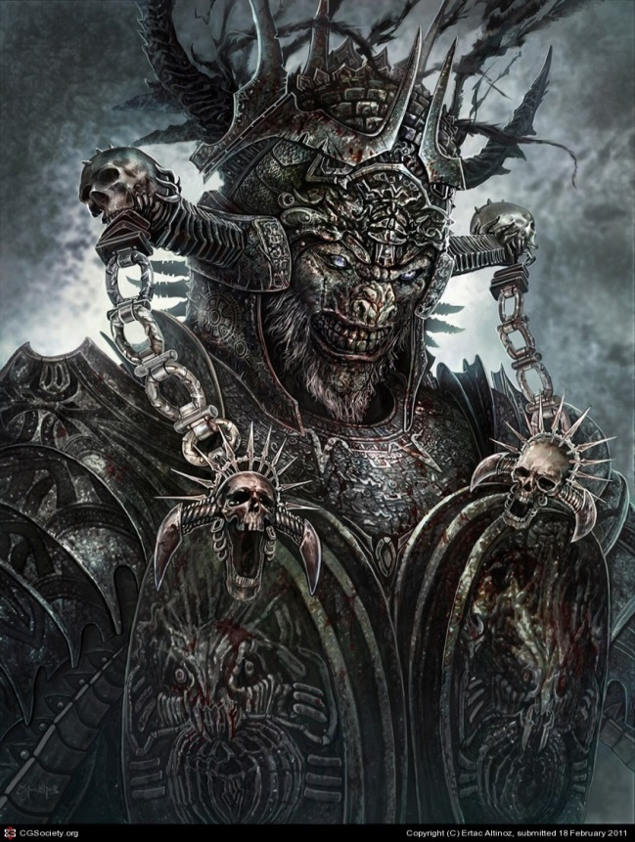
Yek is a demon that is mentioned in the Old Turkish dictionaries and the oldest Turkish texts. “Yek” finds place in the Middle Age dictionaries, one of the oldest Turkish dictionaries Divânü Lugâti’t-Türk (around first years of 11th century) and some of the Buddhist Uygur texts (8th to 10th cc).
According to the knowledge from Divânü Lugâti’t-Türk, the word “yek” means “devil, satan”. Also, Jean Paul Roux kindly gives us hints that yek means “demon, devil, satan, iblis” in Old Turkish. The word “yek” is actually derived from the verb “yemek (to eat)” and, as you can guess, it has cannibalism in its nature. In an Arabic-Kıpçak dictionary, it’s also a dangerous creature in the form of powerful winds that accompany dust clouds.
The word “yek” is explained as “fairy, satan, devil, iblis” in dictionaries about Old Turkish. Also it means “obur” and while this denotation means “someone or something that eats a lot, appetent, glutton”, it’s also the name for a type of vampire in Turkish culture. So, if you are a person who loves eating much and someone bullies you about that, just remember that you may be a vampire incognito. In old Turkish texts the word “yek” takes place in the form of “yek içkek” which is a name for another vampire type In Karaçay-Malkar and Kazak Turkish, this word appears in the form of “cek” and means demon, devil, satan, as well. Altay Turks have “cek” word in their language and this word means glutton, appetent; also it’s one of the epithet of Erlik the arch-devil. Imagine, the arch-devil, the prime antagonist of the
Turkish beliefs, i mean pre-Islamic, Islamic and the other beliefs of different Turkish tribes around the world, actually carries vampiric features! This fact itself alone can show how important of a figure the vampires are for Turkish myths. In old Turkish, the word “yek” is used as the general denotation of evil spirits in the nature.
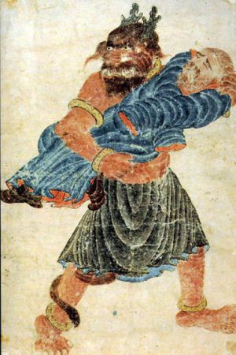
One of the oldest Turkish texts that belong Uygur Turkish (8th to 10th cc), has descriptions of the hell in detail; creatures in it and what kind of punishments there are for sinners. It also contains the demons called Yek, who are a kind of hellhound, demon of the hell; they throw the sinner people, who fell down into the hell, to the boilers and they are monsters that have got stern and sullen faces.
There is “yek” in an another old text Çaştani İlig Beg (The Story of Çaştani Bey, 8th to 10th cc) that belongs to Uygur Turkish, too. Çaştani Bey, the hero of the story, fight againts these demons that send sickness to his people and harm them; he saves his people.
In this text the demons that called “yek” are demons/monsters that wait at the crossroad, eat human flesh and drink human blood, wrap the guts of humans to their bodies, horrible faced, shout with ugly voices, hold tridents and flags in their hands, in the shape of a black giant, with fire-colored and tressed and beautify their bodies with venomous snakes.
Based on the knowledge that we presently have, it can be said that yek is the oldest demon/spirit/vampire in Turkish folk lore.

