Friseur sein in Ungarn
Hair-dressing
Beauty secondary school
- It has 4 years education, but it is not guaranteed that it gives you any benefit in the 2 years long hair-dressing training
Requirements:
- good chic, stamina, primary school (8 years) They learn hair-dressing, basic manicure, cosmetics + You will get GCSE and a solarium handling certificate
- 7-8 lesson on a daily basis 6 practicing lesson per week: rather cosmetics and hair-dressing
- They can practice on people
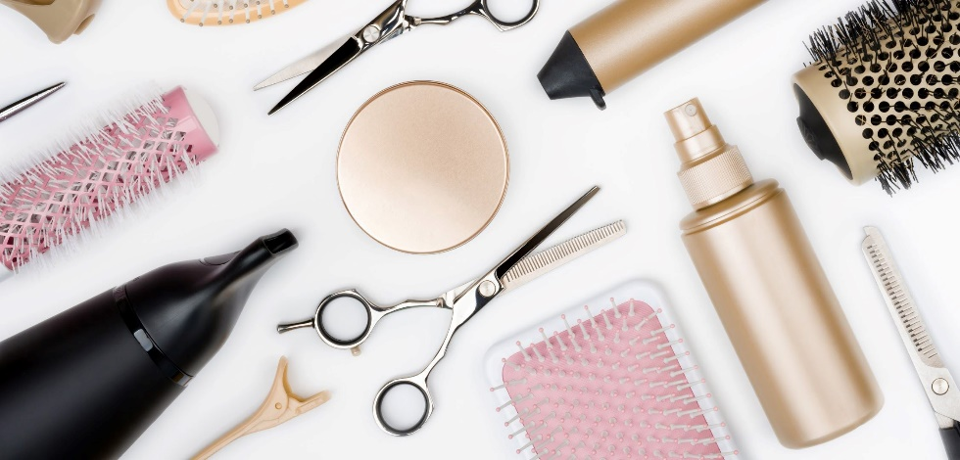
- Here is a business where they can practice

Practicing in Summer:
- It keeps 4 weeks, and includes hair cutting, weaving, colouring + business leading
- It needs so much work to earn a lot of money
- It is not a rare profession in Hungary.
Carrier:
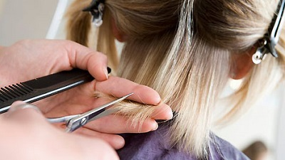
- Applying somewhere for work and earn some experience independent business
Competitons:
- Weaving, casual hair, a lot of practicing, They must do this things for time.
- This system is changing quickly. 2-3 years per change.
They can continue their learning process with 2 years hair-dressing, manicure or cosmetics courses.
They can apply for master courses, but it costs a lot of money and they need 5 year experience to apply. In the meantime they do not have right contacts for the schools, so they are not students.

