POLAND DIARY

**SUNDAY 24/11**

**We started from Tripoli and we went to the airport of Athens and there we waited for our flight which was for Denmark and from there we went to the airport of Gdansk and there the families that would host us were waiting for us. It was a unique moment because they were so kind and friendly people.**

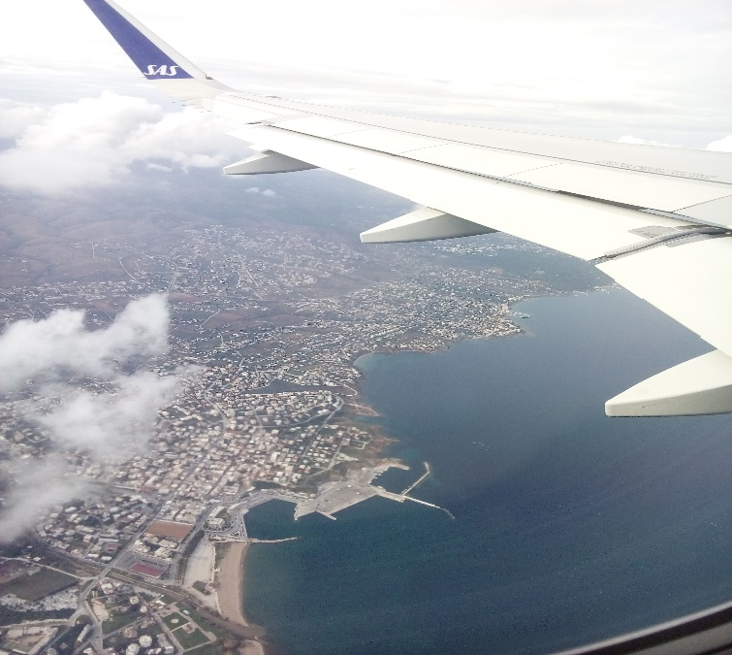 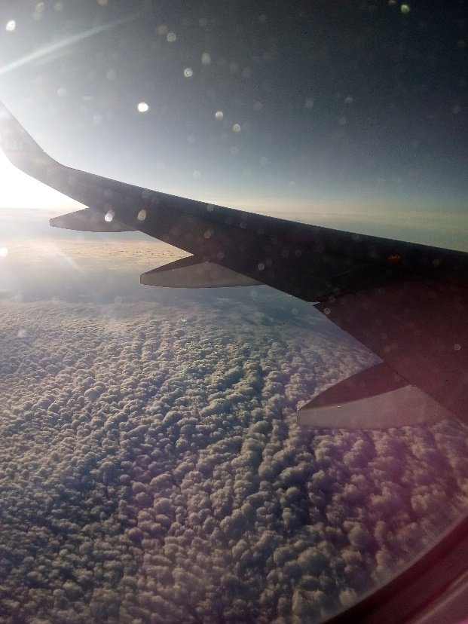

**Monday 25/11**

**Ιn the morning all the teachers and students gathered at X Liceum Ogólnokształce the school that was at the Erasmus+ program too. There was an opening ceremony and the headmaster Mrs. Magdalena Piwowarshka talked to us and she was very kind and hospitable. Then we had a very delicious lunch and last but not least, we went for sightseeing in Gdynia and I realized that Gdynia is wonderful city.**

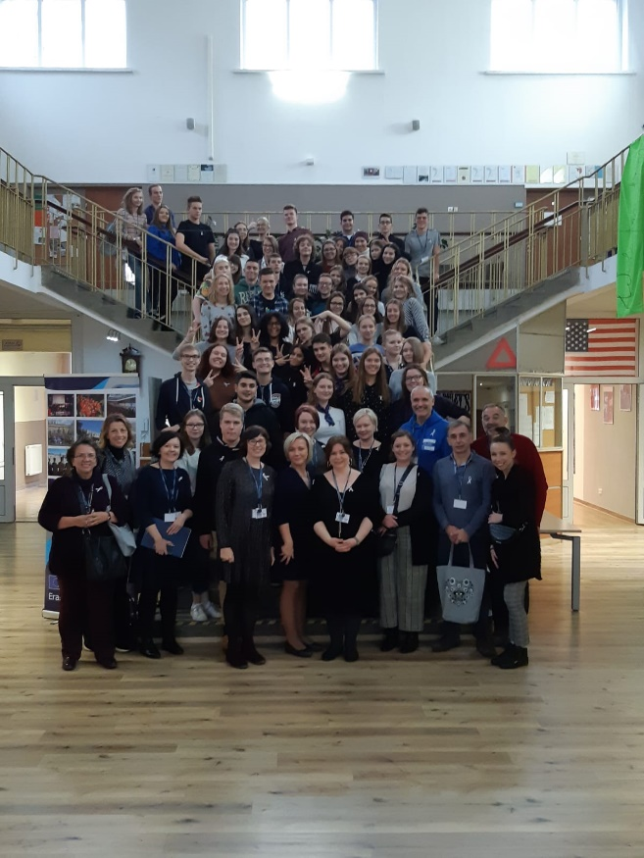

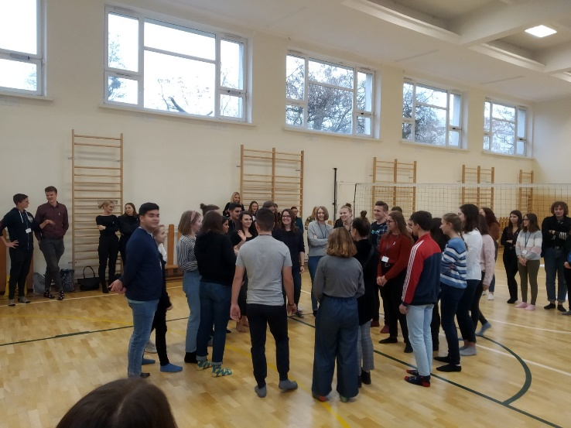

After that we were separated to teams and we did some activities in purpose to break the ice.

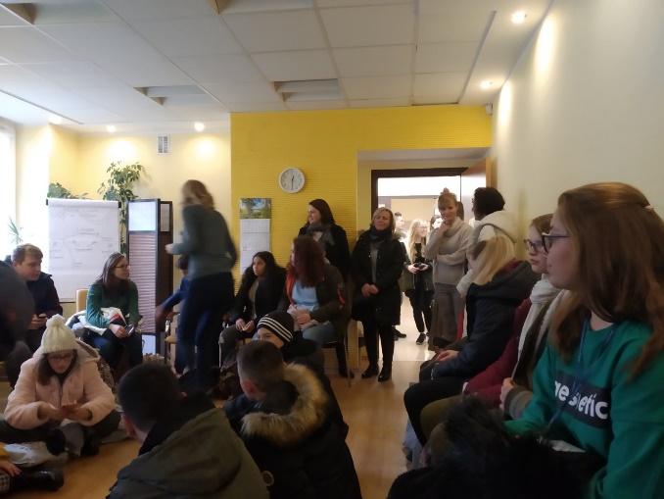

**Tuesday 26/11**

**In the morning we had a official meeting with the city council in Gdynia city hall. After that we did a project work. Then we visited a social care center .**

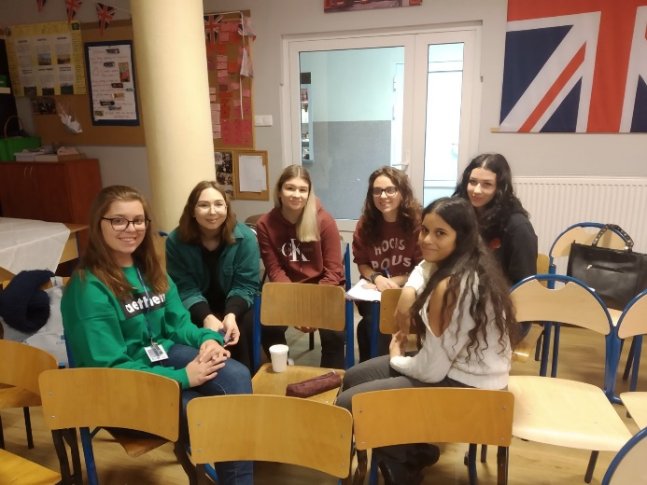 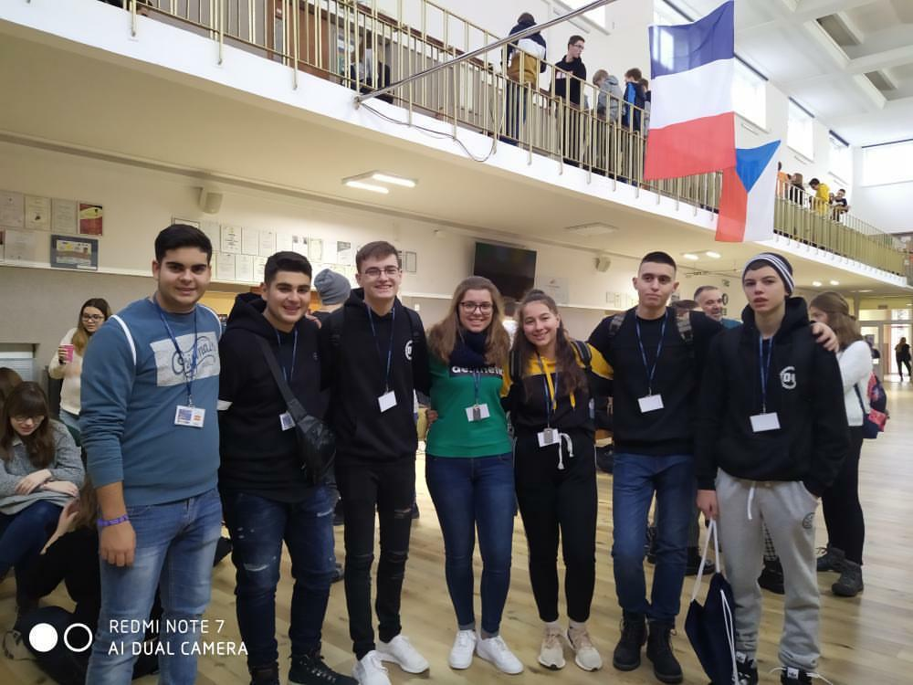

**Wednesday 27/11**

**On Wednesday we went to a very impressive museum which was about emigration and there we visited an exhibition that took place there. We had absolutely a great time.**

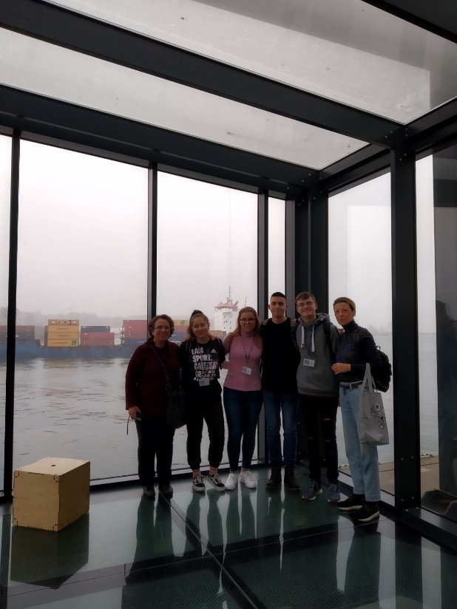

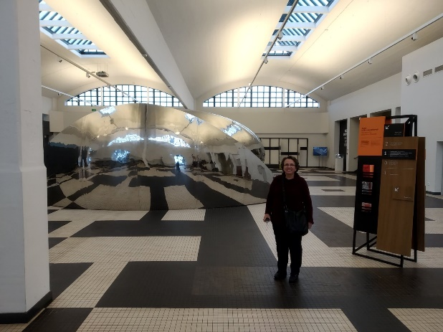 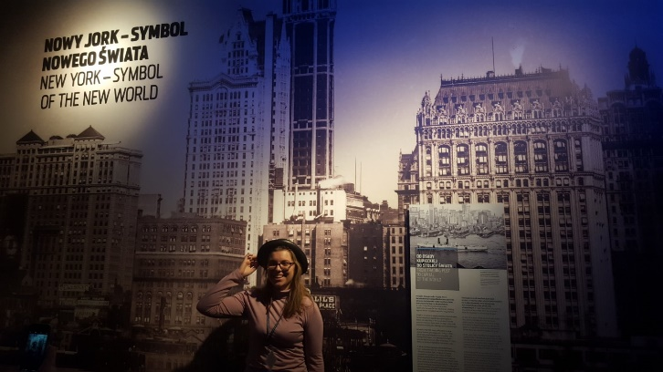

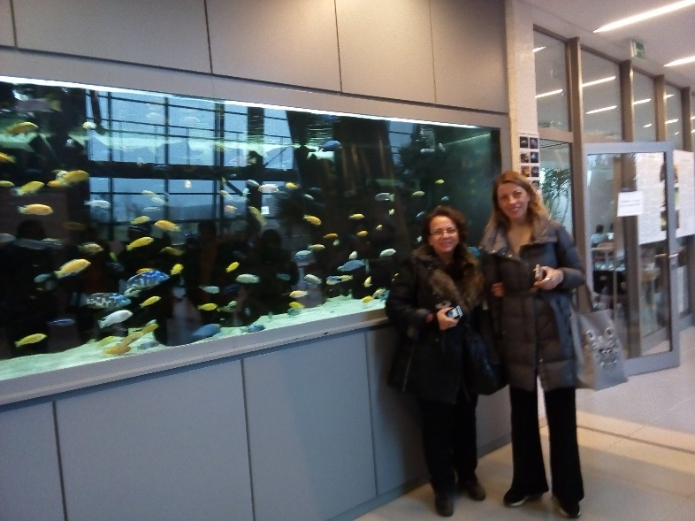

**Thursday 28/11**

**In the morning we gathered all and we had a guided tour by bus and we went at the University of Gdansk – Faculty of Biology- we had unforgettable moments there.**

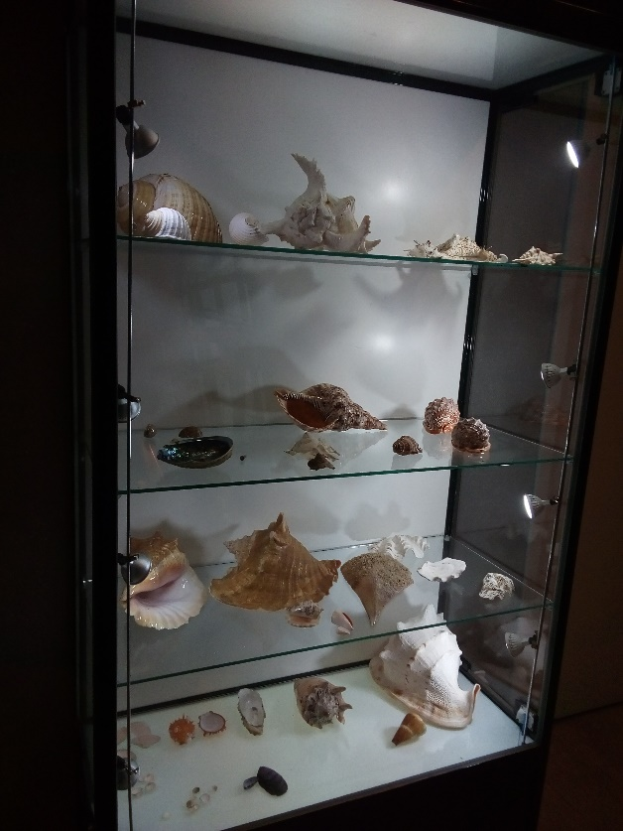 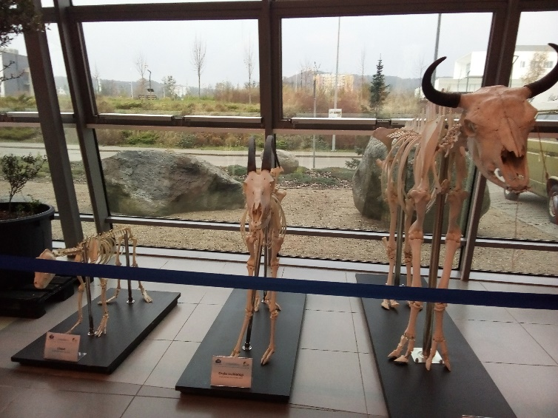

**Then the same day we had the chance to have an educational visit at the European Solidarity center in Gdansk. I learned so much things there and it was an awesome experience.**

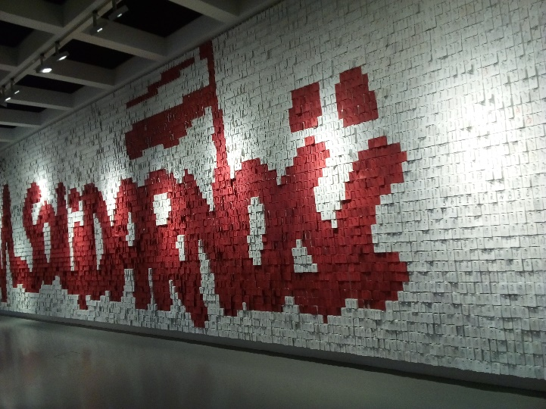 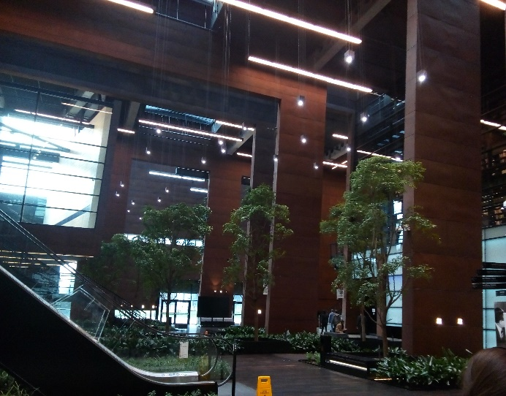

**We wrote our own note and we hang it there!!**

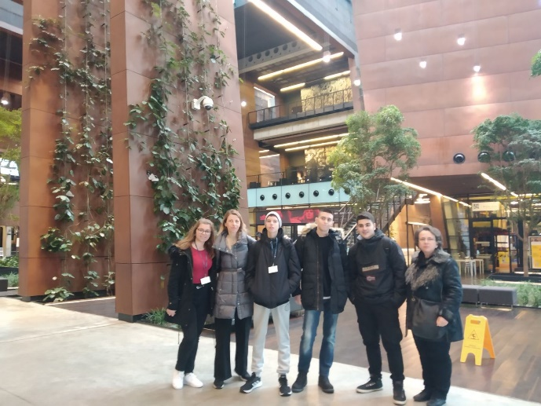 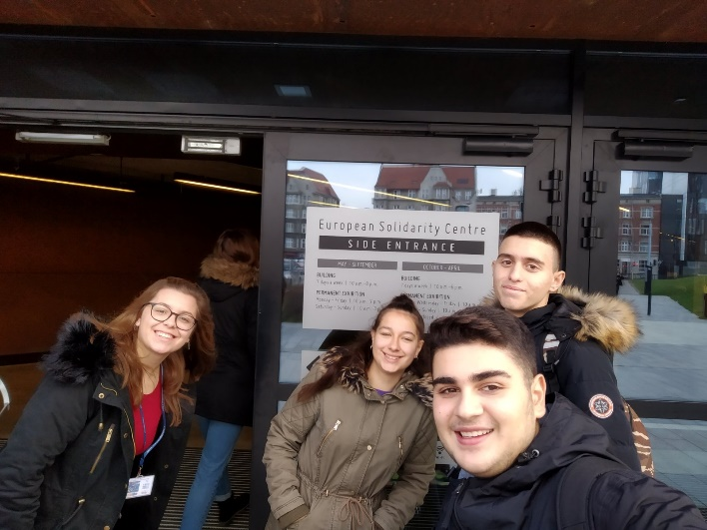

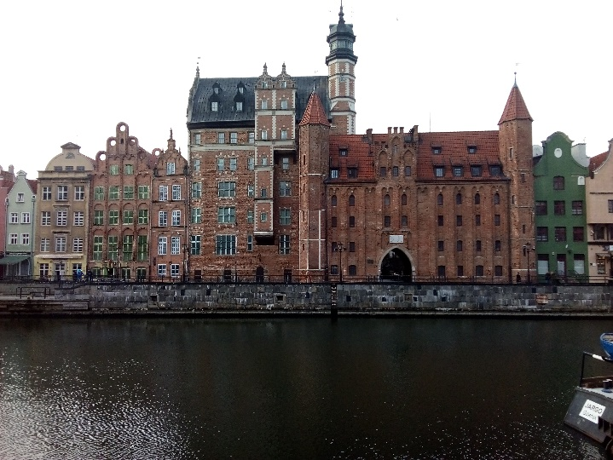 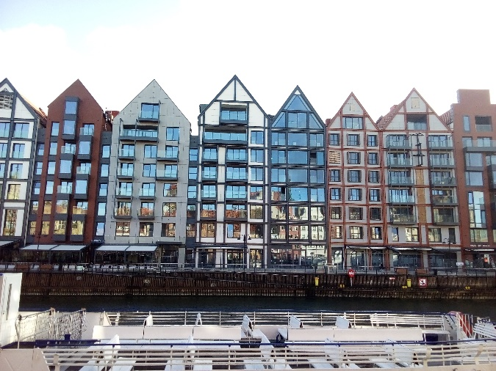 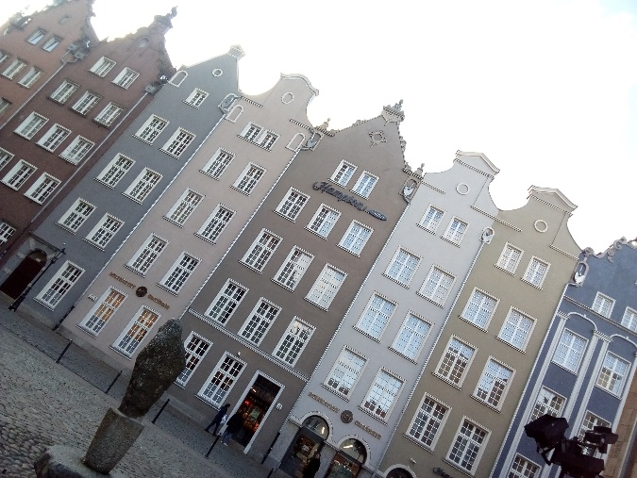

After all this awesome day we had a delicious meal at the Old City of Gdansk. The city was so stunning that i couldn’t stop taking photo every single thing I saw.

**This day was so amazing and at the end we went on a cultural trip to Westerplatte where the second world war began. I felt awe that I had the opportunity to visit this place.**

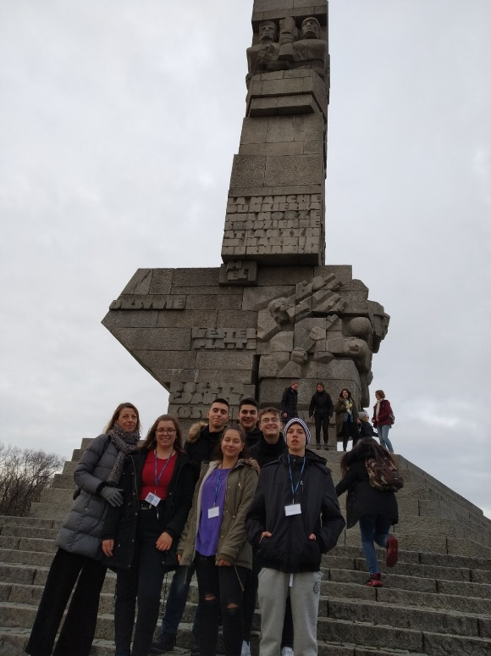

Last but not least we visited a monument to the Defenders of the Coast we had a great time there.

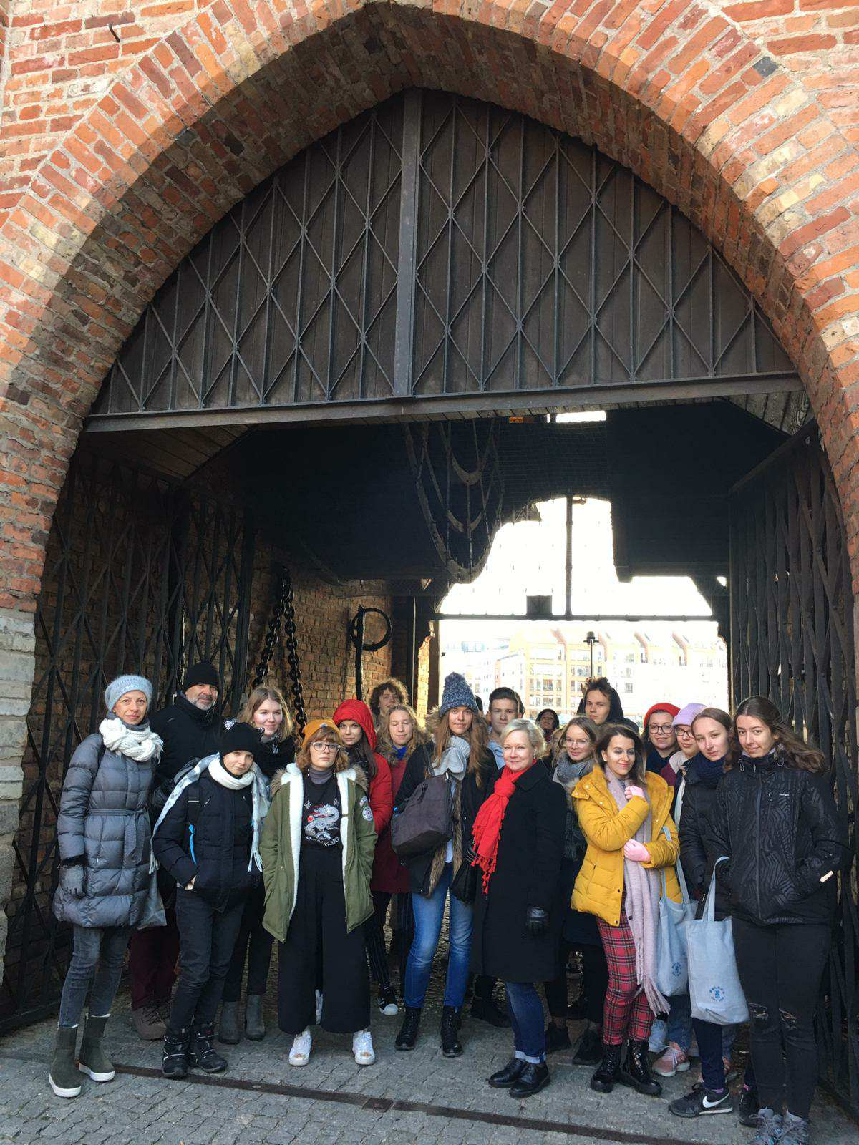**Friday 29/11**

On Friday we went sightseeing the Old City of Gdansk I really enjoyed that.

**After the incredible time we had there we visited the Oliwa Cathedral and we had the chance to hear a church organ concert.**

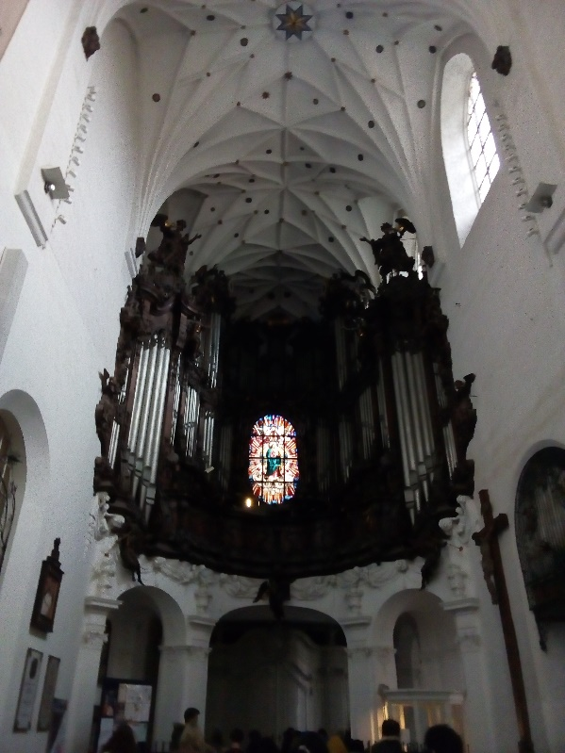 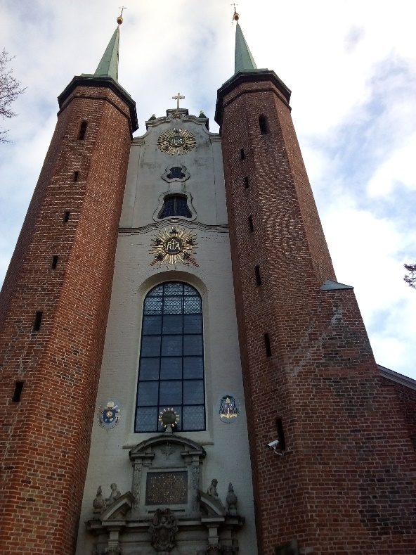

Then we had lunch in Sopot and we visited the Monte Cassino Street. It was a very beautiful city.

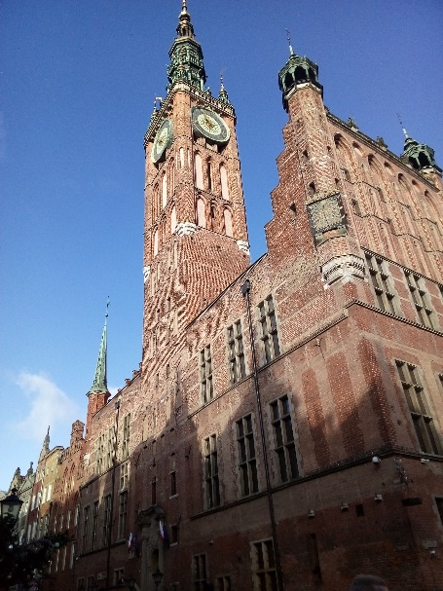 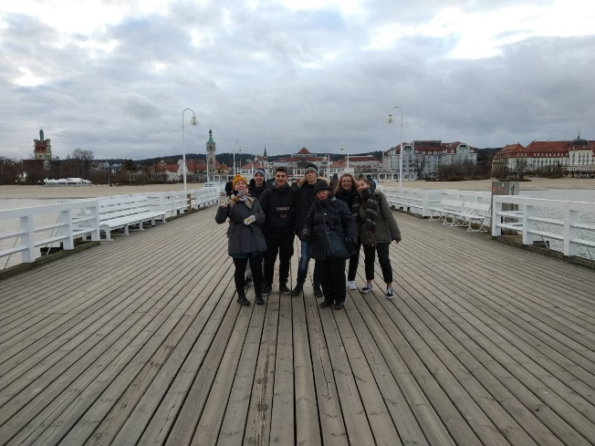

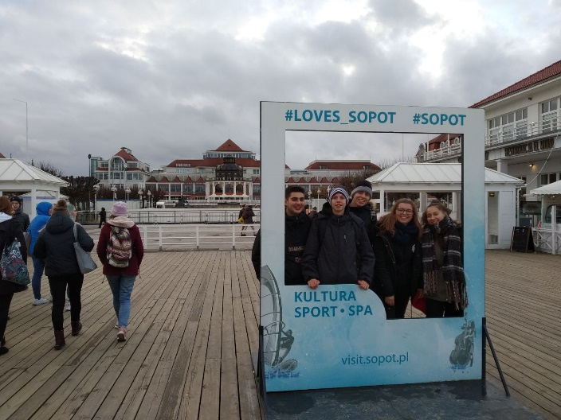 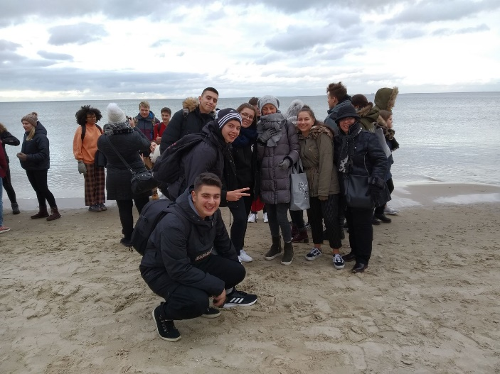

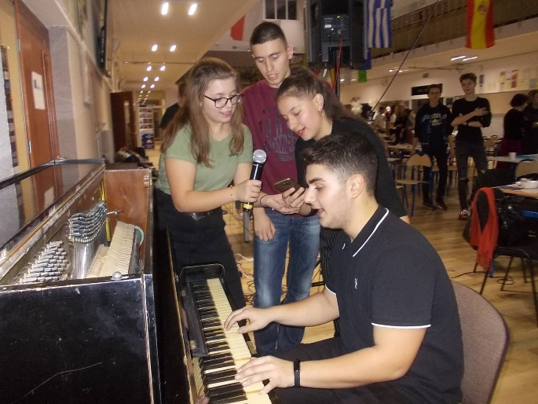

In the evening we had our final presentations of the project. After that there were some performances and we had a certificate ceremony. I was a bit sad because it was our last night that we would be together with all the students.

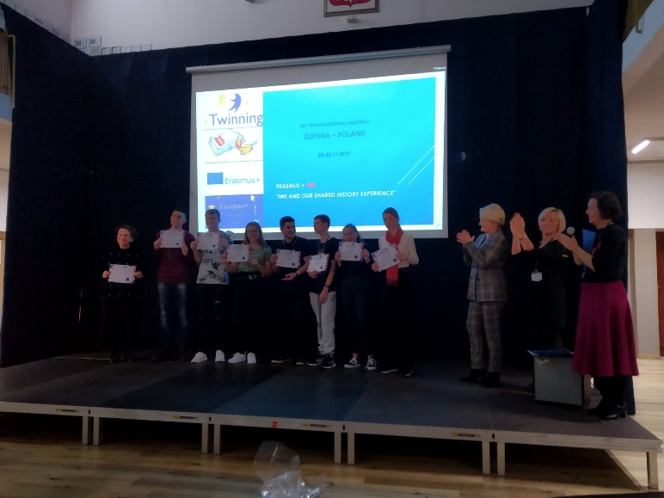

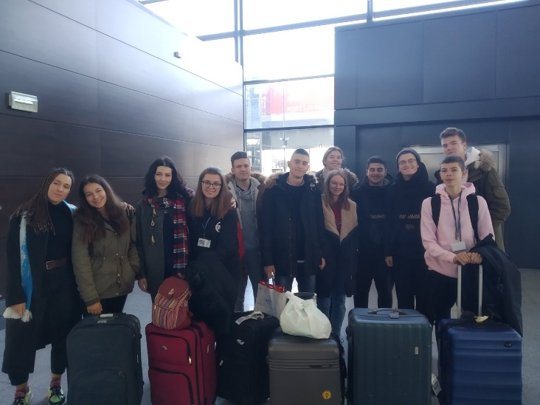

**Saturday 30/11**

**It was the departure day the day that we would return to our city. I really enjoyed every minute I spent in Poland and it was a once in a life trip and it will be unforgettable for me.**

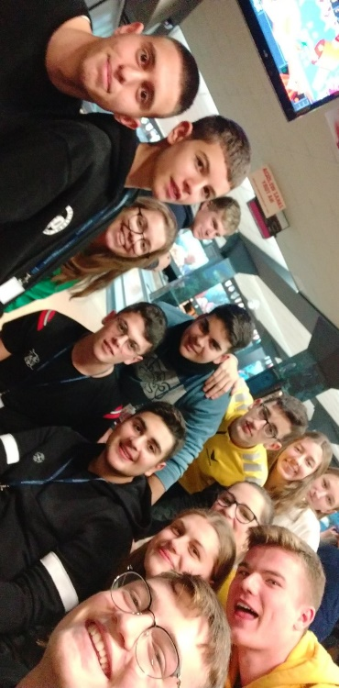

I want to thank my host family for making this week more unique.

Thank you all for this unforgettable week!!

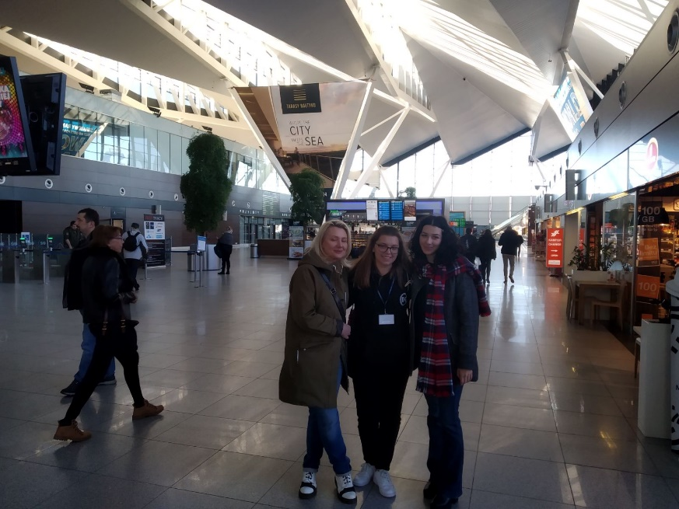

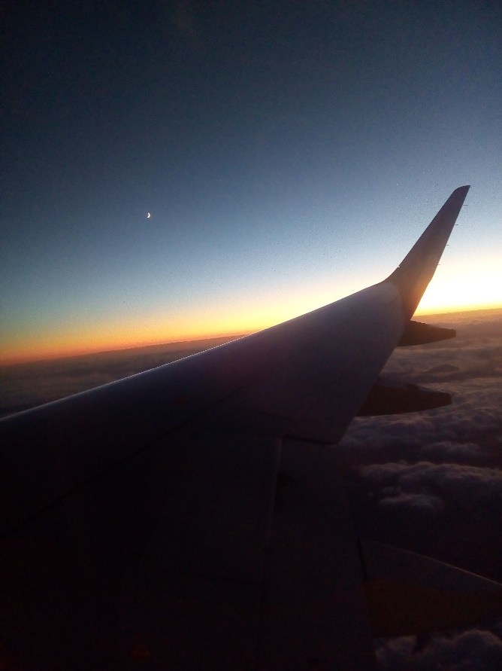

**So, I came home with so many memories. It was one of the most incredible week of my life!!**

**Adela Prroi**

**greece**