MEETING IN SPAIN

Our trip to Spain was certainly a significant opportunity to learn about the European Union and especially for Marmolejo.
Here I will present my experiences for each and every day of the week we spent in Marmolejo and the school which hosted us there.
Monday:
Monday was the first official day of our meeting, it was the best way to start by visiting the school of the students hosting us. So, we visited the “I.E.S Virgen de la Cabeza” which is a vocational school. At school, we were welcomed by the students as well as teachers with a brief speech. Later on, we took a tour of the school and its many facilities, that included an indoors Gym as well as a cafeteria, in which the students had their branch. We then visited the mayor’s office, where we were greeted by his representatives. We then returned to our hosts houses in order to meet with their families.
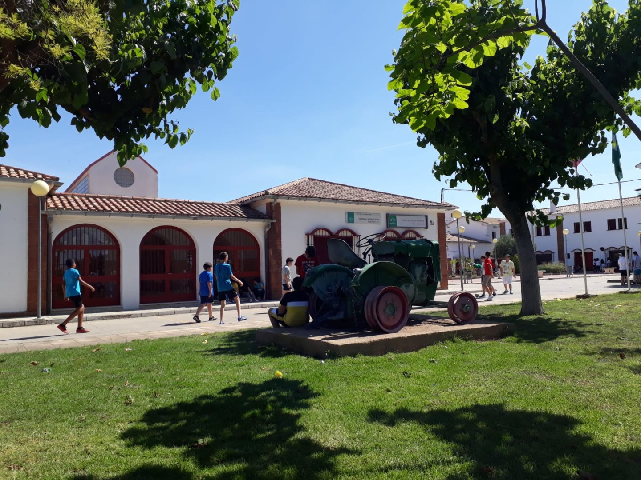

Tuesday: Sevilla
On Tuesday, we travelled to Sevilla. We visited the largest wooden construction and we took a few pictures of the central square and the city in general. It was a picturesque view and I won’t forget it at all.
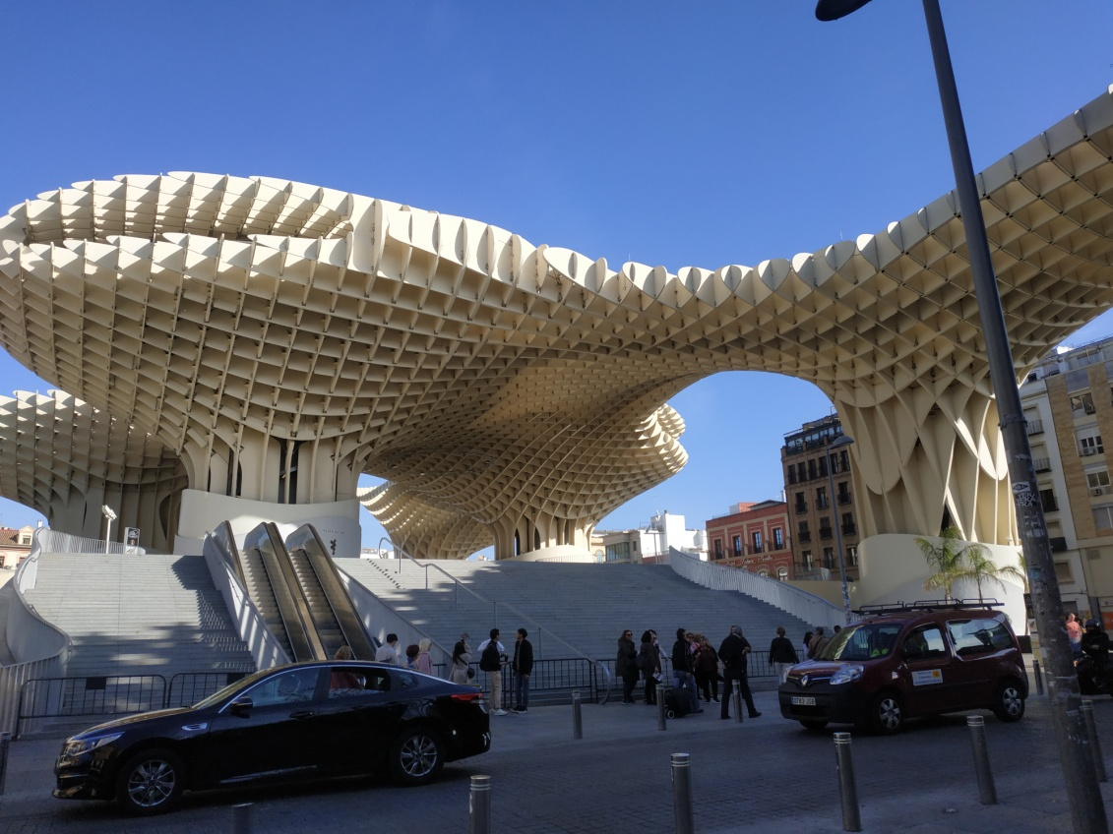

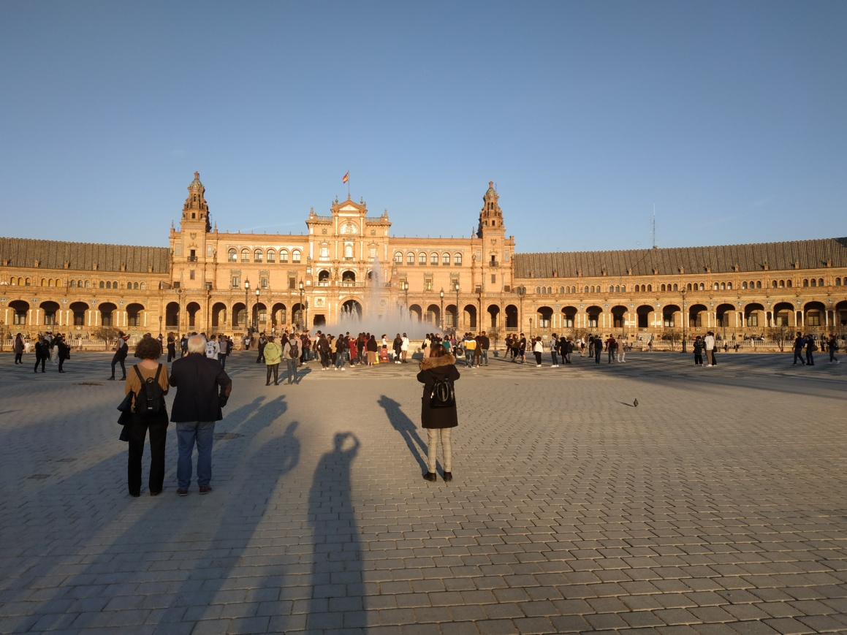
Wednesday: School and football
On Wednesday, it was a school day where we were separated into groups, and we worked at the computer making short clips of movies. In the afternoon we gathered all together at the football field of Marmolejo and we played soccer and we had a great time among all the delegations.
Thursday: Cordoba
On Thursday, we went to Cordoba where we passed the bridge over the river «Guadalquivir” and we visited the extraordinary “ La Mezquita- cathedral de Cordoba”. Then we were separated in groups and we had to find different spots around the city.
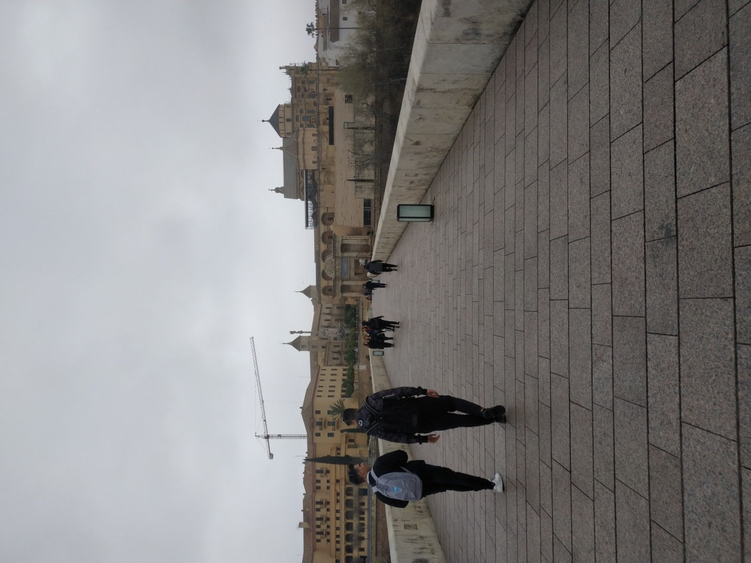
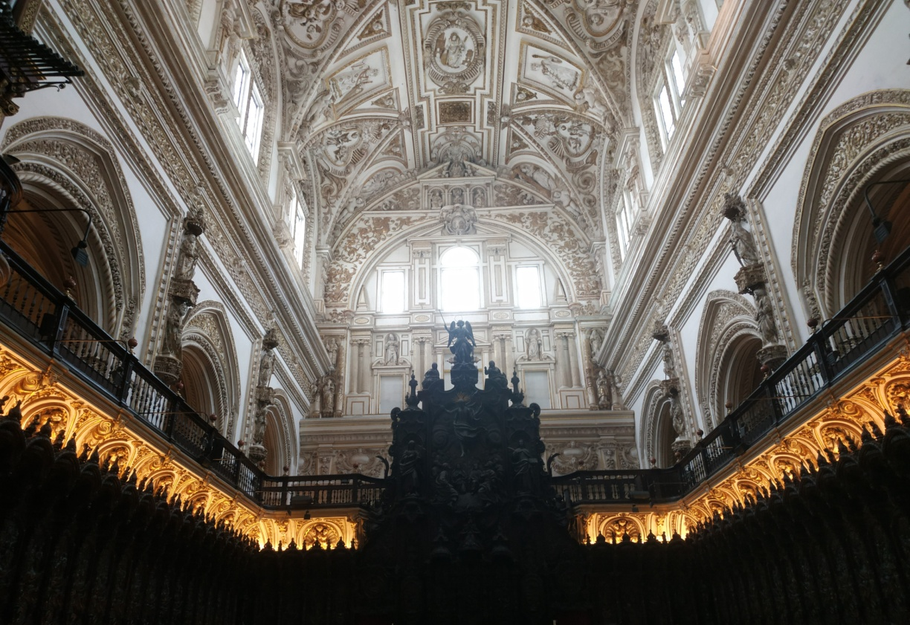
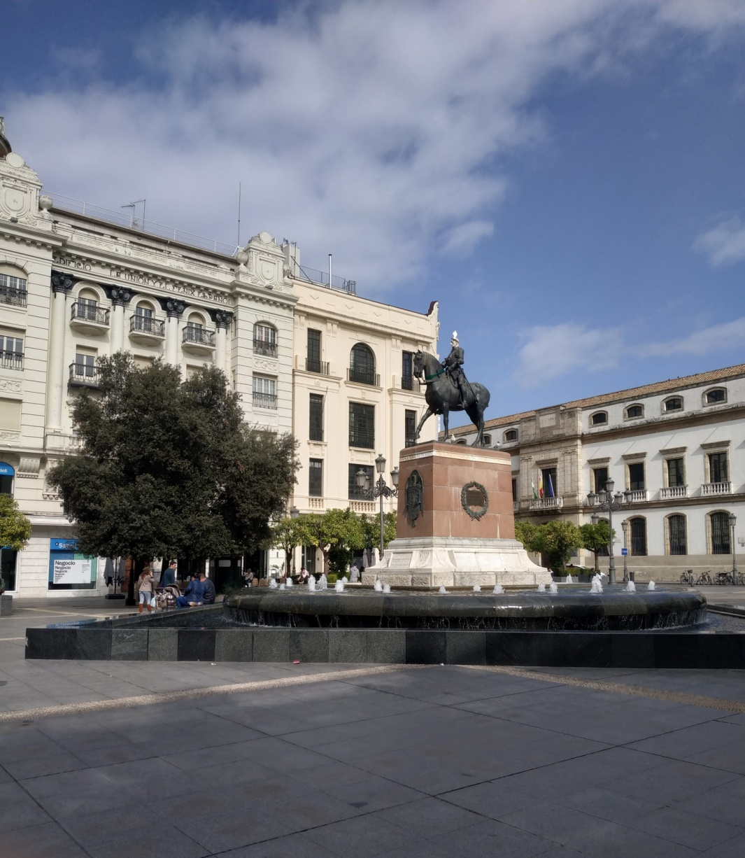
Friday: Andujar and last dinner
On Friday, we had to wake up early, in order to visit Andujar, a small town nearby. There, we visited some Latin people who were immigrants from South America. We gave them some gifts, basically food and other bare necessities products. Then, we returned back at Marmolejo specifically at school and we planted some trees as a symbol of a warm friendship among our countries.
At the evening it was our last chance to be all together and we gathered at a spacious hall that the Spanish people had organized for us all. There we had a delicious Spanish dish, we danced and after that we went to a club party and we stayed awaken until the next morning. The next day it was our departure and we were very depressed to separate from our new friends.
The trip was certainly an immeasurably significant experience, during which we met new friends and learned about the refugees and immigrants people and the difficulties they have to overcome. It will be hard to forget.

