Sunday: we arrived to the airport and I met my host and his family 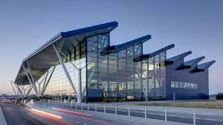

Monday: they show us their school and their town 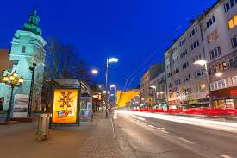

Tuesday : we went to the town hall and we had a talk with the mayor 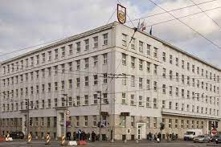

Wednesday: we visited Gdansk and afterwards we went to a museum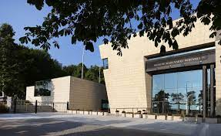

Thursday: this day we visited again Gdansk and we learnt about their history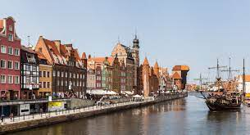

Friday: it was the last day so we had a party

Saturday: every one packed their things and we left for Greece 