POLAND DIARY

Sunday: We arrived at the airport and we met for first time our hosts. It was really good!

Monday: We visited the school, we presented our presentatios and we explored the beautiful city of Gdynia.
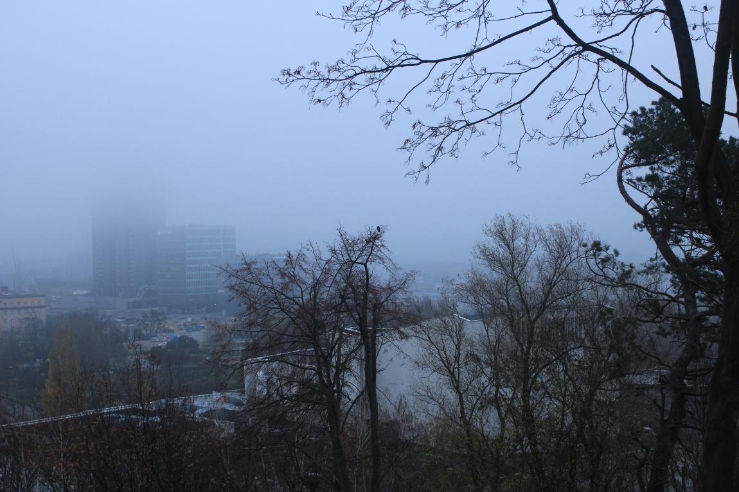

Tuesday: We went to the city hall, we met the major and we went to the port.

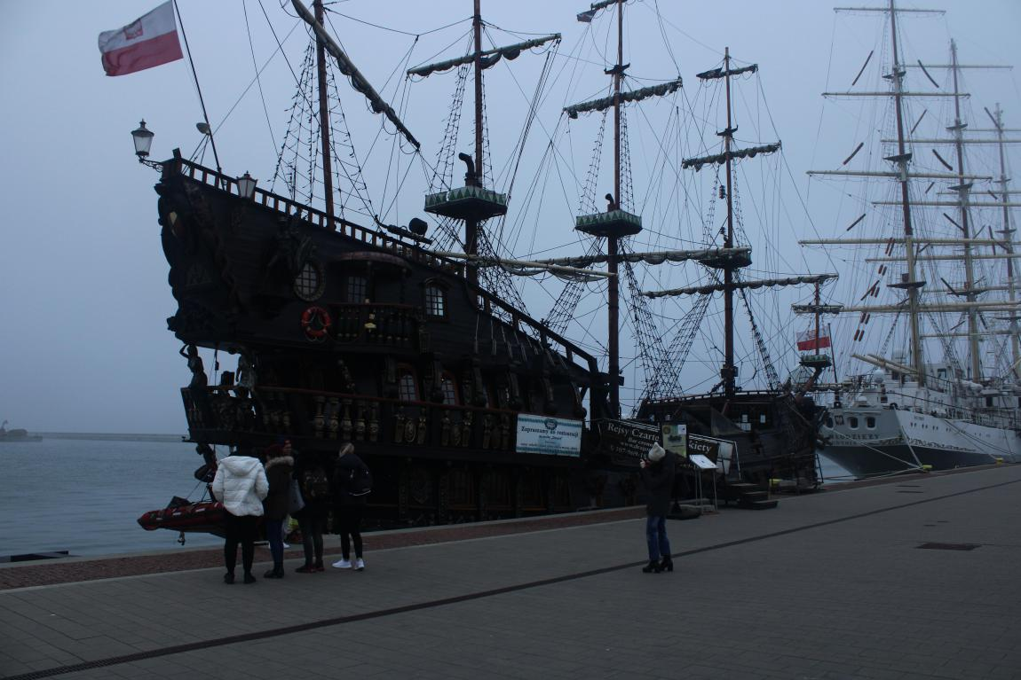

Wednesday: we visited Gdansk and we went in a museum
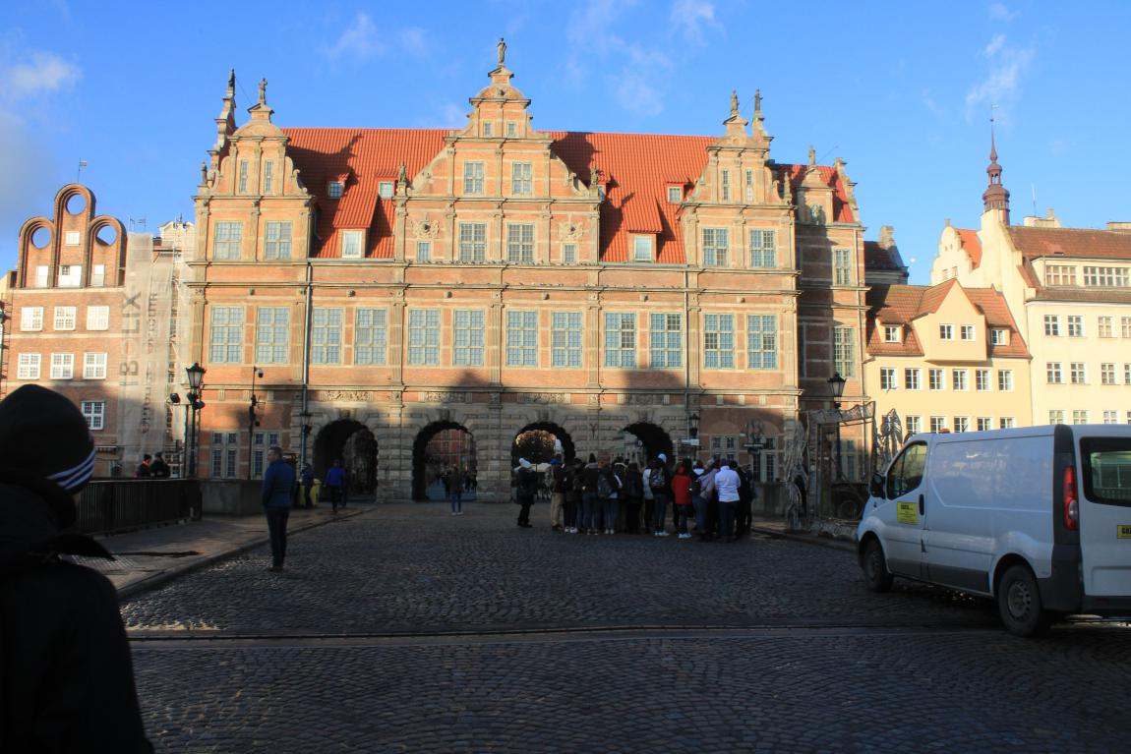
Thursday: We revisited Gdansk it was very nice.
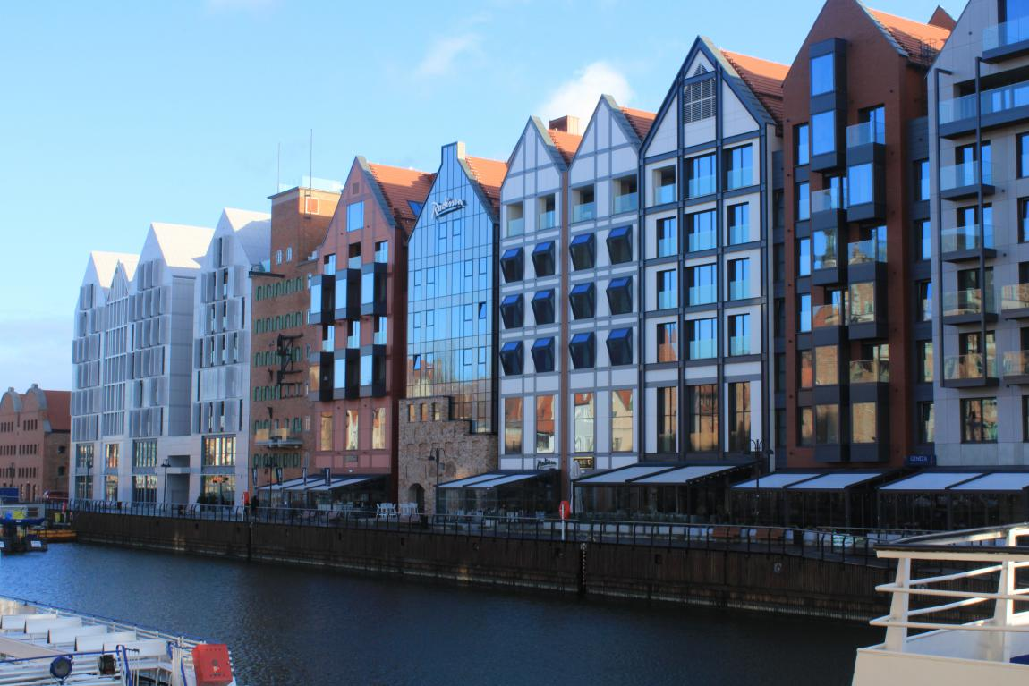

Friday: We finished some last activities and he had a goodbye party.

Saturday: Unfortunately we had to go back in Greece and say goodbye in our friends from Erasmus.
.

Stelios Papantonis

