ERASMUS DIARY
NAME: Maria Kapsimallh
TRIP: Poland

MONDAY

- The first day of the erasmus we visited the polish school and each country made a presentation separately.
- Αfter we saw sights of the city , then we went to a restaurant and tasted traditionals Polish meals.

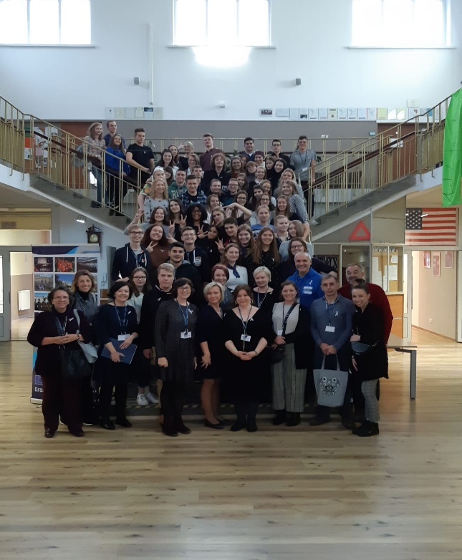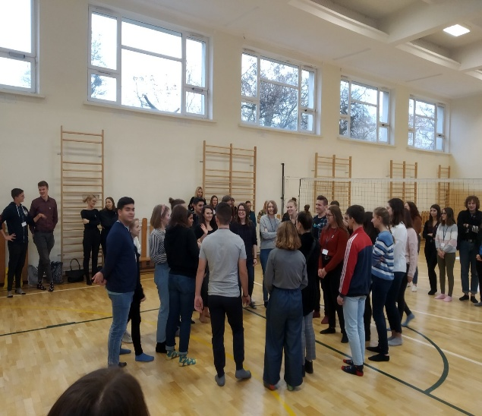

TUESDAY

- The first activity was to visit the mayor who spoke to us
- We return to the school and we were divided into groups to start the anti racism campaign.

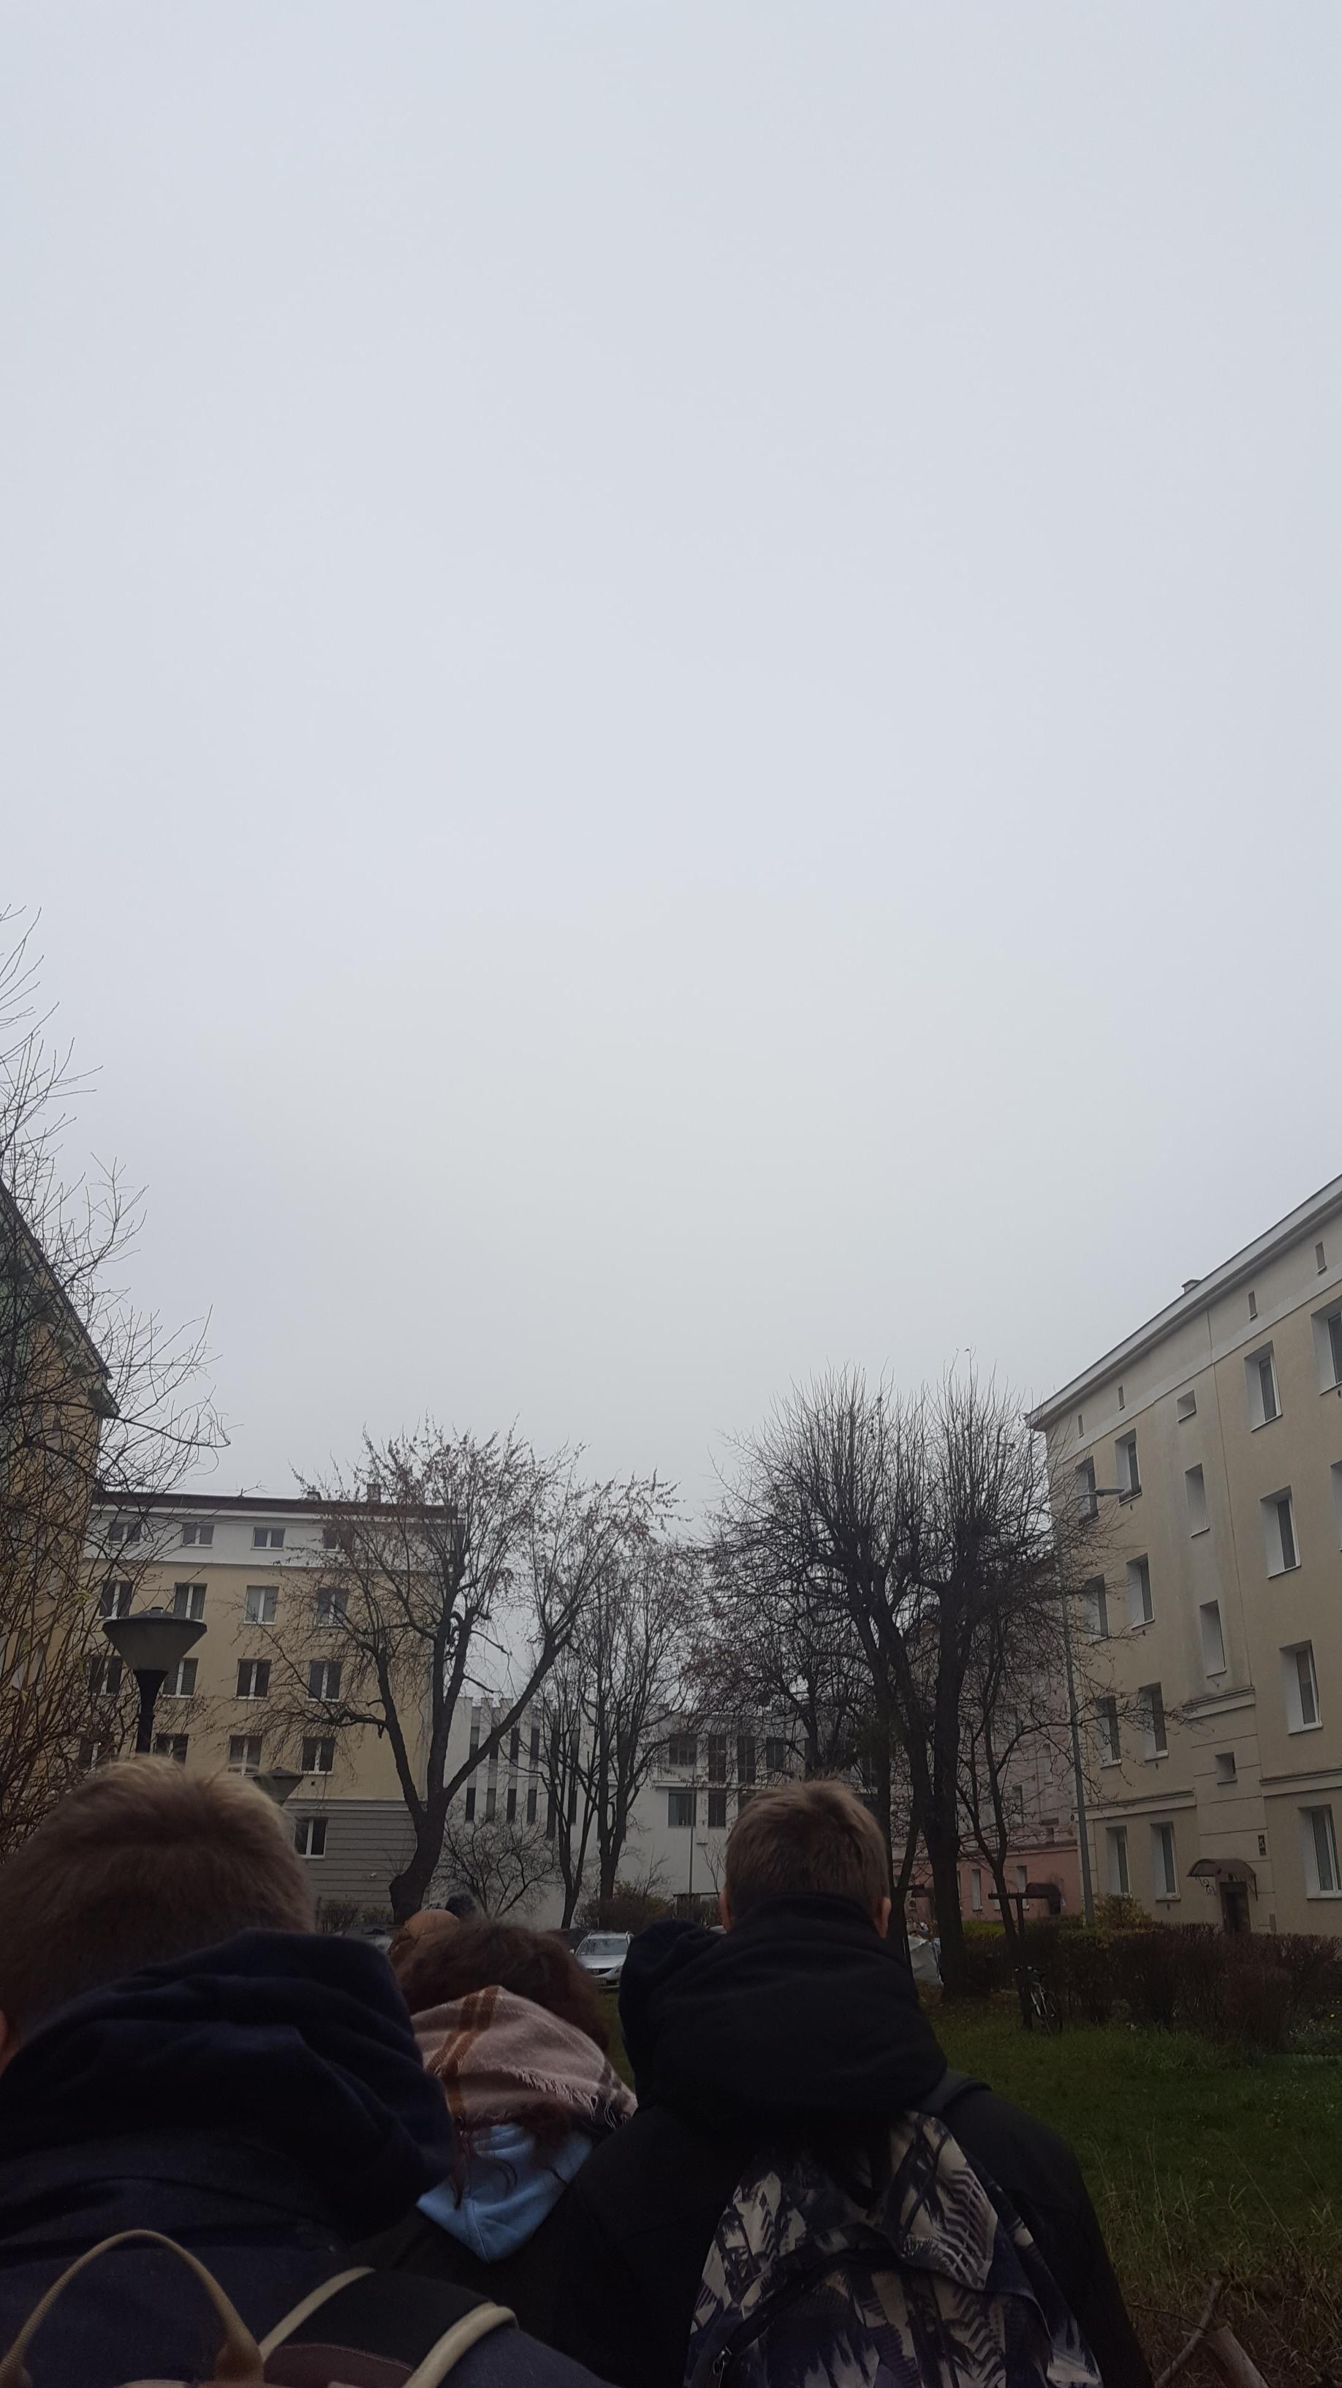

WEDNESDAY

- We visited the emigration museum in Gdynia which helped us to gather information about the campaign.
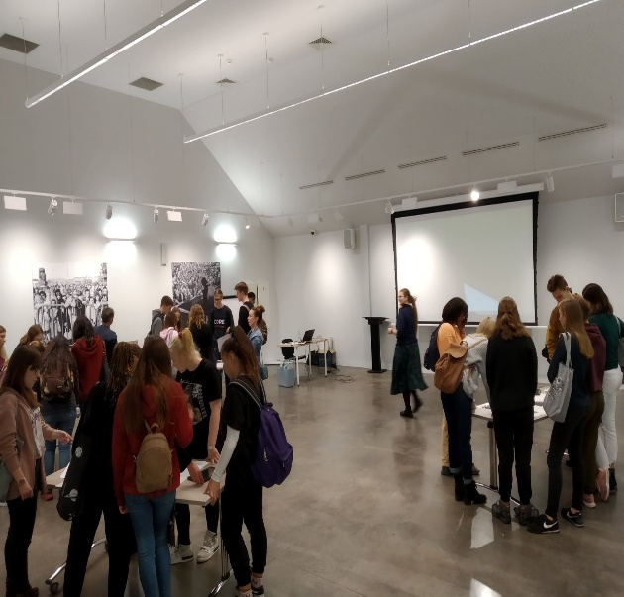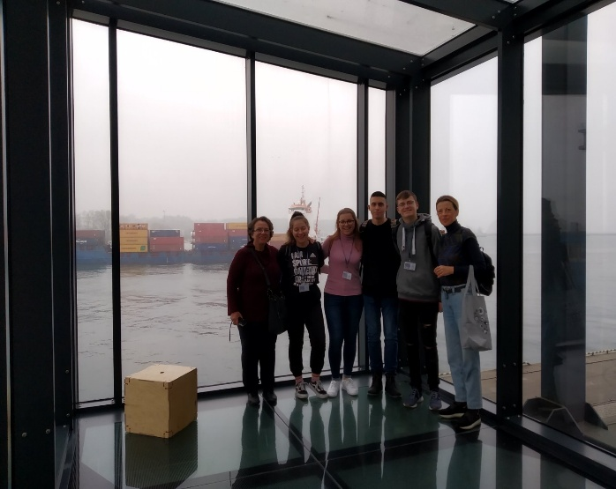

THURSDAY

- We went to Gdansk and visited the Biology university and the War museum.
- We visited the place where WWII started. 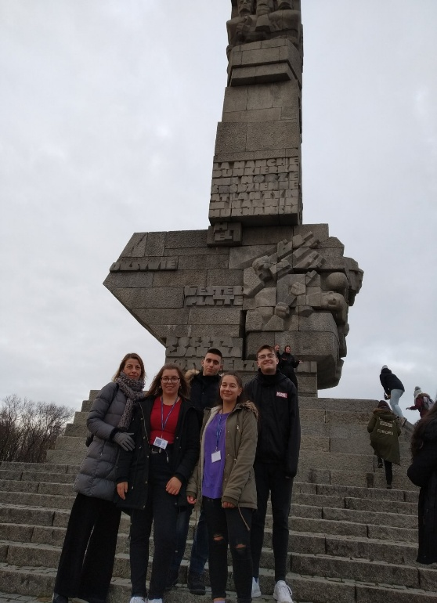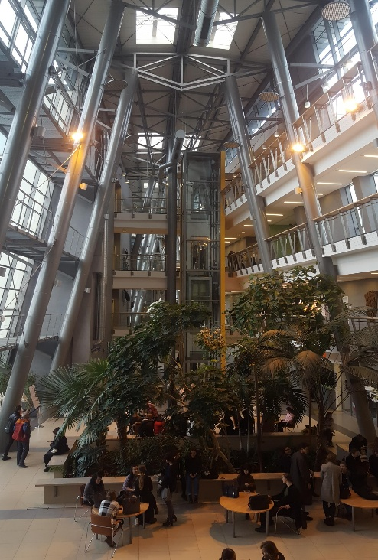

FRIDAY
- Our last day we went the old city of Gdansk and the Sopot Monte Cassino
- The afternnon started the Erasmus party in the Polish school
8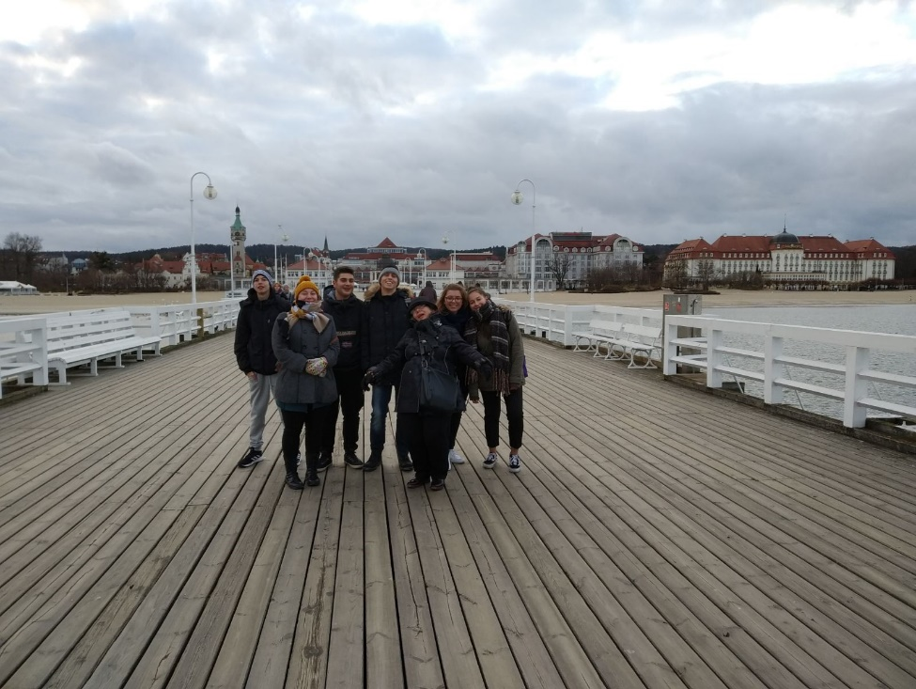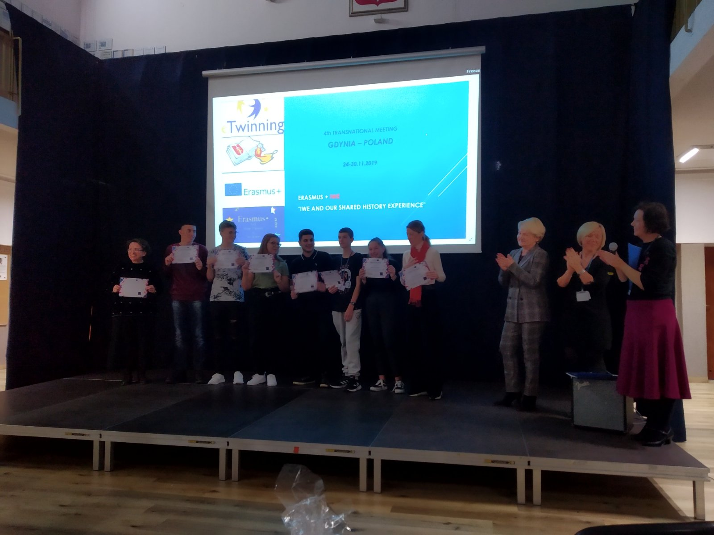

SATURDAY
Our trip ended and we returned to our country with many experiences

