Erasmus dairy
Name:Michael Davlnti
Trip:Poland
Monday
- In our first day of the Erasmus activities we visited the polish school and we did ice breaking activities
- Then we went for sighting seeing in the city
- Lastly we ate at a restaurant

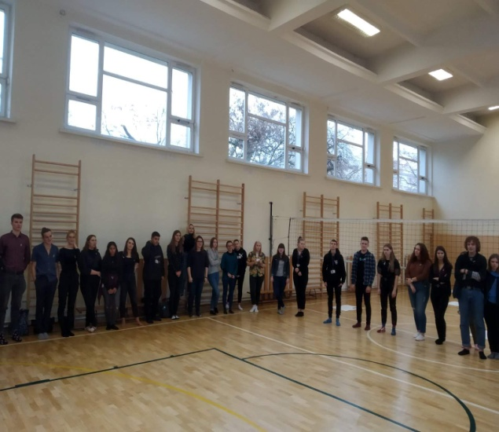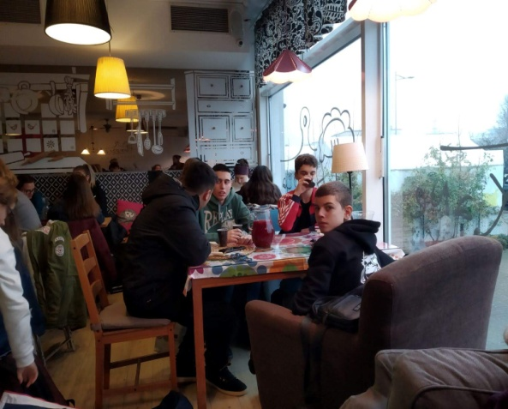

Tuesday
- Our first activity that day was to visit the mayor
- Then we return at the school to start preparing the anti racism campaign
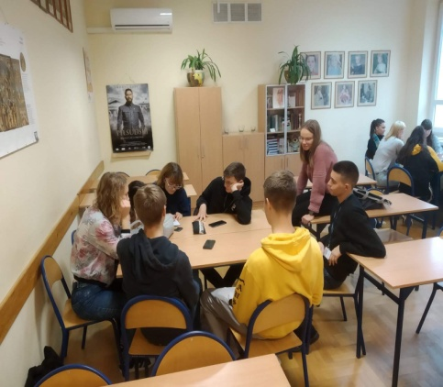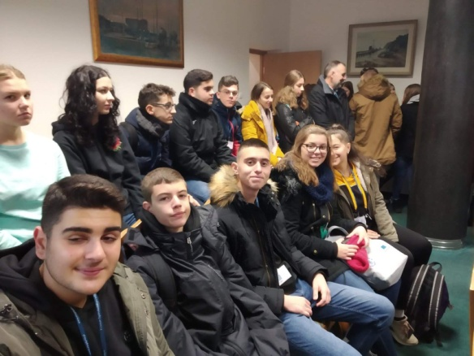
Wednesday
- We visited the emigration museum in Gdynia
To gain information about the campaign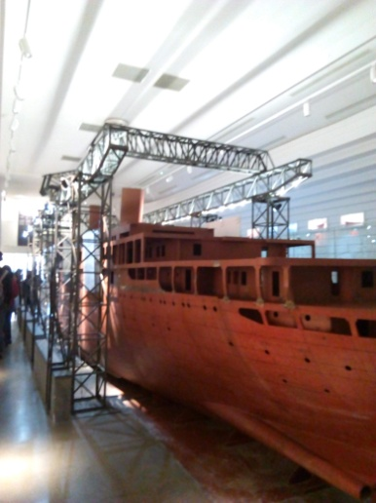 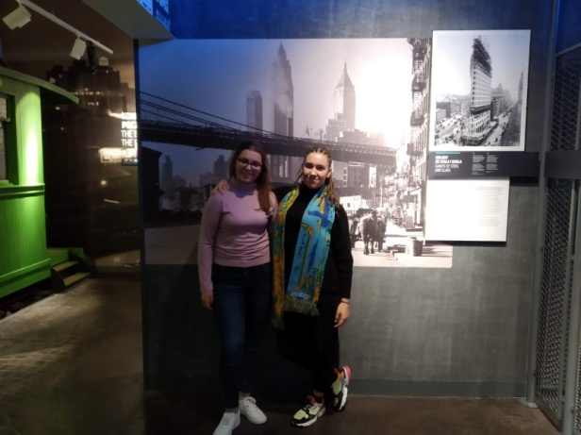

Thursday
- We went to Gdansk to pay visit to the Biology university of Gdansk and the War museum
- In the afternoom we visited the place where WWII started
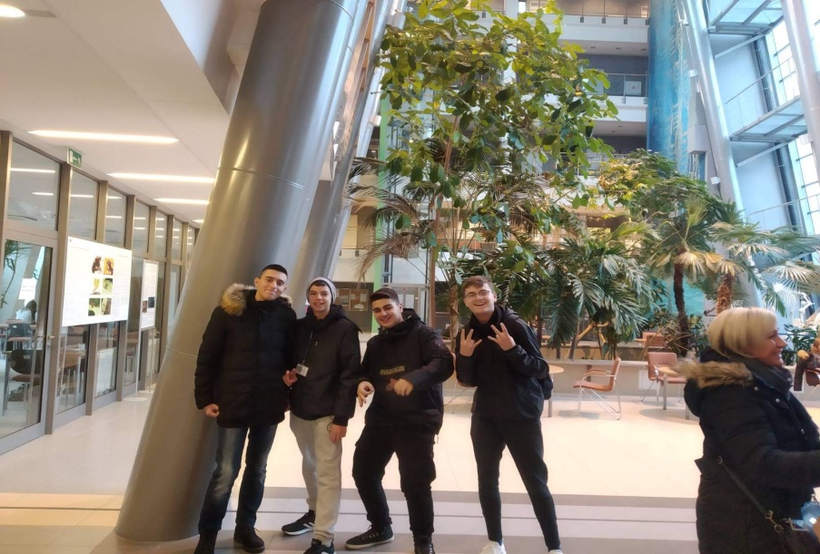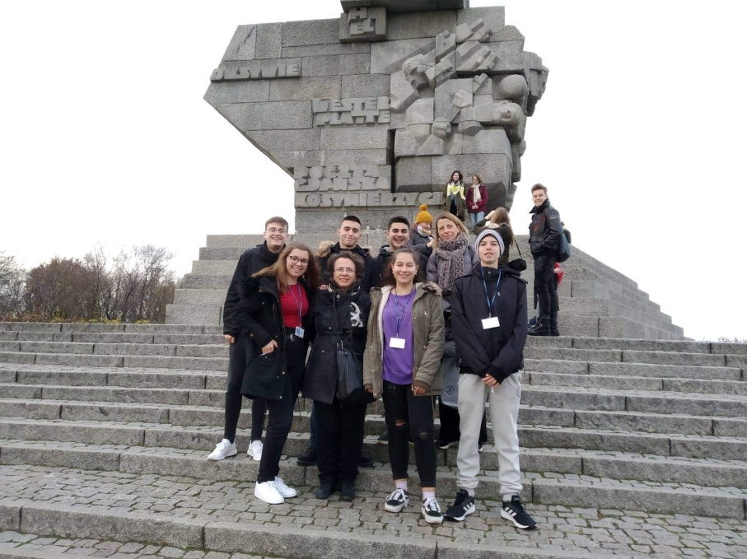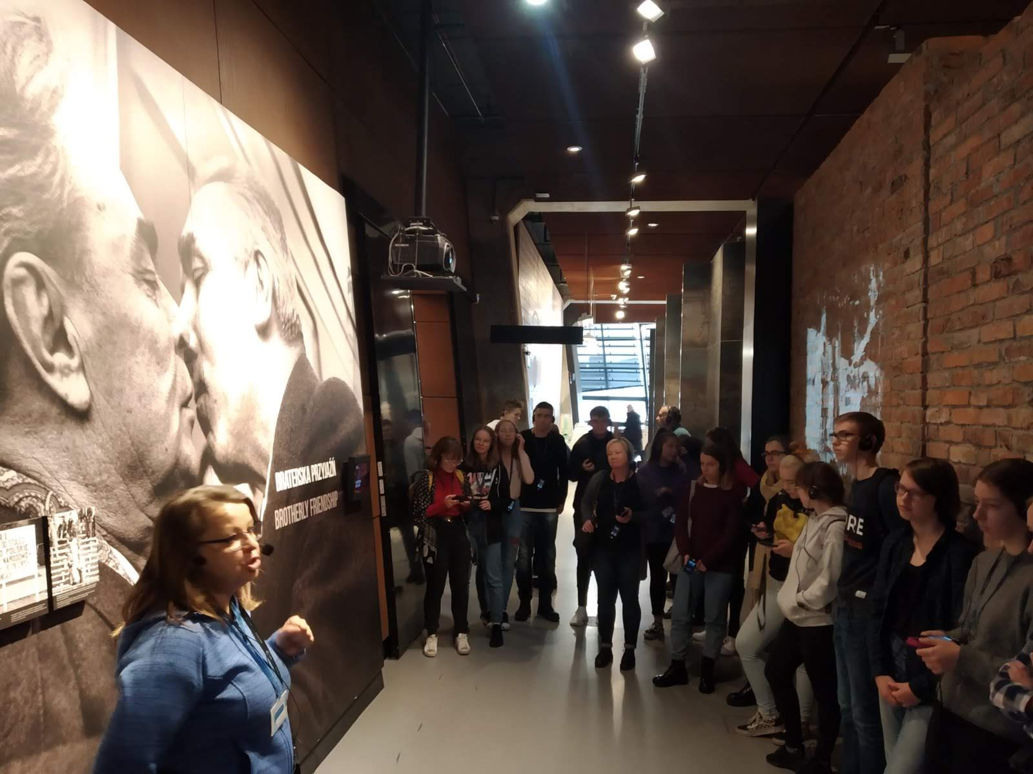

Friday
- Our last day we went sightseeing to the old city of Gdansk
- Later we attended to an organ concert
- After that we visited the Sopot Monte Cassino Street
- Finally we ended the program with the Erasmus party in the Polish school 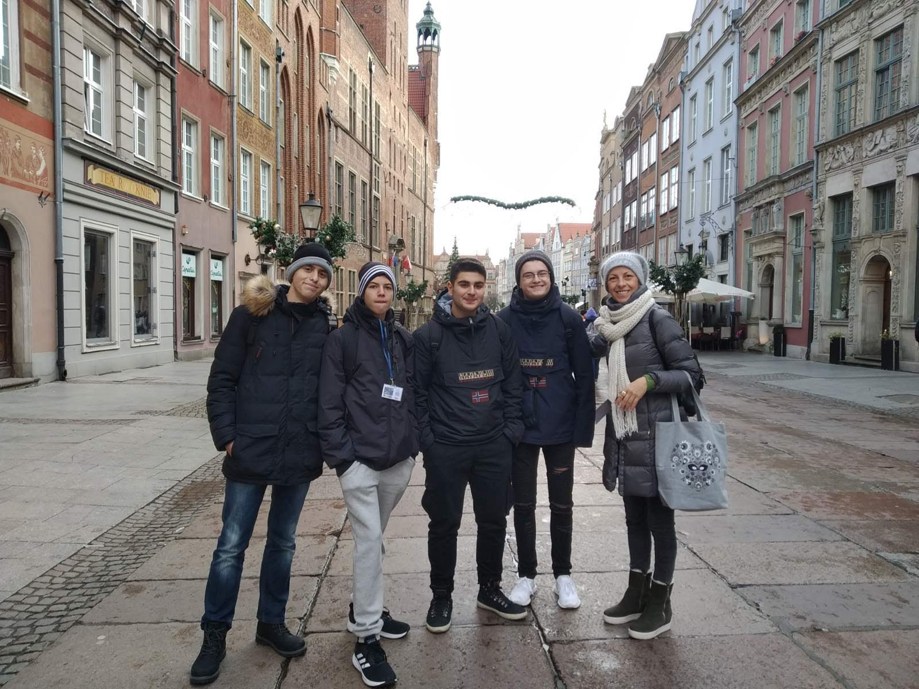
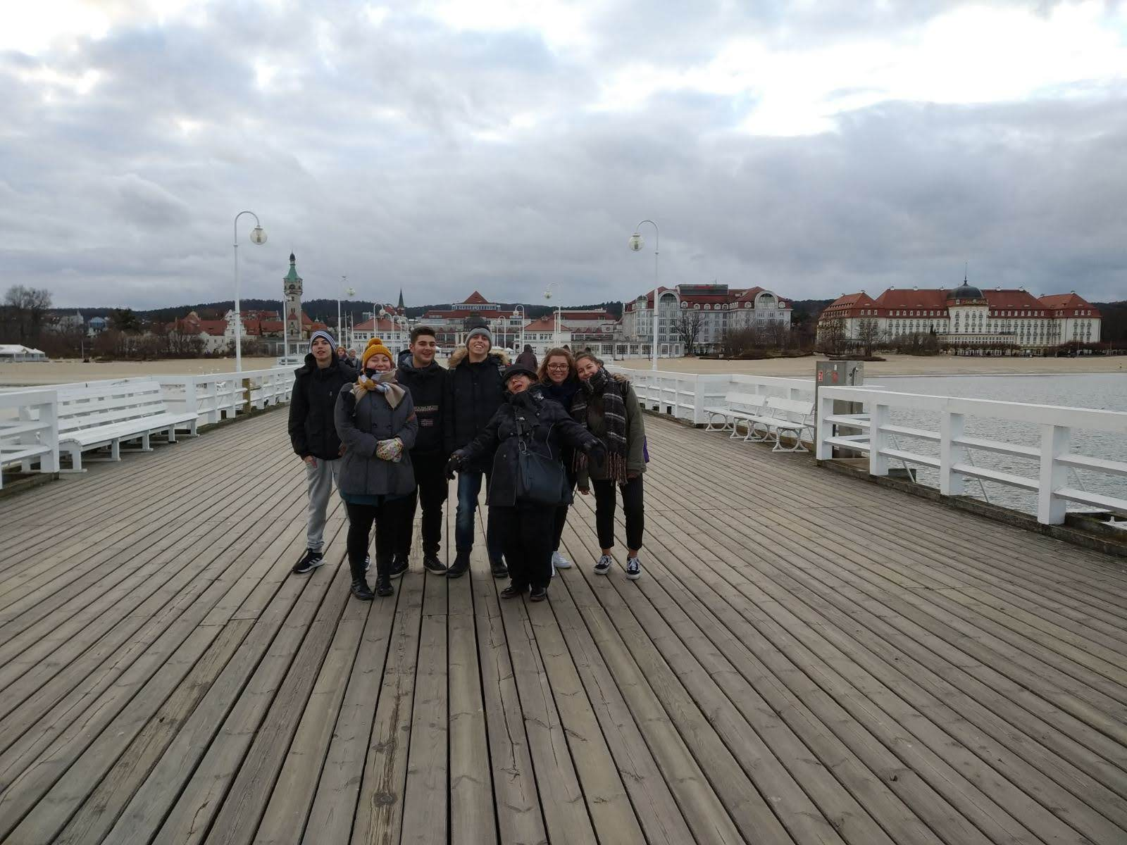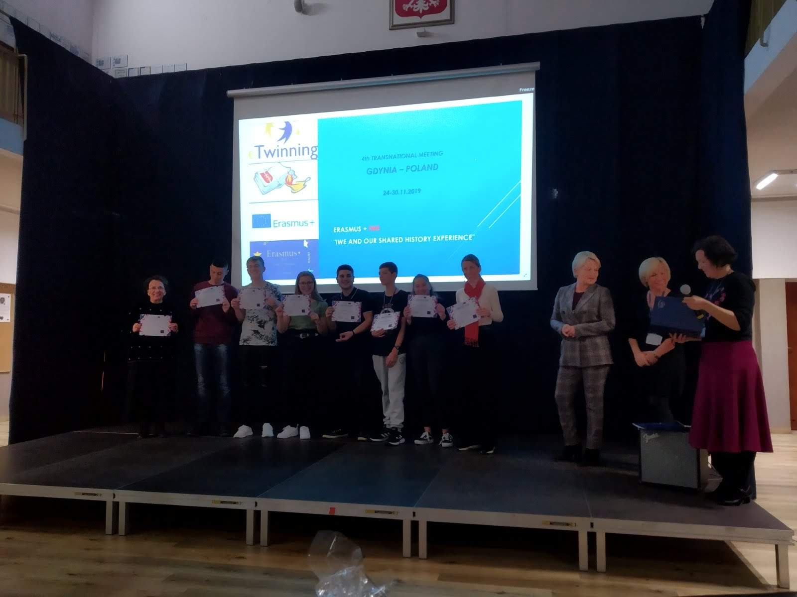
Saturday
- Our trip concluded and we left Poland full of great experience

