Trip in Poland

Day 1: we arrived at the airport and we met for fist time our hosts. It was a nice experience!
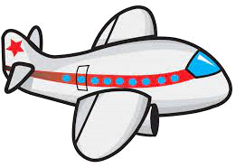
Day 2: we visited the school and we went to explore the beautiful city of Gdynia.We also had to present and share some information about the history of our coutry!
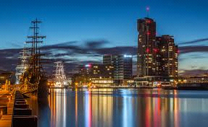
Day 3: We went to the city hall and we met he mayor.
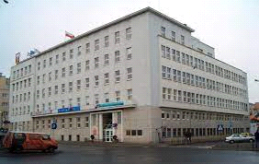
Day 4: We visited a museum and we went to Gdansk for first time!
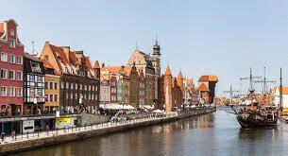
Day 5: In the morning we revisited Gdask and we had a tour guide with us to tell us about the local history.
Day 6: we finished some last activities and we had a goodbye party.
Day 7: Unfortunately we had to go back in Greece so we said goodbye to our friends from Erasmus
Ioannis Sotiropoulos

