SPAIN DIARY

SUNDAY: We were travelling all day.we arrived in Marmojelo late at night and we met for first time the host families.It was fantastic!

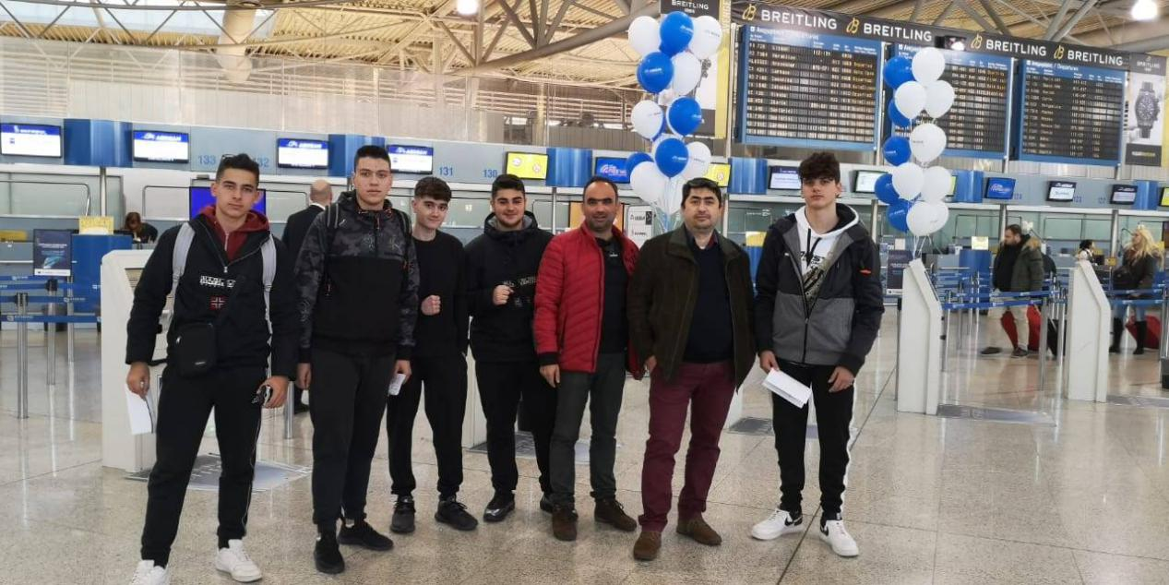

MONDAY: We represent our presentations,we visited the town and we did some ice-breking exercises.The town was beautiful and the people were very hospitable 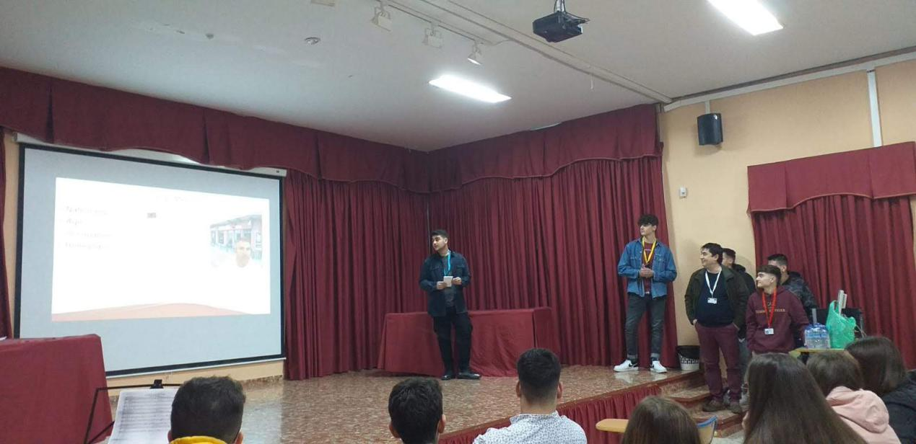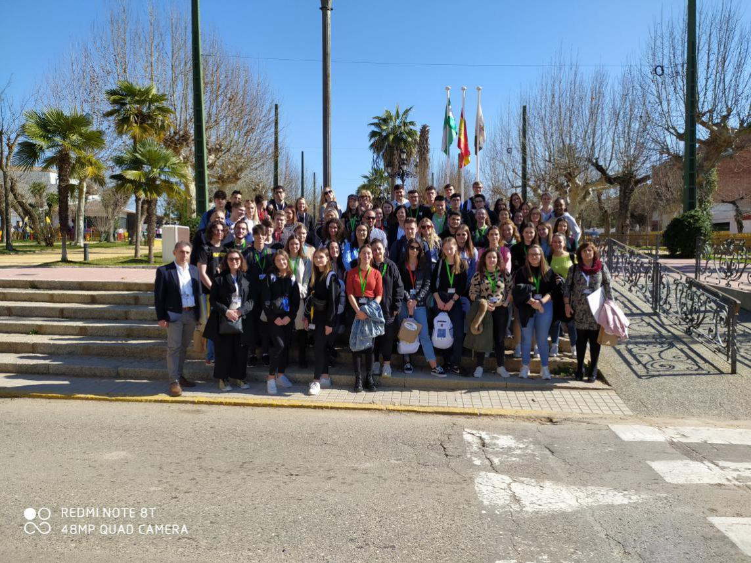
TUESDAY:We went to Seville.

TUESDAY:We went to Seville.In my opinion the most magnificent town I have ever seen!
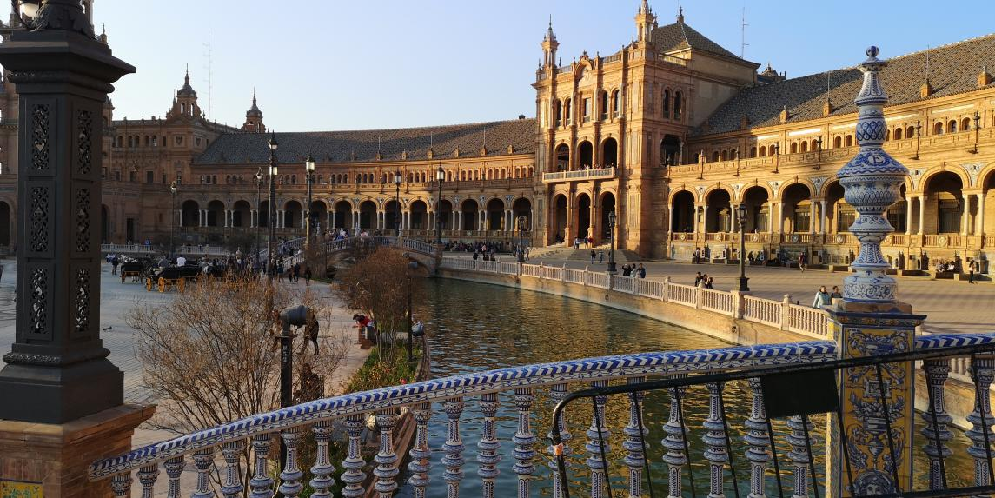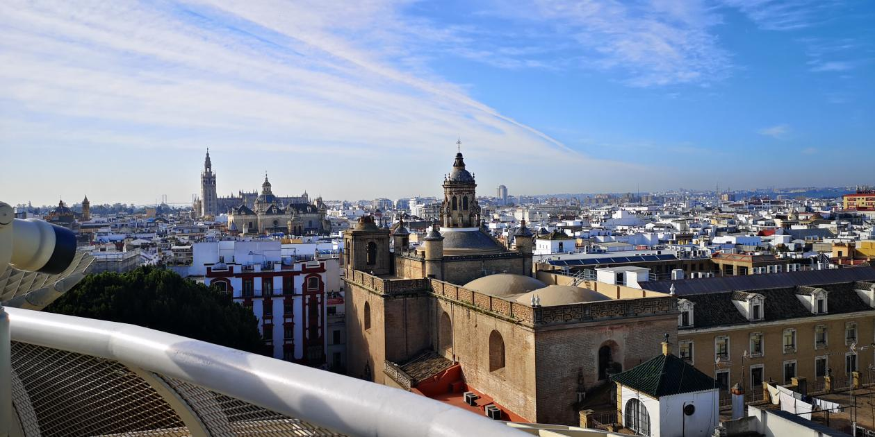

WEDNESDAY: We made videos and we went to an association working with disabled people.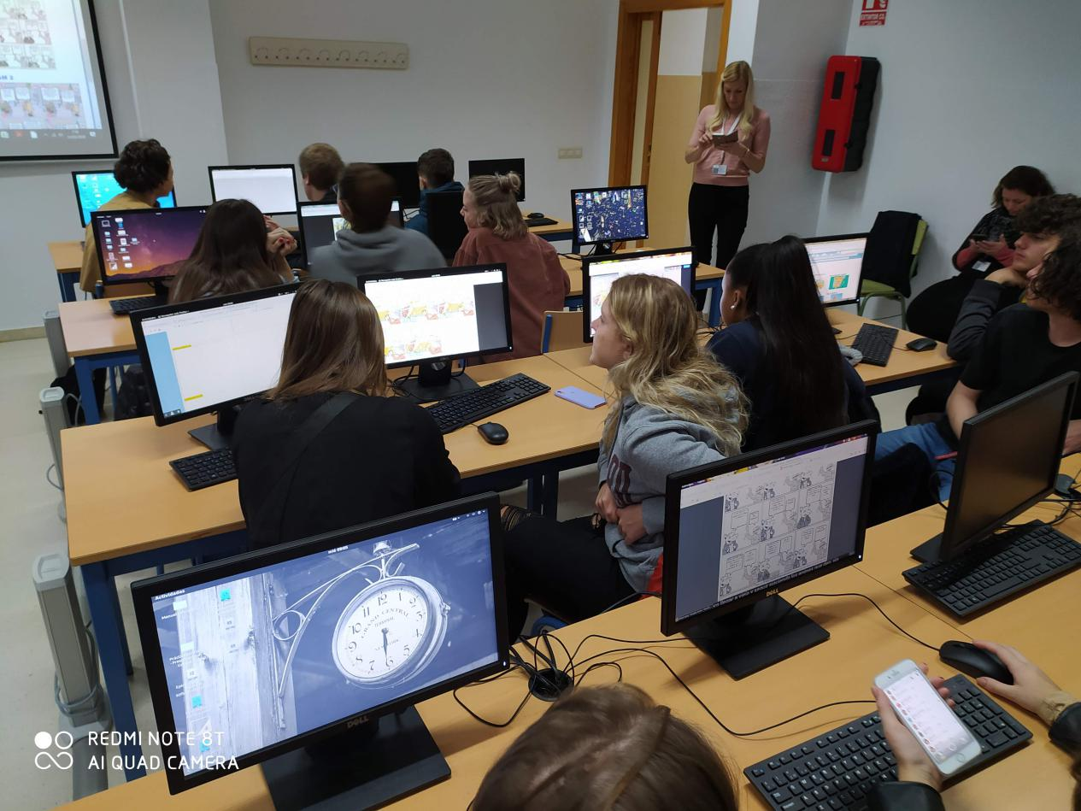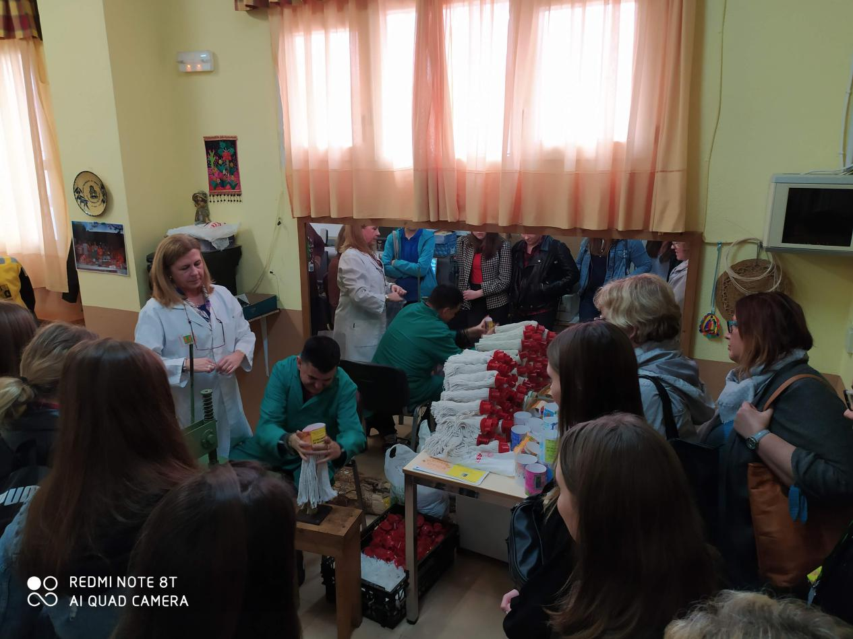
THURSDAY:We went to Cordoba.The sights in Cordoba are amazing!
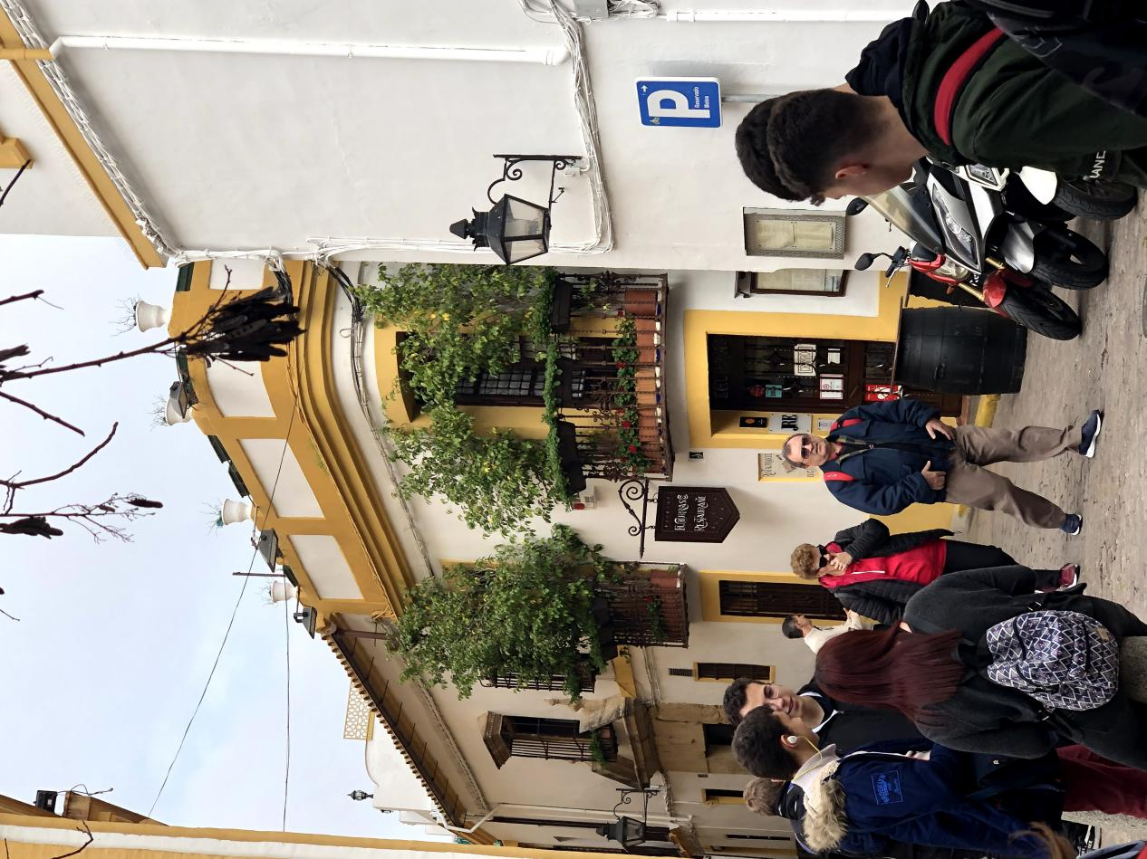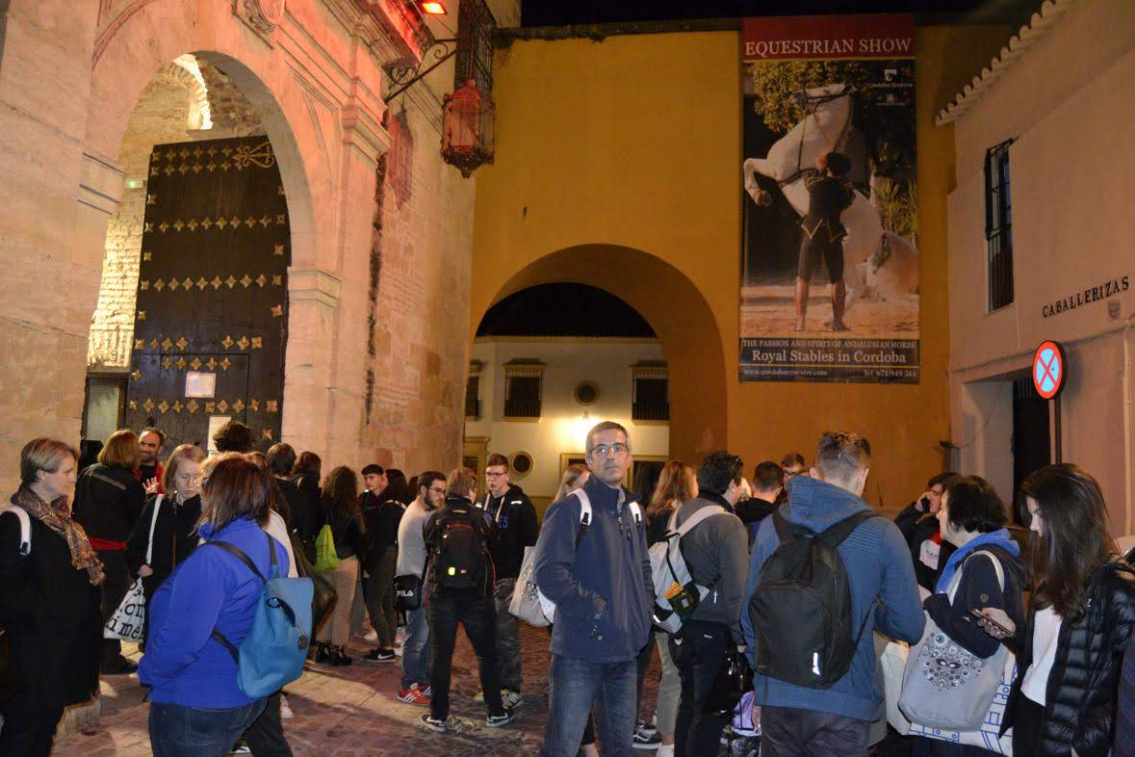
FRIDAY:We planted trees and we went to an immigrant centre and the city of Andujar. It was a very nice experience! 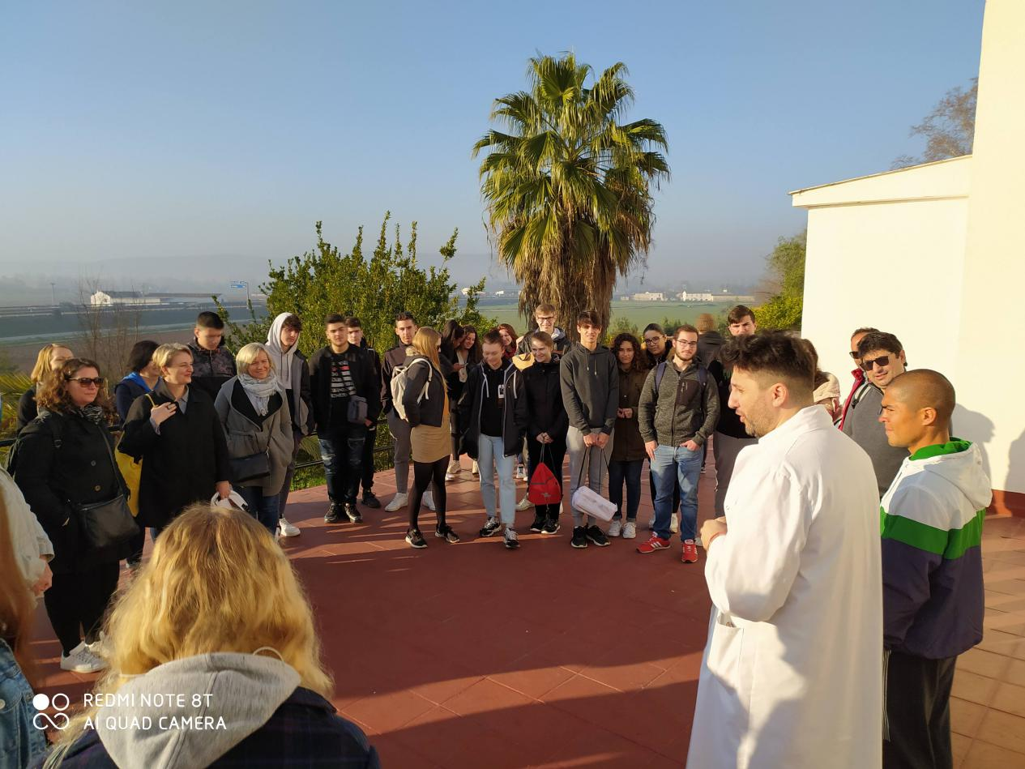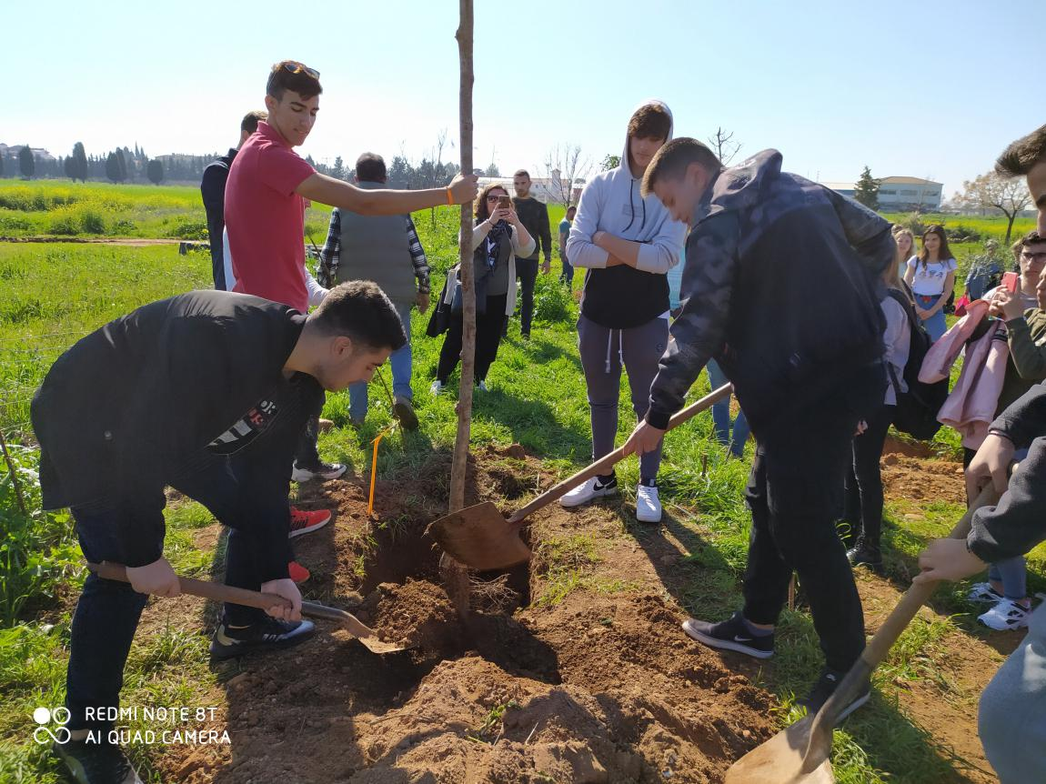
SATURDAY:We came back to Greece.
Unfortunately we left Spain.I hope to come back again!

Stelios Papantonis

