# Hello guys I am Kostas and I am very excited to have had the opportunity to go to Finland. Τhis trip was my first and I have to say that it will be one of the trips I will remember forever….

now I'm going to tell you my experiences …

**So….the day we left I was quite anxious about the plane because I did not fly again. Anyway,** **at 4:00 we arrived at Eleftherios Venizelos airport in Athens where we drank a coffee quickly and at 5:45 We left for Istanbul.**

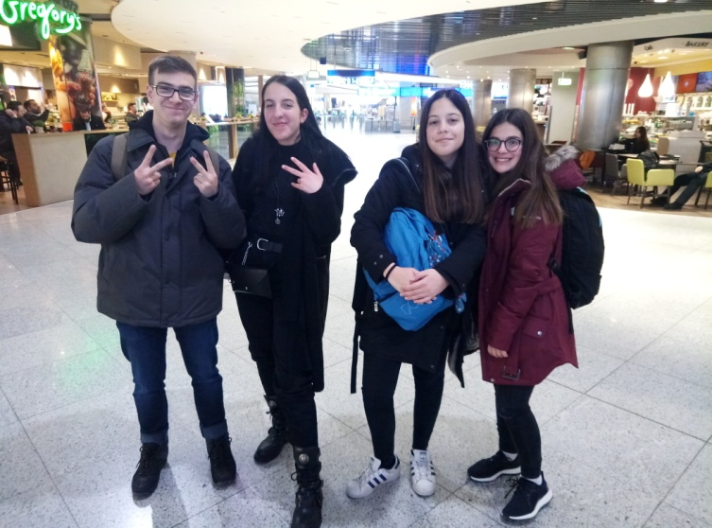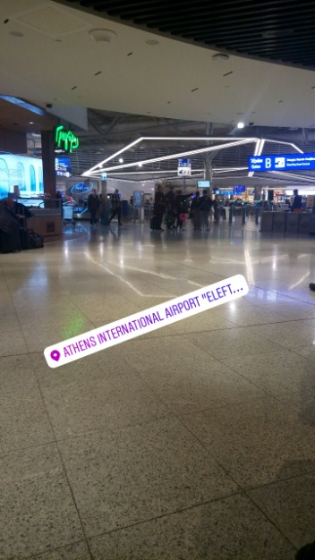

at InstabuI did not get any pictures because we had to rush to get to Helsinki

Then we left for Helsinki. On the plane were fantastic

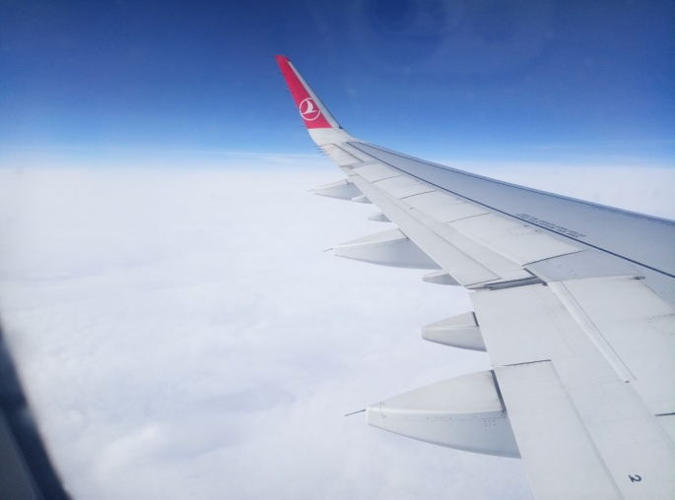

When we arrived in Finland I felt very nice, but it was a bit cold too, hehehe

at our airport we took a bus and went to lahti, there were the families waiting for us….

my first day at lahti was very beautiful…

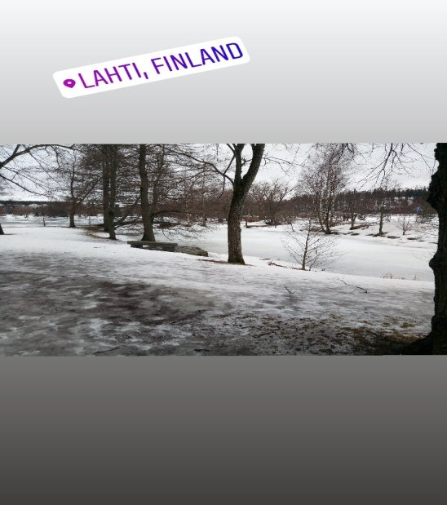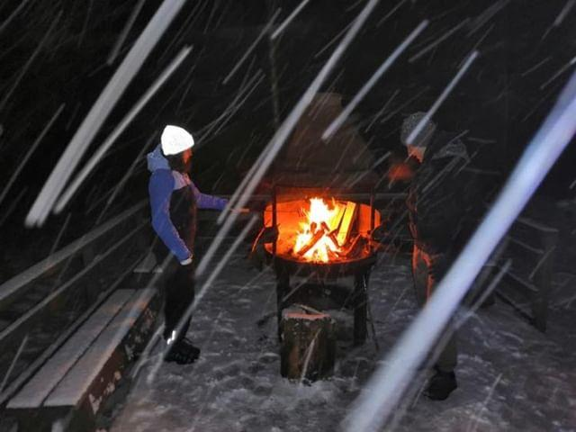

On Monday the official welcome was received from the Finnish, followed by the country's presentations on their educational system. The presentation of the Greek group in English was about the structure of the Greek educational system...

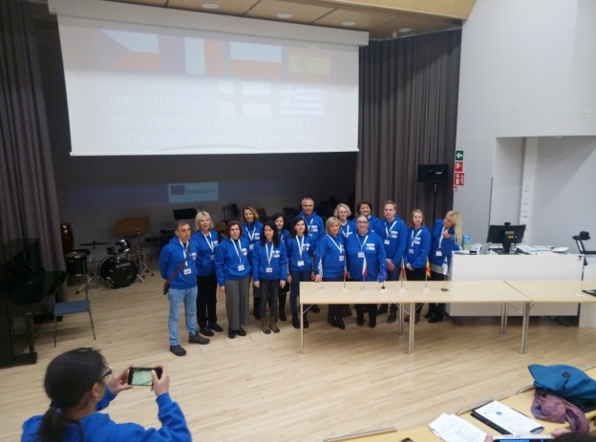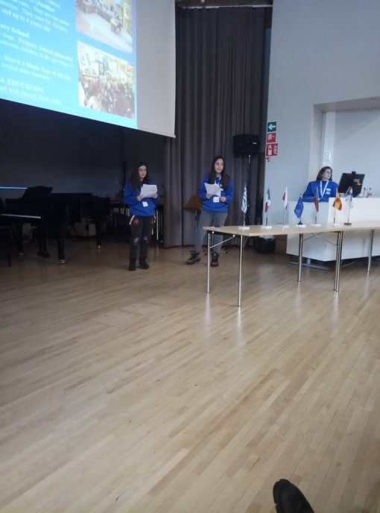

after that they traveled to their school and went to the town hall…

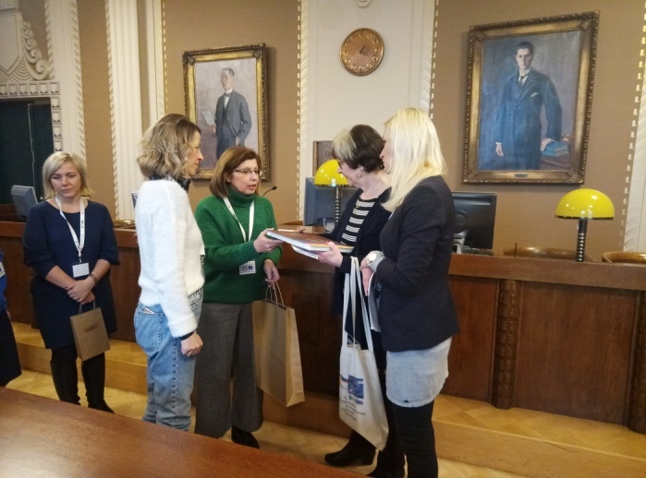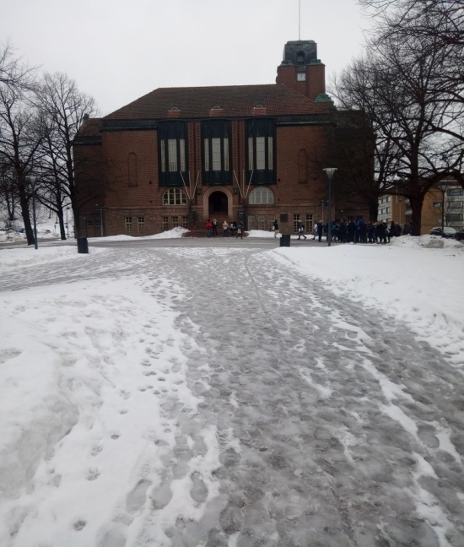

The tuesday was a day devoted to the fight for the registration of human rights representatives of the pupils of the missions participated in one's end or on equality and rights…

The most impressive thing we did was on Tuesday afternoon that we went for a sauna was an unprecedented experience for me but also perfect

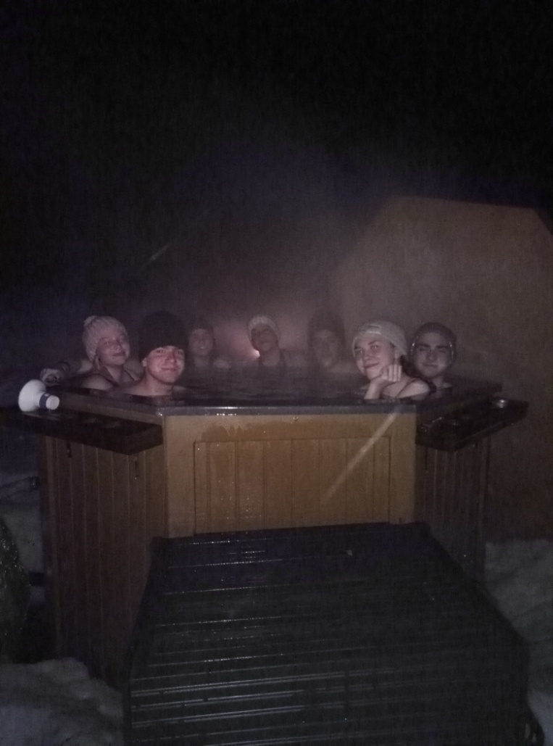

On Wednesday we traveled to Helsinki where we did a small tour of the city and we could see the capital of Finland .Then we visited the Finnish National Museum the university the square Senaatintori and the church Uspenski.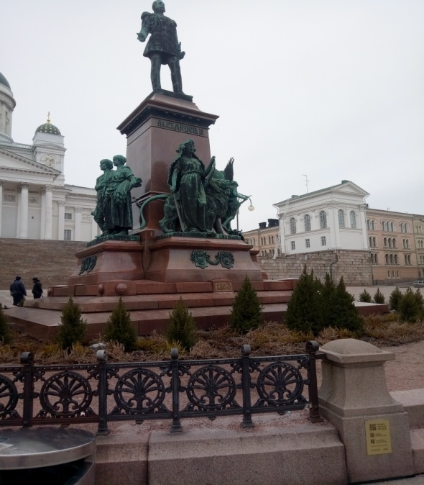 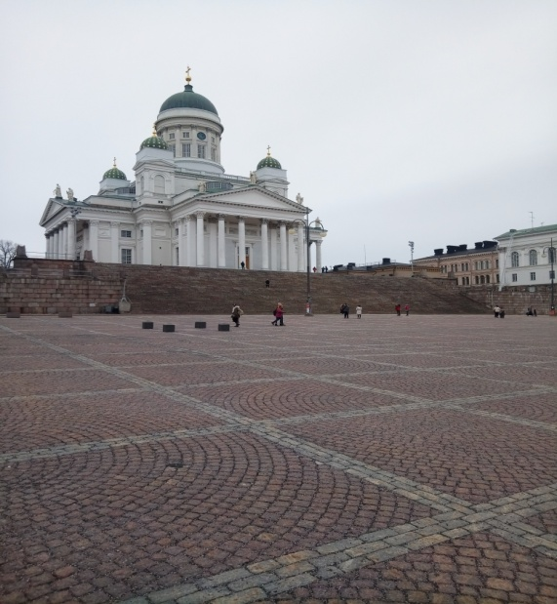

on Wednesday night we went to a mountain that from here you saw the whole lahti there was a lot of snow and it made us harder on our way

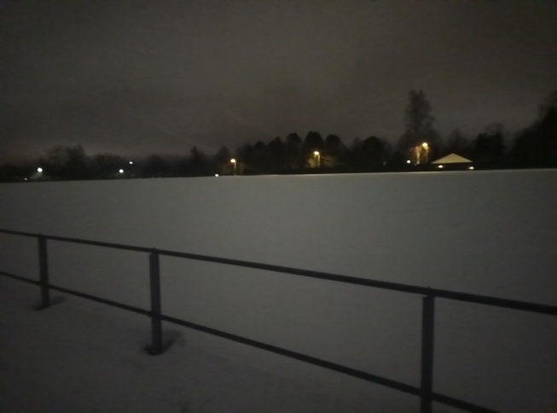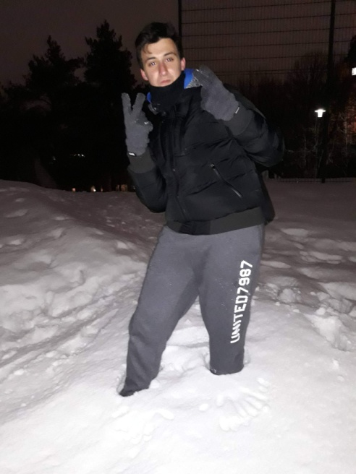

On Thursday, we visited the one stop guidance center where we were informed about the free services to people under 30 years of age in health at work and education

On Thursday afternoon……Again sauanaaa!!!!

On Friday we visited the Kaarisilta Center offering education and employment to young people with special needs

on Friday evening was the erasmus party It was very nice and it was very fun was one of the most beautiful moments of the trip….

Saturday Departure time and farewell….

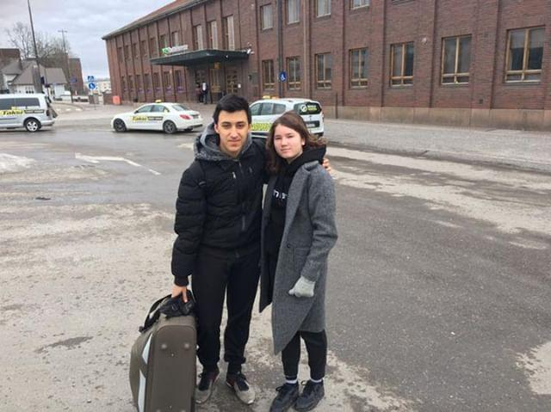

THANKS FOR EVERYTHING GUYS

P.S . some other photos hehehe

