Spain diary (Sunday, 9/2/2020 – Saturday 15/2/2020)

1day Sunday: It was the ‘travel day’, nothing special but it was my first time on a plane! We arrived late at night and we met the host family. They were so friendly and kind people.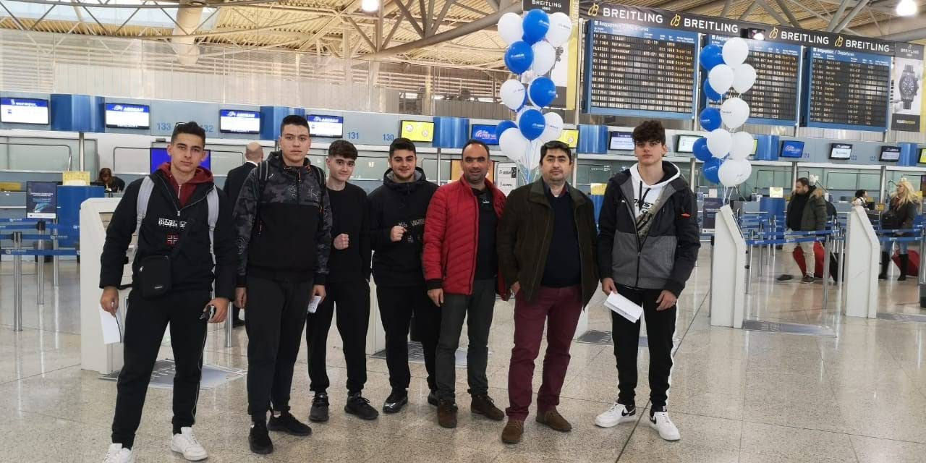
2 day Monday:First day at school! It was beautiful. So kind and friendly teachers and students. After the ‘ice-breaking’ we did present the presentations we had prepared. And then we visited the beautiful full of alleys town.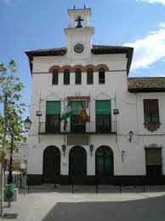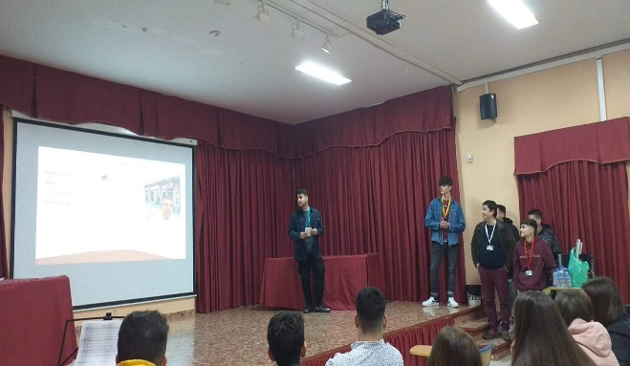
3 day Tuesday: As known as Seville day. Great day, visited a massive city with beautiful nature and sights.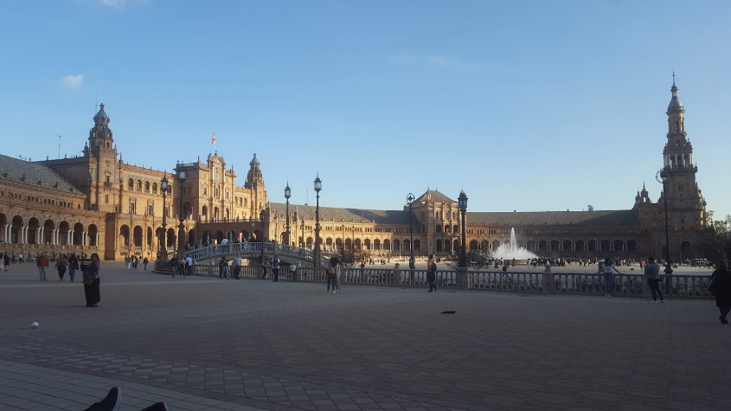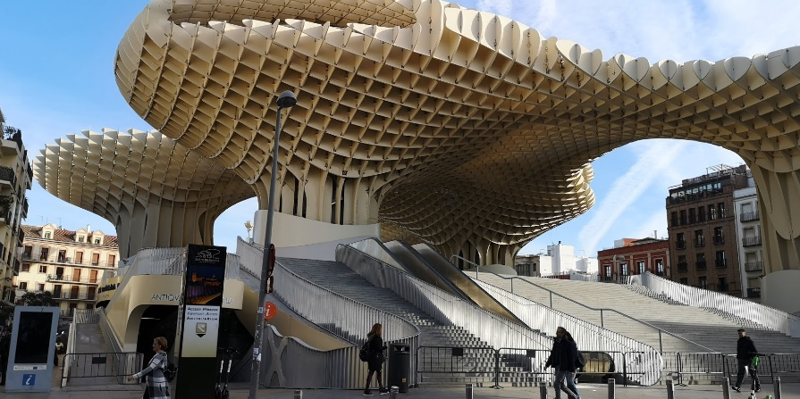
4 day Wednesday:We made a themed video with refugees. Great but awkward experience haha. After the video we went to a association working with disabled people. It was an original thought and different way of treating that kind of people.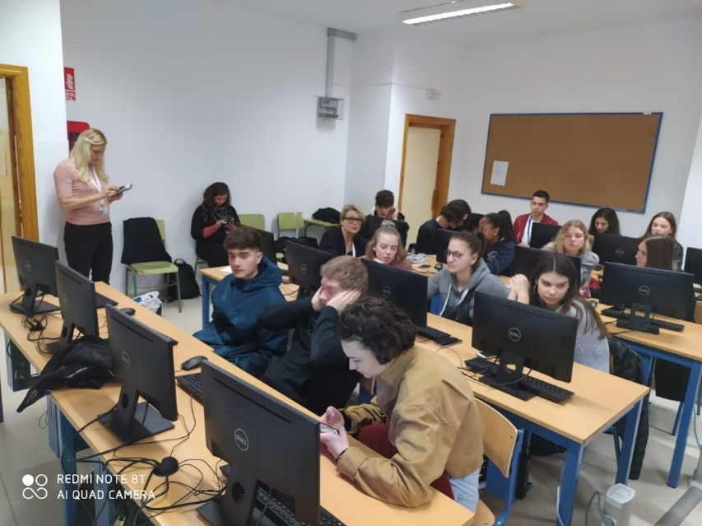
5 day Thursday: The day we went to Cordoba. Pretty beautiful place and nice sidewalks with shops in the center of the town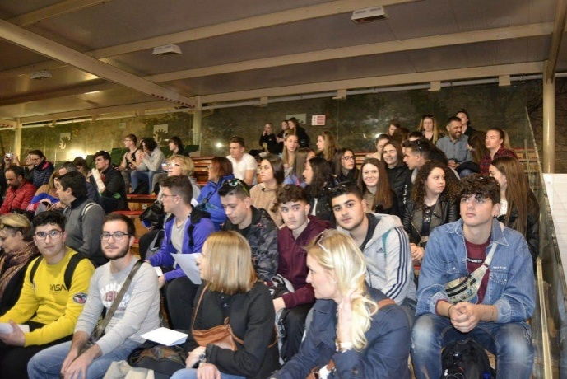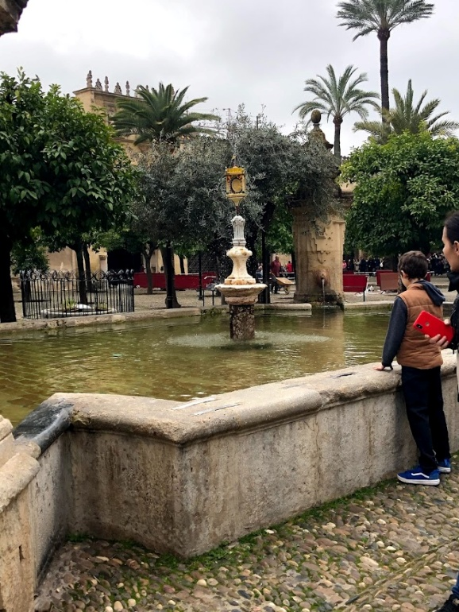
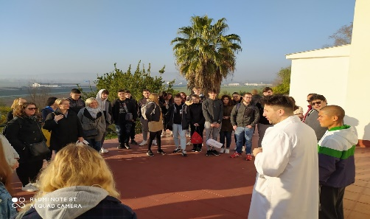
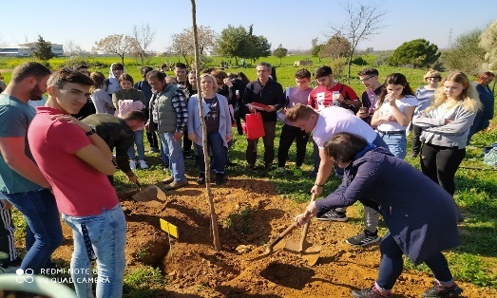
6 day Friday: First of all we had the chance to see the other side of the school, the country side. It was such a beautiful experience and each country planted a tree! After that we went to the city of Andujar, nice city but not like Seville. There we visited an immigrant aid center. It was nice to see that people had a second chance for their life.
7 day Saturday: The sad day. It was the ‘travel day’ back to our countries. Personally I was really sad cause I had to leave all those great people behind and all this amazing experiences.
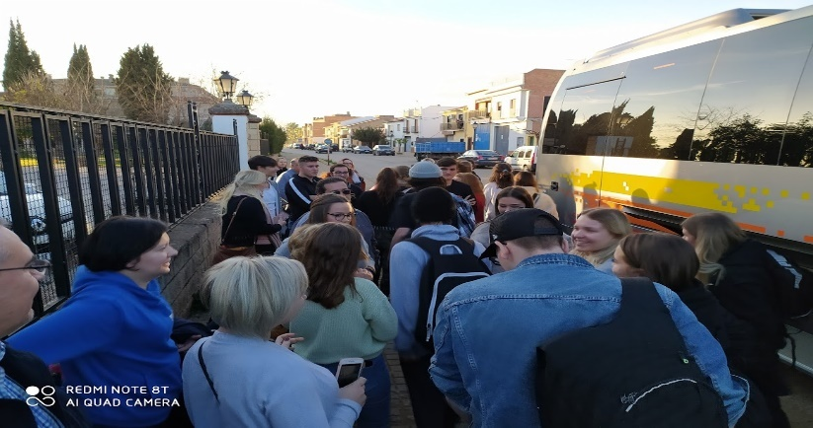
Diary by, Dimitris Schoretsanitis

