KA2 – Cooperation and Innovation for Good Practices

STRATEGIC SCHOOL PARTNERSHIP PROJECT
HIGH SCHOOL DROP OUTS: “One is too many”
Evaluation of the Activity 6 / LITHUANIA

Our school has organized the after school activity for 13-14 year students and their family members. The sixth grade students were chosen to participate in the activity because of the prevailing destructive, unsociable behavior in the classroom. It was decided to strengthen the class microclimate by using the method: musical performance building.
The idea initiator was our music teacher who adapted the play ” The Gospel according the Children”, also theatre teacher, social pedagogue, psychologist, homeroom teacher and curator were involved in the process.
Roles were distributed to the students after consultations with the psychologist. It was very important to decide who is going to play the key roles (they were given to the most problematic students).
The preparation process took 3 months, students were working seriously. The performance was really professional. It was shown to students’ parents and other family members. In the event participated about 90 people in total. It was really successful, students were proud to show their talents to the parents.
We teachers noticed that the special bond was established among the students. The mischievous boys could expose their energy in this way, the quiet students got more attention, the new class leaders appeared, as the performance revealed their true potential.
The homeroom teacher was glad that the parents saw children in a different light - active, passionate, with a common purpose, not only as a class full of problems.
Headmaster who watched the premiere pointed out that it is a true way to handle with class problems.
The activity is a significant success, of course, it took a lot of time and energy resources , but the result is gratifying and inspiring children to believe that they are all excellent, and us teachers to understand that destructive behavior in most cases arises when we can’t find a productive activity and expression.
After the activity random students and parents were given a questionnaire to complete which showed that they are highly satisfied with the results.
All information about the activities was available in our Erasmus Wall.

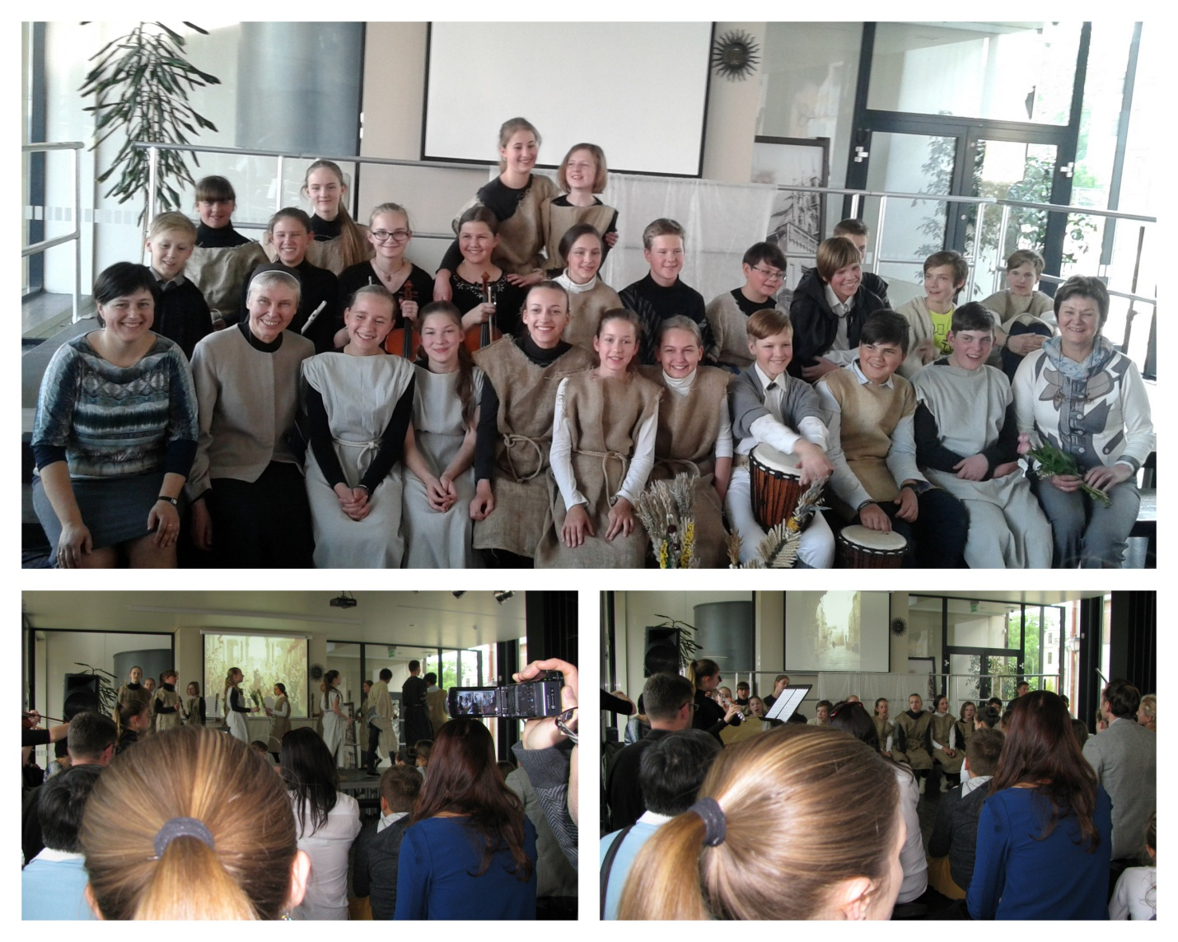

Loreta Čižinauskienė
Teacher Project Coordinator
In Lithuania

