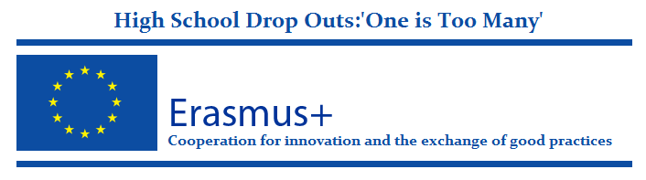
Project BOOKLET

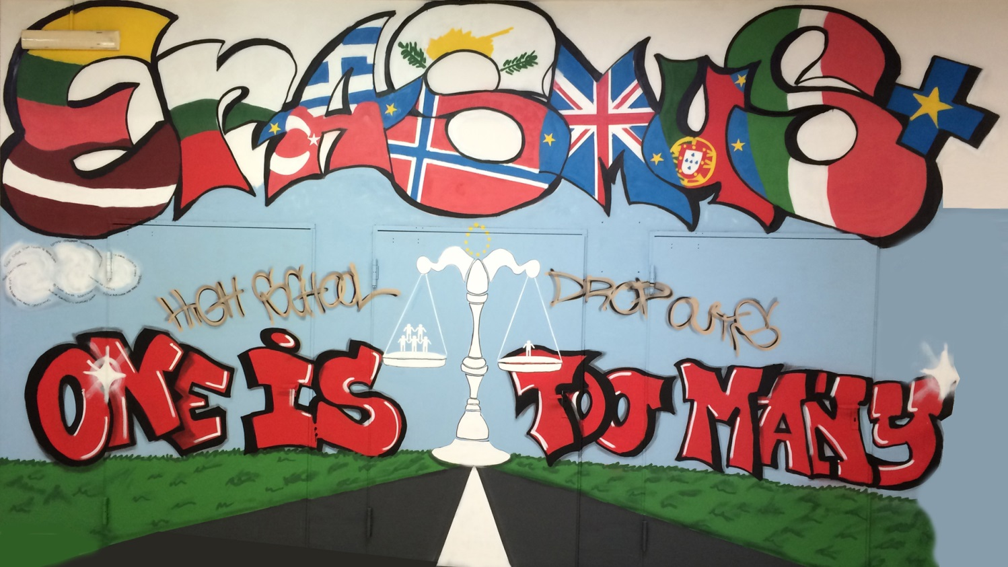
This project has been funded with support from the European Commission. This publication reflects the views only of the author, and the Commission cannot be held responsible for any use which may be made of the information contained therein.

Project Summary
Early school leaving is a multi-faceted and complex problem caused by a cumulative process of disengagement. It is a result of personal, social, economic, education or family-related reasons. Schools play an important role in addressing early school leaving (ESL) but they cannot and should not work in isolation. Reducing ESL can help towards the integration of young people into the labour market, and contribute to breaking the cycle of deprivation that leads to the social exclusion of too many young people.
Reducing the average European rate of early school leavers to less than 10% by 2020 is one of the education headline targets of the Europe 2020 Strategy. Investment in the educational achievement of young people is essential for the employment prospects of every young person.
In this Project High Schools from all over Europe prepared a strategic partnership and they co-operated to tackle ESL problem at roots level: by analyzing the problem and improving education atmosphere in term of; social activities, student teacher, student school, students society, student-parent, parent-school relations.
The main objective of this project was to find new methods for increasing motivation and creating more supportive school environments to decrease the number of student dropouts.
Project activities included the exchange of the information, sharing and analyzing best-practice models; comparing them and adapting them to each partner’s own activities and environment. Our project activities aimed to reduce ESL by establishing conditions for successful learning for all the students. Students should feel comfortable and supported, feel ownership of their own learning and can engage in the life of their school community.
This is important both for the emotional, social and educational development of the pupil and for the overall governance of the institution. As a condition of successful learning, teachers need to strengthen their role as facilitators of learning. They need autonomy, time, and space for innovation, teamwork, feedback, self-reflection and evaluation. They need access to enhanced opportunities for continued professional development.
We mostly targeted students with fewer opportunities in order to provide them with the missing opportunities they haven’t acquired by educational system so far. So our target group was who detected as being in danger of drop out. We also included parents of the students under the risk of drop out and teachers who needed guidance about methods to deal with the students who have drop out risk as a target group.
In long-term we aimed to disseminate the project all the related people and organization who has a role in students 'educational and social life. They were; teachers, families, peers, other organizations leading the same type of activity, local schools in each partner school’s area, local authorities, European authorities by the help of European partners, public, wider life learning community, decision-makers at local, regional, national and European level. We believed that our project results will have long term effects on economy and society with the help of dissemination activities.
www.oneistoomany.net

Description of the Project
The High School Drop Outs: One is too many project’s target groups were: high school students (facing special difficulties) from the ten partner schools which were directly identified by their teachers to be at risk of early school leaving, school leaders and teachers of the partner organizations, school leaders and teachers of other organizations which were located in each partner’s area of interest, and parents, members of the local community and decision makers.
All objectives, planned activities, identified targets and expected results were pursued, carried out, and reached within the framework and guidelines initially set out in the application form
All activities have been completed with the participation and contribution of our students, parents and teaching staff. Moreover, teachers from the local area have been informed with dissemination and educational seminars that aimed to familiarize them with Erasmus+ projects, Early School Leaving and combating and good teaching practices.
Also, during the three year period of the project, parents, the local community and authorities were regularly informed about the project and its outcomes through targeted dissemination actions by all partners.
A set of basic actions were taken in order to reach the project’s objectives: First of all, the coordinating organization systematically organized and initiated communications between all partners, when needed, and each partner did the same during the preparation phases of the Transnational Project Meetings which was planned to take place in the area where the partner organization is located. Secondly, a common language (English) was agreed upon and used for communication during the project’s implementation period. Furthermore, long-distance communication was based on clear communication rules (WhatsApp application, Facebook group, emails etc.)
Furthermore, special workspaces (e-Twinning, social media groups) were created and used in order to gather all kind of documents; data etc. and to further promote all project activities. Summarizing, each partner was able to review, revise and benefit from this partnership's collective work and, at the same time, the work was promoted to other interested educators, students, parents etc.
Nevertheless, some difficulties have been faced. One of the most important challenges was the encouragement of the participating schools’ teacher staff to adapt to the changes incorporated in the new Erasmus+ project structure and putting behind some practices. This difficulty was overcome thanks to the positive disposition and cooperation of all partner schools. On the part of the coordinating school, a constant effort was made to create a sense of “community” with all partners.
Another difficulty was the limited participation of some countries’ students in the social group due to legal barriers. This issue was discussed with the partner schools and all partners made an extra effort to add their students in the social group with parent permission form.

www.oneistoomany.net

www.oneistoomany.net

Partners of the Project
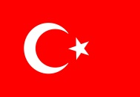
Kocaeli Körfez Mesleki ve Teknik Anadolu Lisesi /TURKEY
Website: http://korfezeml.meb.k12.tr

Shooters hill Campus/UNITED KINGDAM
Website: http://www.shootershill.ac.uk

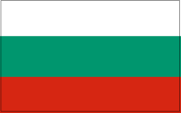
88 School "Dimiter Popnikolov" /BULGARIA
Website: www.88coy.dir.bg

Kaunas jėzuitų gimnazija / LITHUANIA
Website: www.kjg.lt

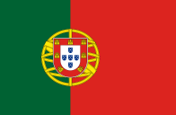
Escola Profissional Amar Terra Verde/PORTUGAL
Website: http://www.epatv.pt

Aluksne municipality`s secondary school /LATVIA
Website: www.anv.lv

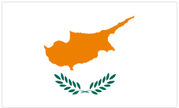
Likio And Techniki Scholi Poleos Chrysochous/ CYPRUS
Website: http://lyk-poli-chrysochous-paf.schools.ac.cy/index.php/el/

4th General Lyceum of Chania/GREECE
Website: http://4lyk-chanion.chan.sch.gr

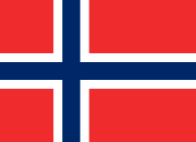
Kuben videregående skole /NORWAY
Website: www.kuben.vgs.no

Istituto Istruzione Secondaria Superiore E. Fermi /ITALY
Website: www.fermilecce.gov.it

Implementation
The problem of school dropout has become a serious problem in our country but also in many other European countries. The project partners came from different backgrounds and countries with different school dropout rates. This fact allowed the partner schools to have a holistic approach to the drop out problem and draw conclusions that were based on data gathered from more than one country. It is possible to find some studies, and local projects about school dropout. These studies were mostly based on data that has been collected on a national level, disregarding the EU wide repercussions of school dropout. Thanks to the project studies, project partners found an opportunity to work on the school dropout issue from a different, wider perspective.
All partners supported and systematically promoted all project activities over the internet and through more than one type of digital means (e.g. websites, social media etc.). Moreover, it is certain, thanks to these digital media, that this nonstop, three year long-distance cooperation between the ten partners will continue even after the project’s finished.
CREATING PROJECT TEAM AND TOOLS

Firstly, a project team, Erasmus corner and project study room was created. Students were invited to the project social networks. As a first step, Project partners organized a competition for the project logo and short film activities which were initially shared through our digital groups and then during the short term mobilities were presented and put through a selection procedure among students and participating teachers. Each partner school students created logos for the project. They showed their creatvity in this activity. A lot of logo was created by the students. After online voting on project facebook group Lithuanian Student’s logo was choosen as a project logo. To see other logos, please visit our website.

Activity Target Group
All the partner schools’; students and school staff
Activity Object
Increase awareness about the project
Better communication and teamwork skills.
Activity Expected results
Disseminate project activities/good examples and results
Increase the collaboration between all the stakeholders ın the project
Increase students and school staff awareness about the project

Students from each partner countries, prepared short films about school dropout. The Italian film was chosen as a best short film by students' vote in the Learning Teaching Training activity in Italy.
Short films’ links
https://youtu.be/cHaQSDaU6mk ITALY
https://youtu.be/msKiszWcC8I TURKEY
https://youtu.be/zCtu67cjefA BULGARIA
https://youtu.be/8gMihTocVmM GREECE
https://youtu.be/4dYkvGlbsZQ LATVIA
https://www.youtube.com/watch?v=qFjvUP2_OA8 LITHUANIA
https://youtu.be/7vustAUY2vw PORTUGAL
https://www.youtube.com/watch?v=He4lbp3lPOI CYPRUS
https://www.youtube.com/watch?v=DMHp6__RBEo&feature=youtu.be NORWAY
https://www.youtube.com/watch?v=Bkcnj1RJBzQ&feature=youtu.be UK
www.oneistoomany.net
CAREER ACTIVITY

What is career?
Career as vocation: a viewpoint accepting the traditional psychological position on stability of personality in adulthood; associated theory is intended to help guide individuals and organizations fill job openings in a mutually satisfactory way (Holland, 1985).

Why this activity?
This activity was one of the good parts of our first year in this Project. The aim is giving students a focus on their career path opportunities and motivating them to continue further education, Also we aim at increasing learning skills, diminishing learning difficulties and better school performance. The seminars and workshops are led by professionals, counsellors, graduate students, and visits to further education institutions of the area.

Activity Target Group
High risk level students

Activity Object
- Giving students a focus on their career path opportunities at an early
- Stage, motivating them to continue further education,.

Activity Expected results
- Increase in learning skills
- Diminished learning difficulties
- Better school performance

SEMINARS AND WORKSHOPS FOR ALL STAKEHOLDERS
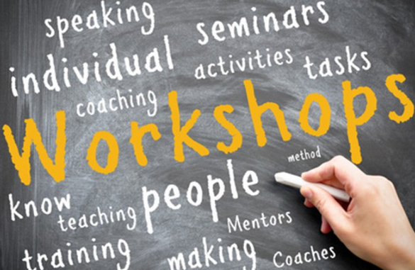
All partners arranged various seminars and workshops by professionals, counselors. These seminars and workshops are as follows.
*Seminars to teachers to deal with drop out problems
*Seminars to students about effective study methods.
*Practical students' activities with implementing results of effective study methods.
*Workshops with students and with their families.

Activity Target Group
High-risk level students, teachers, parents

Activity Object
- Better school performance.
- Increase parents’ awareness about their students' education and the importance of their support.
- Increase teachers’ skills about dealing with students under the risk of drop out
Activity Expected results
Students are supported in their pursuit to gain or to improve a secondary education degree.
More effective learning environment
Cooperative school atmosphere
AFTER SCHOOL ACTIVITIES WITH FAMILY
Students with parents who are involved in their school tend to have fewer behavioral problems and better academic performance, and are more likely to complete high school than students whose parents are not involved in their school. Positive effects of parental involvement have been demonstrated at both the elementary and secondary levels across several studies, with the largest effects often occurring at the elementary level. A recent meta-analysis showed that parental involvement in school life was more strongly associated with high academic performance for middle schoolers than helping with homework. Research shows that students perform better in school if their fathers as well as their mothers are involved, regardless of whether the father lives with the student or not. In the view of such information, after school activities with family have been carried out by partner countries.

The aim of these activities is to prevent drop-out and promote participation of disadvantaged groups in society. We’d like to increase student’s motivation and create co-operative school atmosphere. Each partner school organizes different after school activities for the students.

Activity Target Group
All the risk group students

Activity Object
- To prevent drop-out and promote participation of disadvantaged groups in society
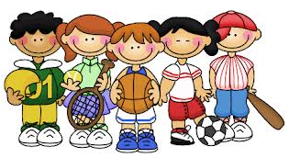
- Increase students motivation.

Activity Expected results
Cooperative school atmosphere

SPORT ACTIVITIES
Sport is thought to be one of the ways of creating an equal environment and a way of preventing the dropping out of those students. That is why sports activity was planned.
The aim of the activities is to create cooperative school atmosphere and increase student’s motivation to attend the school.
Students, especially risk students, feel they belong to school. The sports events improve communication and increase team spirit. Sport is thought to be one of the ways of creating an equal environment and a way of preventing the dropping out of those students. Each school organizes tournaments for the risk group students

Activity Target Group
All the risk group students

Activity Object
Cooperative school atmosphere
Increase students’ motivation to attend the school.

Activity Expected results
Students will feel they belong to school
Better communication and increased team spirit.

There were three short term students’ mobilities, one in the middle of each project year. Before these mobilities the students were asked to participate in certain activities which were designed to be performed in the mobilities.

A CREATIVE WORK IN ITALY
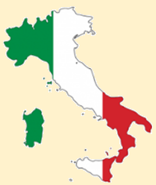
The first short term exchange of groups of pupils was realized in Italy from 22nd to 27th March 2015. Students created posters which are represent the project by this activity. In addition, the best short film about school drop outs created by each partner was chosen in Italy.
It was thought that it is very important for the project to leave an impression on students because it was the first students’ activity abroad. At the end of the activity the results were great.
Preparatory Phase:
After the approval of the project, the works began intensively. Each country first formed an Erasmus corner. Workshops and project announcements were communicated to all students through these Erasmus corners.
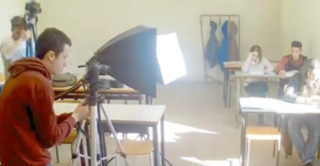
After the identification of the risk group students determined by the questionnaires applied in each school, they were encouraged to participate in project works as well. The short film competition was announced in The Erasmus corners and students started to work. The students made a short film based on the life of a drop-out student. They directed, wrote scripts and perform in it themselves.
After montage and subtitling works on films, all short films were published on YouTube and e-twinning project page. This activity motivated students to attend school and to reach higher results.
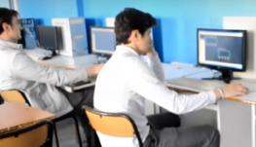
Those who improved their academic performance and attendance were chosen to participate in the short-term exchange of groups of pupils in Italy. Partner schools facilitated students with disadvantaged backgrounds and fewer opportunities.

Working Session in Italy
The activity was held at Istituto di Istruzione Secondaria Superiore “E. Fermi” in Lecce, Italy.
77 students from 10 countries participated in the Learning teaching and training activity in Italy. Participants and countries are as follows.
Countries | Number of Teachers | Number of Students
Greece | 2 | 5
Turkey | 3 | 4
Latvia | 1 | 3
Lithuania | 1 | 3
Cyprus | 1 | 3
Portugal | 2 | 3
UK | 2 | 3
Bulgaria | 2 | 4
Norway | 2 | 4
Italy* | 10 | 45
Total | 24 | 77
*Host country
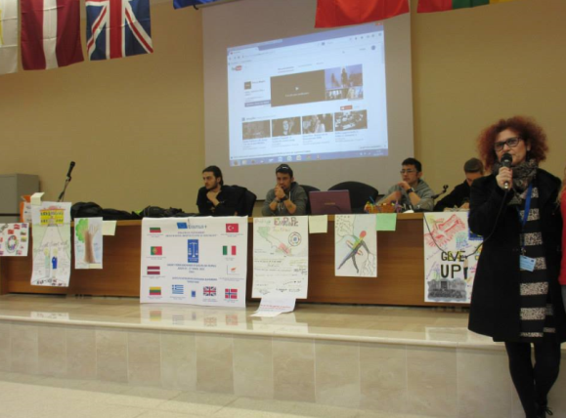
The activity started with the opening ceremony on the first day. Students showed short presentations about their cities and their schools. After the visit of the host school the students presented their own school experience within the discussion:
“Being a student in my school “ to introduce the 10 short films about drop outs, which was prepared by each country. Then the students voted for the best short film. In this selection, Italian students’ short film was chosen as the best film.
NOTHING IS ORIGINAL: CREATIVITY IS ALL ABOUT MAKING CONNECTIONS

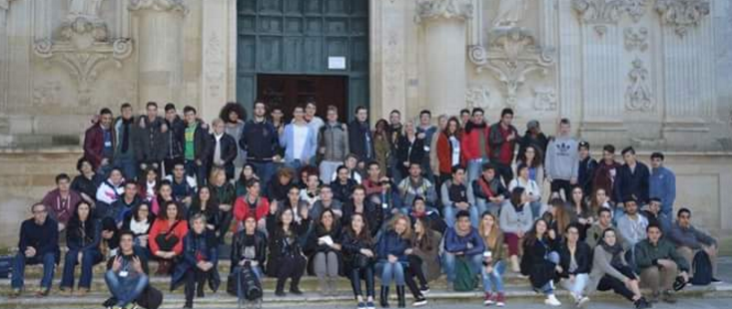

As a second step, students were involved in a workshop to create the poster of the project representing the drop outs’ problem. The activity was designed to make the students express their creative thoughts and express themselves with the creative intelligence.
Modern life, surrounded by developing science and technology, requires using people’s creative thinking skills. By this activity, students can develop their creative thinking and demonstrate that they will be able to put out beautiful things when they actually get the opportunity.
As it is known, creative environments allow the development of creative abilities. For this reason, this activity was designed to improve the creativity of the students in a positive way.
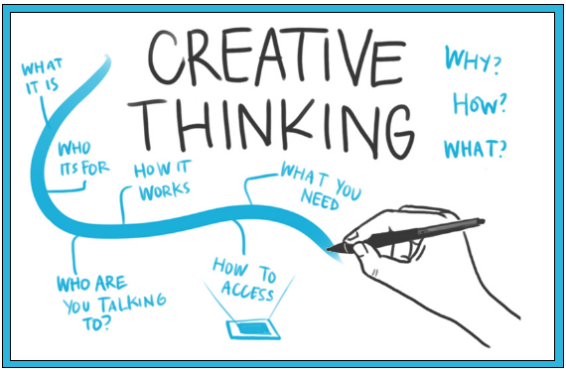
Besides, this activity also aimed to increase their motivation with team work. Teamwork in the activity offered the students the possibility to become more familiar with each other and learn how to work together.
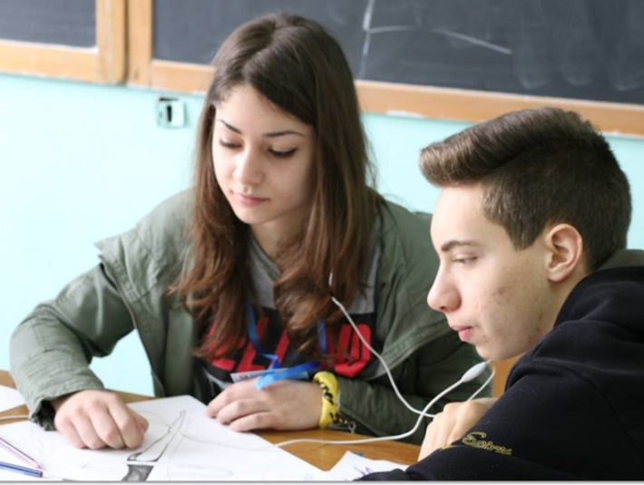
During the activity, all students worked in 6 international teams. These teams, coming from different cultures, collaborated on creating posters representing the project. They were also asked to prepare a short presentation about their poster to promote communication among students from different countries, the level of their communication skills in English, the exchange the ideas and above all, feeling of mutual respect, self-esteem, and self-confidence. At the end of the activity, six different posters were designed as results of international creativity.
A democratic election was held to determine the best poster.
Evaluation of the Activity
In many countries, cultural norms differ greatly, so it follows that we might see an increase in creativity by travelling abroad and meeting different culture. Moreover students involved in mobility realized they are the same all around Europe, with the same problems and difficulties
An evaluation questionnaire of the short-term students’ mobility in Italy was applied to the participants on the last day of the meeting. The results are the following:
- 98% liked very much being involved in this project
- 97% answered that Facebook is the communication tool useful to the project
- 100% of participants answered that working in a team with students from different countries was good to feel more involved in the project
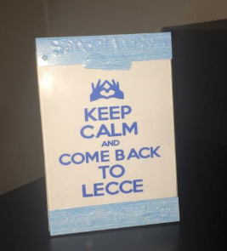
- 98% of participants knew a little about the countries involved in this project
- 60 % of participants knew enough about Italy before their arrival in Lecce
- 100% of participants knew much more about Italian culture after their short stay in Lecce.
- 98% of participants Accommodation in families/hotel excellent
- 98% of participants considered Meals: excellent
- 100% of participants considered Italian students’ welcome excellent
- 95% of participants considered Cultural programme excellent
- 93% of participants considered Social programme good
- 98% of participants considered Project activities excellent
- 82% of participants considered Prizes good
- 98% took advantage of your accommodation in Italian families.
- 98% of participants thought that workshop for the creation of the poster gave good results.
- 100% of participants felt they were democratically involved in the voting of posters and short film competitions
Local Media reported the news about the Erasmus plus project and the participation of students and teachers from 10 European countries in the meeting held in Lecce
http://www.salentoweb.tv/…/erasmus-plus-istituto-e-fermi-le…
http://www.lecceprima.it/eventi/progetto-scuola-fermi-lecce-23-marzo-2015.html

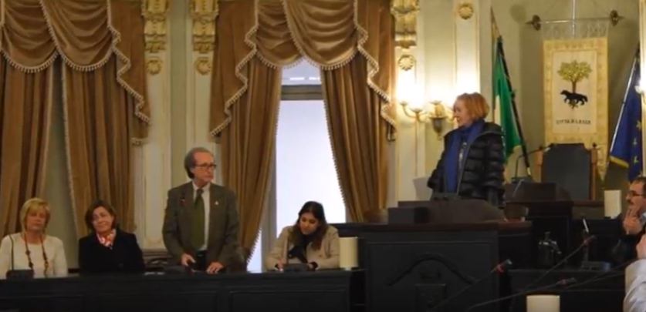
Meeting with the Vice-Mayor of Lecce

During the short-term students’ mobility, the Vice Mayor of Lecce, Mrs Carmen Tessitore, welcomed the delegation of Erasmus plus teachers and students into the Council Room of the City Hall.
She underlined how such a partnership, made of 10 different European countries, and the cultural exchanges of students, with exposure of one’s culture to another, help create the Europe of the future. She asserted our project was an excellent example of how investing in culture and education can form European identity. She expressed her joy in meeting a great number of students coming from so many different countries because students represent the future and the hope of a better world. She declared the importance of the topic of our project and affirmed that the School and all the local, regional and national authorities must contribute to prevent the early school leaving of students because even one drop out represents a failure of society. She appreciated the value of our project and encouraged both teachers and students to continue investigating the topic thoroughly.
Then she focused on the city of Lecce considered “gateway to Europe”, a city open to any kind of culture and religion and to welcome immigrants and refugees. She also mentioned the art of the city, the baroque, the numerous churches and the natural beauties of the Salento area. She sang the praises of the worldwide famous tenor Tito Schipa, source of pride for the city of Lecce.
She closed the meeting reaffirming the importance of education and the fundamental role of the English language in today society. She took her leave and told thank you to all the students and teachers.
POSTER OF THE PROJECT
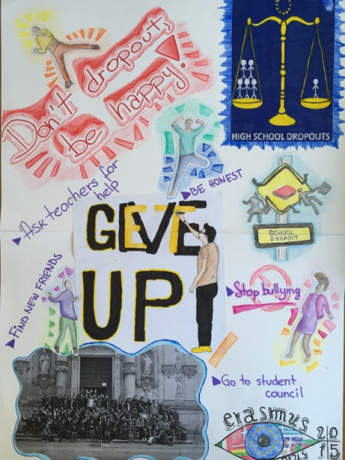

This poster was chosen as the poster of the project by the participants.

European Parliament Activity in Portugal
In this activity, a total of 48 students from 10 different countries came together to discuss school drop-out problems. Students who discussed the reasons for school drop-out and the precautions to be taken have made important decisions.
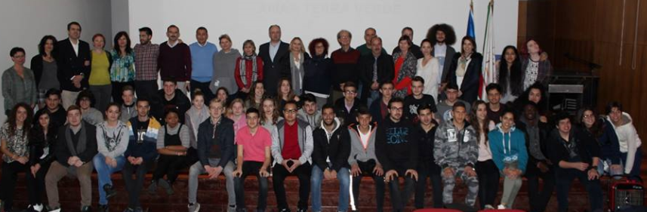
Preparatory Phase: Before the activity to be realized at short-term exchanges of groups of pupils, each country carried out a number of preparatory work within itself. First, a brief presentation was made to the students to introduce Erasmus projects. Information about the content, methodology and purpose of the work to be done had been shared.
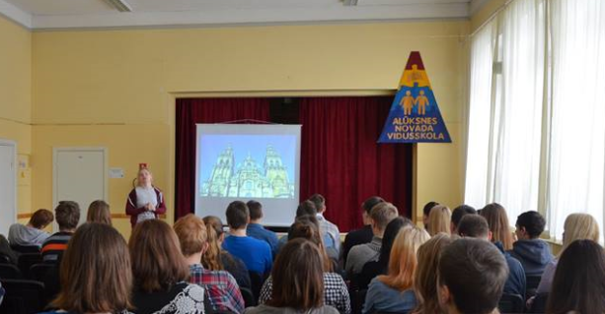
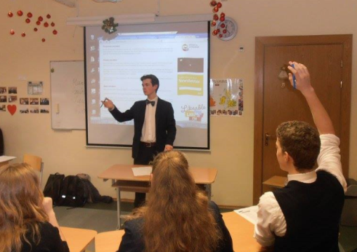
Within the scope of the activity, each country first formed its own student parliament and discussed educational problems, reasons for schooling, measures to be taken to create a better schooling environment and to prevent students from dropping out of school. Their friends, who were elected by voting, were responsible for the management of this session. Especially risk groups students were allowed to participate in this work. These students, who expressed their ideas to prevent school drop-out and sought solutions to educational problems from their own perspectives, were actually able to express their own problems. The 3 students who were active in the study and selected from the students in the risk group were offered the opportunity to transfer their education problems to the European Parliament simulation in Portugal.
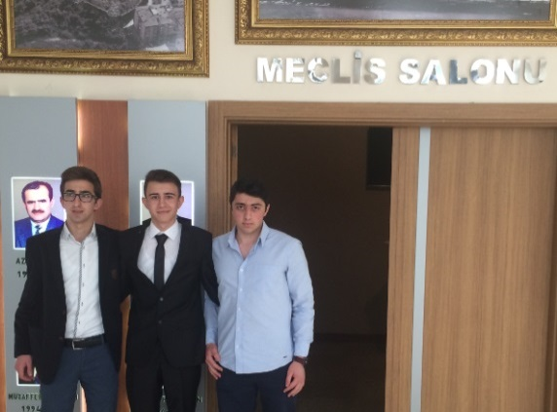
Selected students have been given foreign language preparation and cultural preparatory training. Moreover, these students, who had never seen parliamentary work before, were allowed to monitor the work of the municipal councils in local governments in order to be informed about how the parliamentary work was done.
European Parliament Works:
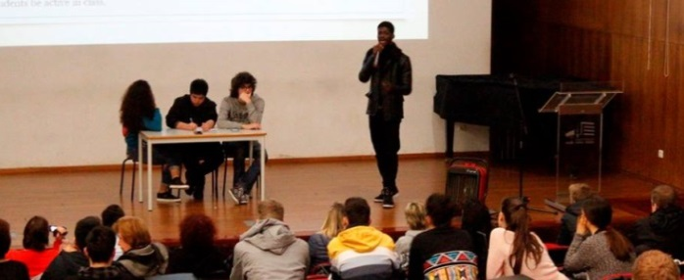
The event was held at 'Escola Profissional Amar Terra Verde' in Vila Verde, Portugal from 29 February to 4 March 2016. An example from Euroscola was taken in the planning of the activity.
48 students from 10 countries participated in the activity. Participants and countries are as follows.
Countries | Accompanying persons | Number of Participants
Greece | 2 | 8
Turkey | 2 | 3
Latvia | 2 | 3
Lithuania | 2 | 3
Cyprus | 2 | 3
Portugal | 3 | 15*
UK | 2 | 4
Bulgaria | 2 | 3
Italy | 2 | 3
Norway | 2 | 3
Total | 21 | 48
*Host Country
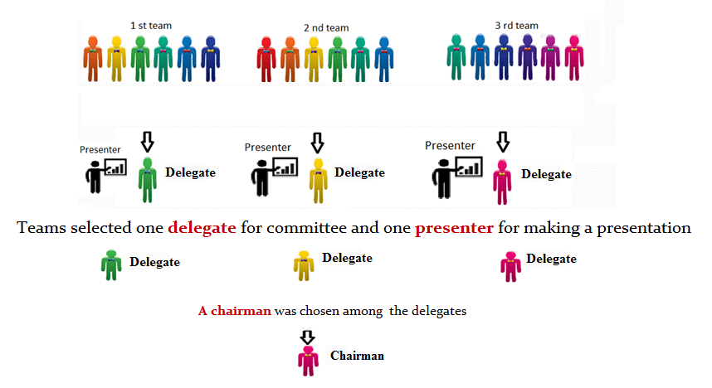
On the first day, the students who came together visited the school and the environment and got to know each other. Then, 3 different student groups were formed, with students coming from the same country in different groups. Students intensively discussed educational problems, school dropout reasons and the precautions to be taken. Students have turned their ideas into a presentation. Each group has selected a spokesperson to present their ideas among themselves and a delegate to manage the session. In total, 3 delegates selected a president among themselves. Thus, they conducted the session management with their chosen representatives.
Students' Determinations:
The students working in three groups shared the problems they identified and suggestions for solutions with other groups by transforming them into presentation under general headings.
Groups were briefly concerned with the educational problems of each country and then offered general solution proposals.
There are many factors that put a student at risk to dropping out of school. Many times not all risk factors apply to all students. Students choose to leave high school for a variety of reasons, but the decision to do so has serious long-term consequences. Here is the groups offers;
- All of the students combined have over 25% of the students drop out due to loss of motivation, no equipment, bad teaching skills from the teachers and not engaging lessons.
- Schools must carefully monitor attendance and notify parents immediately if students are missing school are missing school on a regular basis. Aggressive persistence, teacher support and engaging parents could be the key to making sure students show up for school and stay there.
- High schools need to seek a variety of activities to help engage all students. In addition, schools, teachers and administrators need to seek to create a community atmosphere to help students feel as if they belong. Parents can help by encouraging students to get involved in activities and develop talents and outside interests besides academics.
- While dropping out of high school may seem like the only choice for struggling students, many excellent options are available. Many factors that cause students to drop out of high school are preventable or manageable if administrators, teachers and parents work together to provide early intervention and support. The effects of dropping out are felt for a lifetime, both financially and emotionally. The decision to stay in school can be difficult, but is well worth it.
- Students learn in very different ways meaning that there should be a variety of methods in which each student can feel like their leaning needs are being met.
- Work experience should be put in every learning curriculum throughout the globe so that each student can have an experience of what it is like to work in their chosen field.
- For those who choose to drop out or not attend school, the parents of that particular child should pay a fine, because they are allowing their child to miss out on an opportunity to learn new things and meet new people.
- In some countries in Europe like England and Latvia, parental irresponsibility is a major issue that poses a threat to the academic growth of young students. Parents fail to oversee their child´s education causing the child to also not care.
- Dropping out of school is a process, and does not occur overnight. The process often starts prior to a child entering into the school system. Poor academic achievement as early as elementary school is a predicator of dropping out of school
- The government can impose and enforce a law where every parent is required to attend an individual parent meeting so that they can discuss the education of their child with teachers and tutors.
- In conclusion we have learnt that each country has at LEAST one issue which can cause an effect later on in their lives and may not allow them to have a good job or earn good money.
- This can also lead to a cycle where their children, if they choose to have any, may all so have this attitude towards education and may end up as drop outs, for drop outs have a big import within today’s society.
- Facilities like libraries and computer should not have a time restriction so that students can visit these facilities whenever they have free time
- A law could be implemented and enforced where teachers have to attend training or seminars on how to build a good teacher and student relation ship
- In the same way, students could be made to attend seminars on how to build a good relationship with their teachers.
- Struggling in school on a daily basis is the biggest reason most students choose to drop out of high school. When a student is held back due to low grades, it puts him at higher risk of dropping out.
- Poor academic performance is generally linked to drop-out rates. Students who have to repeat specific classes also face higher drop-out risks.

Meeting with a Member of the European Parliament Euro Deputy José Manuel Fernandes
School drop outs problem is growing increasingly and being a common problem of many countries. It is undoubtedly not wise to expect schools to solve this problem alone. Everyone from the local authority and politicians taking an active role to the solving this problem could be an important step. Therefore, meetings have been held with politicians and the local governments in order to inform them about the existence and the magnitude of the drop out problem.
In these meetings, following the general information on the scope of the Erasmus projects, they have been informed about the project goals, expectations and achievements. They also informed the project team about their working on educational issue.
Meeting with Mayor of Vila Verde
António Vilela (http://www.cm-vilaverde.pt/) is Vila Verde’s Mayor since 2009 and received the project’s group at the town hall, welcoming everyone to the town and wishing the works produce the desired results.

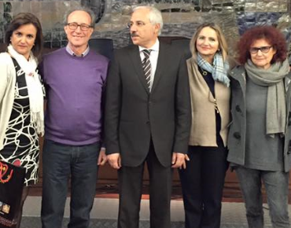

The municipal government who are closely interested with the students group have listened also gave information about the work they have done for education.
Evaluation of Activity
Students' opinions were consulted to determine the success of the European Parliament activity carried out as a learning teaching training activity. For this, a survey was conducted with 38 students participating in the European Parliament activity. According to the findings obtained from the questionnaires;

- 97% of the participants in the activity are generally very satisfied with the host country's hospitality.
- 92% of the participants in the activity are very satisfied with the food provided by the host country for the students.
- 96% of the participants in the activity are very satisfied with the cultural tour that the host country provides for the students.
- 96.7% of the participants in the activity are very satisfied with the accommodation provided by the host country for the students.
- They were pleased that 87% of the participants were able to discuss educational issues on the international platform.
- 81% of participants stated that they can express their opinions about education problems.
- 93% of the participants stated that thanks to this activity, they are also acquainted with the educational problems of other countries.
- 73% of participants indicated that language skills have improved with this activity.
- 68% of the participants stated that this activity was the first overseas experience; therefore they will never forget it.
Survey findings indicate that participants are satisfied with the activity in general. In other words, the survey results show that the activity is successful.
Educational problems identified by students are published on the project facebook page, e-twinning platform and project web page. It is hoped that this work, which is included in the project catalog, constitutes an example for similar works, is a source.
At least one person among students participating in the activity from each country is required to voluntarily write an essay. The essays about the students' feelings are engraved on the facebook page. The essay written by a student who came from Italy as a participant became the most admired essay. These essays are also included in dissemination tools.

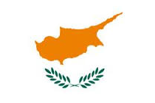
ART WORK AND CITIZENSHIP IN CYPRUS
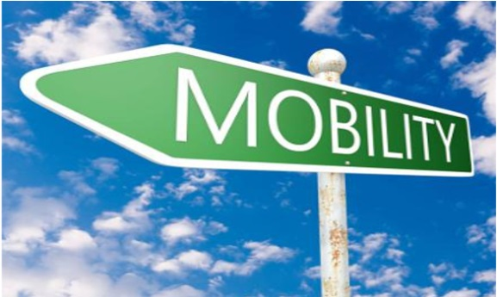
The basic aim of the education is to give the students the qualities of being an individual and to prepare these individuals for their life. In our day, educational environments which is do not go beyond a certain curriculum have been become controversial situation. Our world needs generation who is researching, querying, thinking and producing and this situation has made the emergence of new educational concepts as a compulsory.
In order to bring all these positive qualities to our children, it is important for the family and teachers to bring them together with art, sports and music in social life as well as social activities in school.
It is an important step to reach the knowledge and to use social activities in the educational process frequently so that the acquired knowledge can be transformed into a skill and used in daily life.
Through social activities, students are able to acquire qualifications beyond their achievements in curriculum development and skills development.
In our project, social activities are seen as an important step in preventing school dropout. For this reason various social activities are planned. One of the social activities was arts workshops. The Citizenship and arts workshops activity was held in Cyprus with the participation of 32 students from ten countries and took place at the Lyceum and Technical School of Polis Chrysochous.
The concept was intended to allow students to express their interpretation of ‘dropping-out’ of education. Each country then portrayed their own perception of the concept through their photographic displays.
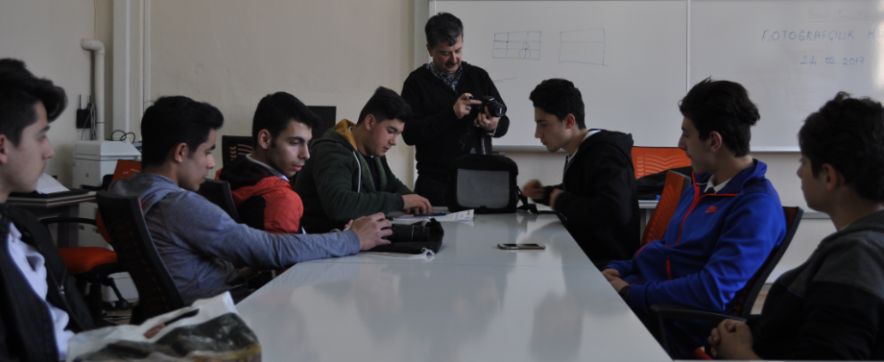
Preparatory Phase
Particularly attention has been given to the participation of students who are under risk groups for this activity.
Some schools do not have adequate facilities for activities and for the success of the activity, photography education was given to the students.

Working Session in Cyprus
The activity was held at Lyceum and Technical School of Polis Chrysochous. 32 students from 10 countries participated in the Learning teaching and training activity in Polis Chrysochous / Cyprus. Participants and countries are as follows.
Countries | Number of Teachers | Number of Students
Greece | 2 | 3
Turkey | 2 | 3
Latvia | 1 | 4
Lithuania | 1 | 3
Cyprus* | 3 | 3
Portugal | 1 | 3
UK | 2 | 4
Bulgaria | 2 | 3
Norway | 2 | 3
Italy | 3 | 3
Total | 24 | 32
*Host country
Students presented their creative process and ideas on videos and curated their own photographic display. Students voted for the best photo from each country and then the best overall photo of the day. There was a committee who administered the voting and prizes were awarded at the end. All photographs were shared amongst the contributing teams – some taking the exhibition back as a display to their home country.
Evaluation of the Activity
After all countries turned back into their country surveys had been conducted to students in order to evaluate the mobility. The results are the following:
- 100% liked very much being involved in this project
- 100% of participants answered that working in a team with students from different countries was good to feel more involved in the project
- 98% of participants knew a little about the countries involved in this project
- 60 % of participants knew enough about Cyprus before their arrival in Lecce
- 81% of participants Accommodation in hotel good.
- 83% of participants considered Meals: excellent
- 96% of participants considered Cultural programme excellent
- 93% of participants considered Social programme good
- 98% of participants considered Project activities excellent
- 82% of participants considered Prizes good.
- 98% of participants thought that sport activities were good.
- 100% of participants felt they were democratically involved in the voting of the best photos
Best Photo of the Project from England
To see other photos please visit our website….
www.oneistoomany.net
Also, do not forget to visit our project in e-Twinning platform
&

https://live.etwinning.net/projects/project/111598

SCHOOL DROPOUT PREVENTION GUIDELINES

End of this three years project we have reached some consequences that may help prevention of school dropouts. This guideline was prepared from activities' results that obtained during the project period.

In the light of the project activities' results;

During the project students’ absenteeism and academic achievement were pursued by their teachers. It was like an early warning system for risk group students. For prevention of dropout, systems should be established for monitoring regularly the risk group students.

Project activities were based on students’ team-work. All activities completed with the cooperation of students. It understood that for students to achieve a comprehensive, well-rounded education, integrated teamwork on several fronts is vital. Teamwork is necessary between students, between students and teachers, and among parents and educators. The more teamwork fundamentals exhibited, the more opportunity exists for students to learn the vital skills of compromise and collaboration. Students' teamwork in schools will increase their commitment to the school.

We organized after school activity with family. It was observed that the parents were very satisfied with their participation in school activities. Parents play a vital role in a student’s education. When teachers and parents act as a team, it can reinforce positive behaviors and learning skills developed in the classroom and practiced at home. When students see educators and parental figures working together, they learn to value education and get academic and behavioral support both inside and outside the classroom. Parent-teacher teams that communicate well can share information about the student and help devise ways to individualize learning approaches to best meet the student’s needs.

In the last year of the project, various sport activities were arranged by the partners. Students who participated in the sport activities were found to be quite happy. The importance of sport activities in school encompasses more than just the benefit of physical activity. Increases in self-esteem and mental alertness make school sports necessary for all students. It is thought that sport activities may prevent school dropout.

Career planning organisations were organized as project activity by all partners. This activity was one of the good parts of project. The aim is giving students a focus on their career path opportunities and motivating them to continue further education, Also we aim at increasing learning skills, diminishing learning difficulties and better school performance. The seminars and workshops are led by professionals, counsellors, graduate students, and visits to further education institutions of the area. The process of career planning helps the students to have the knowledge of various career opportunities and help to look forward to the future with hope.

