KA2 – Cooperation and Innovation for Good Practices

STRATEGIC SCHOOL PARTNERSHIP PROJECT
HIGH SCHOOL DROP OUTS: “One is too many”
Evaluation of Sport Activity 7 / LITHUANIA

The aim of Sport Activity was to foster team spirit, responsibility and the sense of belonging to the school community.
In January 2017 with the help of physical education teachers we organized a sports week for students of 6-8 grades. 30 students participated in the activity.The students had an opportunity to compete in such games as basketball, indoor football, table tennis, chess. One of our tasks was to involve students with behavioral problems they could demonstrate their abilities and express themselves in the field of sport.
All information about the activities was available in our Erasmus Wall.

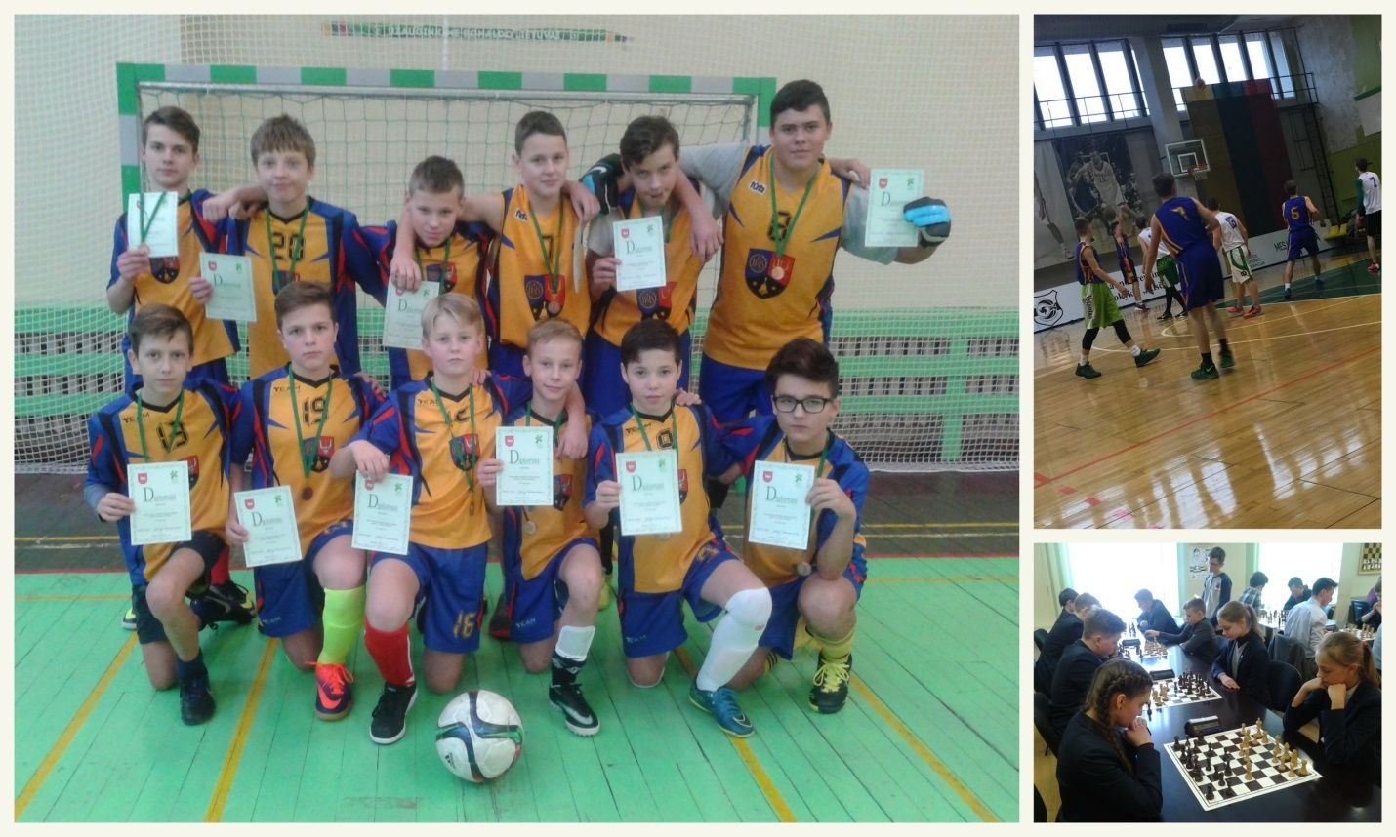 Loreta Čižinauskienė
Teacher Project Coordinator
In Lithuania

