- Questionnaire results–
We applied a small questionnaire aiming to assess the effectiveness of the activities, which description follows in point 2. Therefore, of the 213 students that answered the questionnaire. From these 79% opined that this activities had an positive effect on them, 85% that they increased their knowledge on career awareness, 77% have shown interest in increasing their knowledge in this matter, 81% answered that these activities will help them finding a job after graduating

- Activities applied during the year and their result –

  - Activity C1 – at the beginning of each school term (excepting the first) and at the end of the last, students’ educative in charge and the students receive their grades by the class tutor hand. At this moment the Tutor has the grade goal already established during the teachers’ evaluation meeting held at the previous term end. During the last second term students were monitorized and selected according with their results and consequent goal attainment so that they can be present in Italy’s STSM meeting. Back at the school, the students spoke with their lower graded colleagues about their experience using an informal environment.

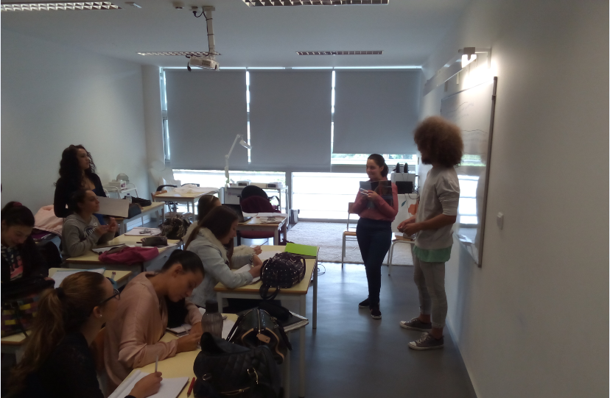
Figure 1 – Lecce mobility student passing his experience to his peers.

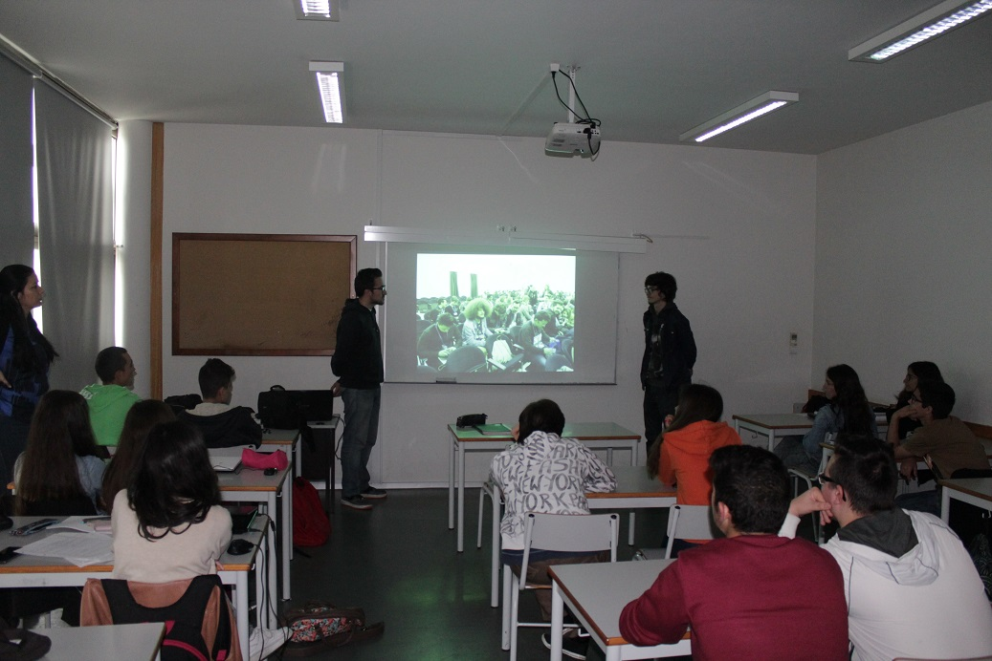
Figure 2 – Lecce remaining mobility students passing his experience to his peers.

Concerning the graduated students seminars, these went on trying to induce a comfortable informal environment, and the assisting students posed questions about the information passed on by the graduated student (Figure 3).

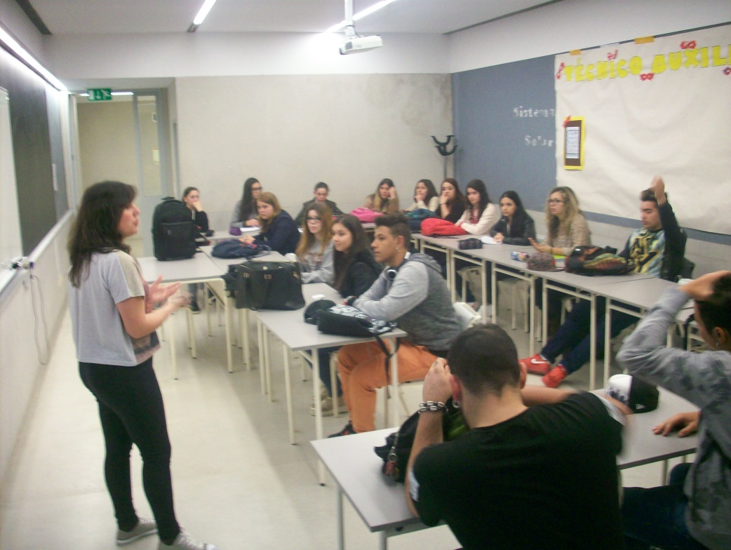
Figure 3 – Graduated ex-student of the school talks with the students about her personal experience.

Concerning the career seminar, a guidance counsellor was the lecturer and the theme was discussed and the career options were discussed concerning the several areas present. The technician was open to questions posed by students what allowed an interactive atmosphere that privileged the free ideas exchange and speaching, enabling the professional to dismount some preconceived ideas and motivate students to pursue studies aiming a career (Figure 4).

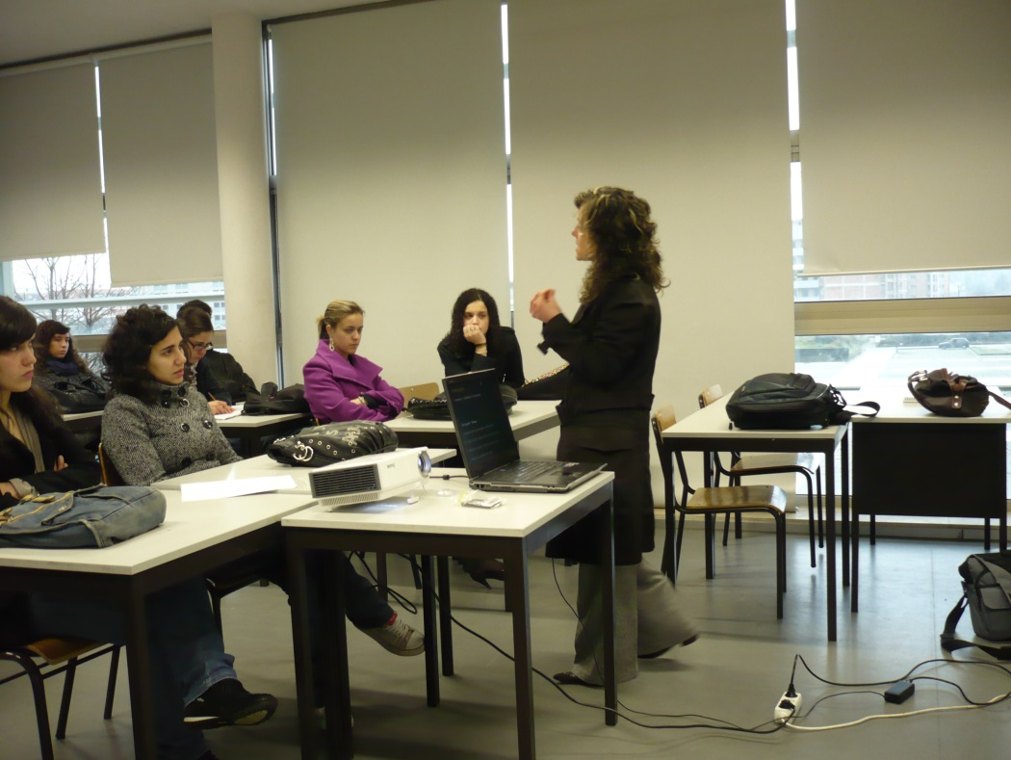
Figure 4 – Seminar with professional for classes wih dropout risk students.

Was organized, also, the career day, in which an workshop on career was the stepstone for a discussion on careers.
This event central piece was a professional of the motivation and guidance that showed the assistants how to face frustration and to be resilient but,also the career options they could consider in future. Together with this lecturer were three graduated students that gave their opinion on the career options they took and the value of the course diploma, in order to motivate the public.

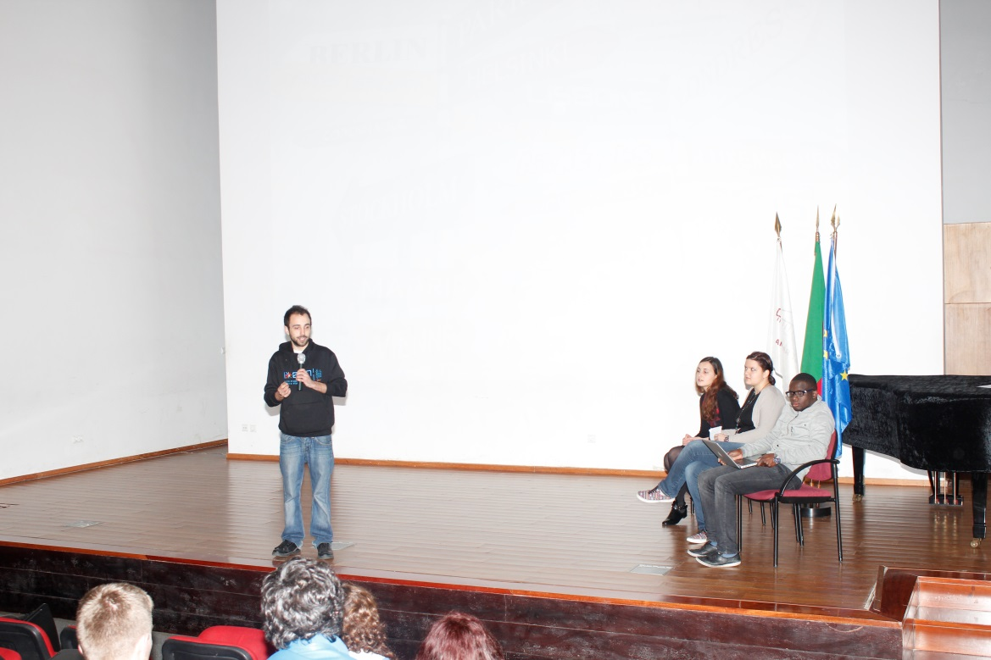
Figure 5 – Career Day workshop with a professional and of graduated students for an audience of dropout risk students.

  - Every year we organize several compulsory sessions of Teachers training regarding concrete themes with practical application at the school. This school year training plan we have already had several sessions, all can be looked as adapting to a strategic dropout combat, as follows:
    - “Ciga-nos na Educação Escolar de Minorias” – this session is part of a joint project developed to avoid dropout in minorities, mainly gypsies, giving teachers study cases to analyse, but also motivation tools and pedagogical strategies to motivate them to remain at school;
    - “Criatividade e inovação em sala de aula” – this session intended to develop innovation in classroom aiming to keep students interested and motivated;
    - “Organização pessoal e gestão do tempo” – this session aimed to improve skills in what concerns personal organizing and time management, what is a powerful tool to help students build consistent methods, so that they can aspire to better results at school.
    - “Liderança em sala” – the theme was about Leadership in classroom what can ensure a proper learning environment to students and enabling to conduct the lesson adequately.
    - “Comportamentos em situação de risco” – the theme was related with behavior in risk situations, what can be in sensu lato considered useful to our project’s theme.
    - Coaching – this theme intended to help teachers to assist their students’ pursue for the objectives.

