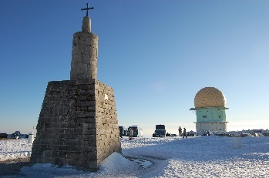
“Serra da Estrela”
The Serra da Estrela is the highest mountain range in the mainland Portugal and the “Torre” is the highest peak.
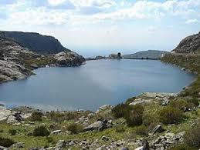
The “Parque Natural da Serra da Estrela” is rich in flora and fauna.
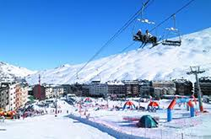
In the Serra da Estrela, there is a ski resort that offers tracks for all experience levels, from easy to difficult.
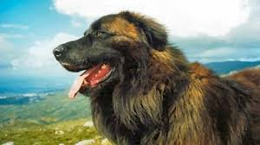
This region is well known by its local cheese and it is home to one of the oldest dog breeds in the Iberian Peninsula - the Cão da Serra da Estrela. This dog is a mountain dog traditionally used to help guard the sheep and other livestock, in addition to the farms and homes.

- How tall is the “Torre”? (1 point)
- The Serra da Estrela is the source of three rivers.
What are their names? (3 points)

- When is the ski resort open? (2 points)

- What kind of milk is used to make the local cheese? (1 point)

