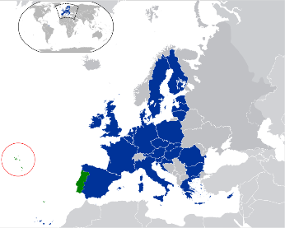
Azores archipelago - Portugal
The Archipelago of the Azores, along with the Madeira archipelago, is an autonomous region of Portugal and it is in the North Atlantic Ocean. It is a part of the Macronésia region, where Madeira, the Canary Islands, Cape Verde and the African Northwest are also included.
The Azores archipelago has got nine islands: Flores, Corvo, Graciosa, Terceira, São Jorge, Pico, Faial São Miguel and Santa Maria. They are all from volcanic origin and are divided into three groups.
- What are names of the island groups? (3 points)

- Which is the largest island? (1 point)

- What is the capital of this archipelago? (1 point)
- What can you eat that is slowly cooked inside the sand? (1 point)

