Madeira Archipelago - Portugal
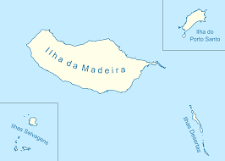
The Madeira Archipelago is situated in the Atlantic Ocean, 500 km distant from Africa, 1000 km from the mainland Portugal.
The Archipelago is constituted by two inhabited islands, Madeira and Porto Santo, and two subarchipelagos: Desertas and Selvagens.

The archipelago is famous for its very mild weather and luxuriant vegetation. Hence, Madeira is often known as “The Atlantic Pearl” or “Atlantic Garden”. Porto Santo or the “Golden island” is famous for its nice beach, in an arid landscape.
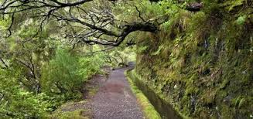
Madeira island is also famous for the natural patrimony, namely the Laurissilva Forest, classified by UNESCO as a World Natural Heritage Site.

- What is the main island of the archipelago? (1 point)

- What is the name of the capital of the archipelago? (1 point)

- Are the subarchipelagos inhabited? (1 point)

- When was the Laurissilva Forest classified as a World Natural Heritage Site? (1 point)

