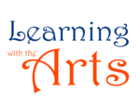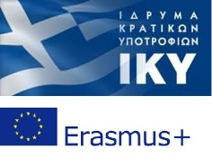
GUEST DAY
TITLE: LET’S TRAVEL AROUND GREECE
OBJECTIVE
To familiarize host students with the most important sights in Greece
PROCEDURE
The Greek teacher, assisted by her students, presents information about the most important sights in different prefectures of Greece, one by one.
Each sight:
- West-Ionian sea (Zakynthos- Caretta- Caretta),
- North- Macedonia (Vergina-Tomb of Phillip II-King of Macedonia),
- Central Greece (Thessalia- Meteora),
- Central Greece (Delphoi),
- East-Aegean sea (Santorini-volcanic eruption),
- South (Peloponnese-Ancient Olympia)
is presented through a power point, prepared back home by the Greek pupils who participate in the mobility. Initially some simple information is delivered followed by a short video, for better comprehension. After the presentation is over, recapitulation takes place to make sure pupils have fully realized the position and the importance of each sight.
Afterwards, the class, divided in groups, is provided with handmade Greek maps and a pack of cards depicting the pre-taught sights. They are challenged to place the sight on the correct area on the map. Greek pupils go around the class and help the students with their task.
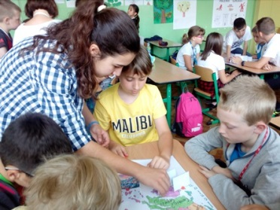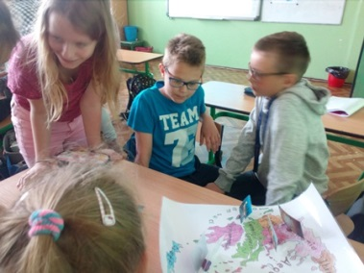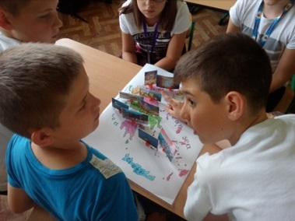
Guest pupils heling out host students
As soon as the activity is over, the steps of the Greek dance ‘Hasaposerviko’ is presented (https://www.youtube.com/watch?v=NTPbsGv2UDI). In the beginning, only those who are ‘brave enough’ dance along with the guest students! At the end of the lesson the whole class participates and the classroom turns into a dance stage!
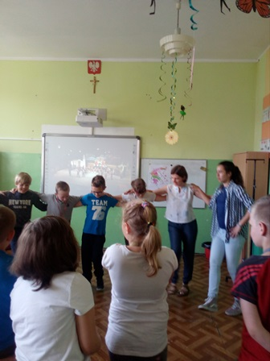
From our guest day in Poland

