The Group “IL VOLO”
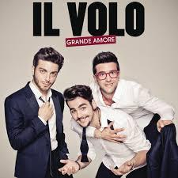

Piero Barone, Ignazio Boschetto and Gianluca Ginoble are the components of “IL VOLO”, a particular pop group..
The 2009 is the year of the debut at the talent show of RAI 1 "I leave you a song”, They are the first Italian artists in history to sign a contract with an American major in the world of discography. Their first album "Il Volo" gets the "Platinum Record" certification and enters the Billboard Top Ten.
The 2014 is another important year for Il Volo, awarded as best group of the year of Latin album at the Latin Billboard Awards in Miami. On December 21st of the same year the three young artists had the privilege of performing for an international charity concert, broadcast live on Rai 1.
In the following years ( 2016 and 2017) they are involved in the project "Notte Magica", a tribute to the event of the 1990 when the three Tenors, Josè Carreras, Placido Domingo and Luciano Pavarotti, have enchanted the whole world from the stage of the Baths of Caracalla. It was the beginning of an international success, debuted on March 4 at the Radio City Music Hall in New York, registering sold out. They performed 15 stages in the United States, all sold out.
For several years, the activity of these young artists is almost uninterrupted with a lots of projects and initiatives: they are committed as UNICEF ambassadors, they are always present in the field with the national team and they are the promoters of an initiative organized with Caritas.
There was a concert in Warsaw of this trio, on 06/26/17.
QUIZ:
- When and where did they start their activity? (2 POINTS)

- Why are they called “il volo”? (2 POINTS)
- In how many languages ​​have they sung? (1 POINT)

