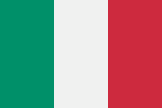 School website www.icbrigatasassari.gov.it

Our Institute is a Comprehensive School is located in a central district of Sassari, the second largest city in Sardinia.

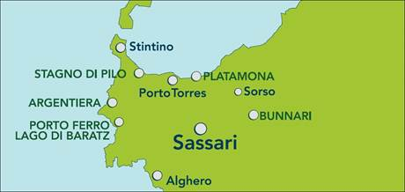

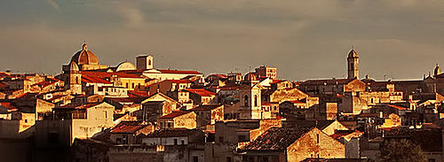

it is made up of 5 buildings on which three school systems are distributed:
- Nursery school (pupils aged 3-5)
- Primary School (pupils aged 6-10)
- Lower Secondary School (pupils aged 11-14)

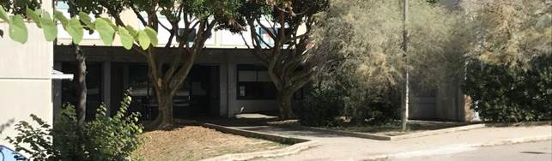

It has a school population of 1457 students and 180 teachers, about 20 of them providing additional support to students with special educational needs. The institute is also accredited to provide suitable educational paths to DSA students. Pupils attending Nursery and Primary School come from neighboring districts, while part of the students attending Lower Secondary School comes from other areas of the city and from the surrounding countryside, attracted also by the presence of a musical course.
The challenge of our Comprehensive School is to enhance the intelligences, skills, resources and experiences of our students and to identify educational strategies able to:
• prevent the phenomenon of early school leaving and demotivation by reinforcing the skills;
• promote active participation in social life;
• promote the knowledge of our culture and different cultures in order to prevent any form of racism, discrimination and exclusion;
• develop autonomy and responsibility;
• to teach a variety of subjects in order to understand different aspects of reality;
• support the pupil in his/her growth through a mutual collaboration with the families;
• create closer relations with local authorities, associations, voluntary organizations and cultural institutes;
• strengthen the spirit of European citizenship while enhancing the cultural heritage and the specific identity of belonging.
Our school promotes among the students the values of legality, tolerance and participation in democratic life basing its educational path on the principles of equality, impartiality, acceptance and integration.

