Our school is
Szkoła Podstawowa im. wł.Syrokomli w Michałowie.
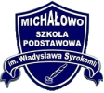
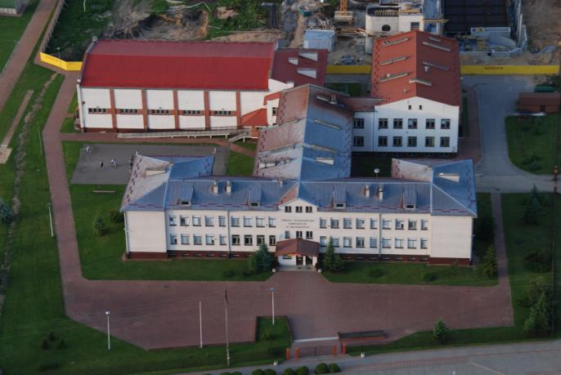
We live in podlaskie region. The capital of Poland is Warsaw. The capital of region is Białystok. Our town is Michałowo – 37 km from Białystok.
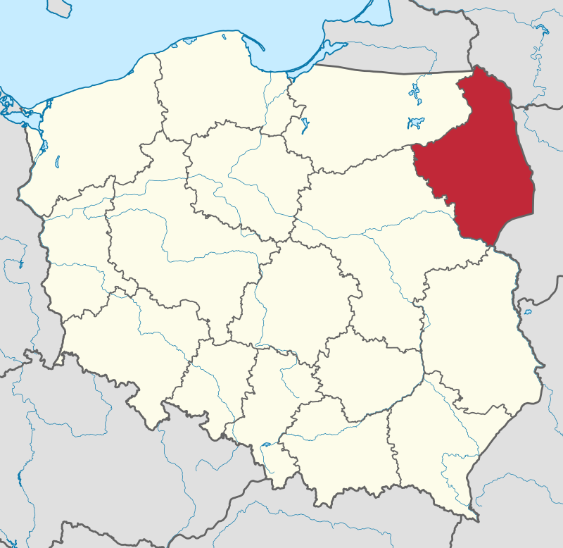
Podlaskie region.
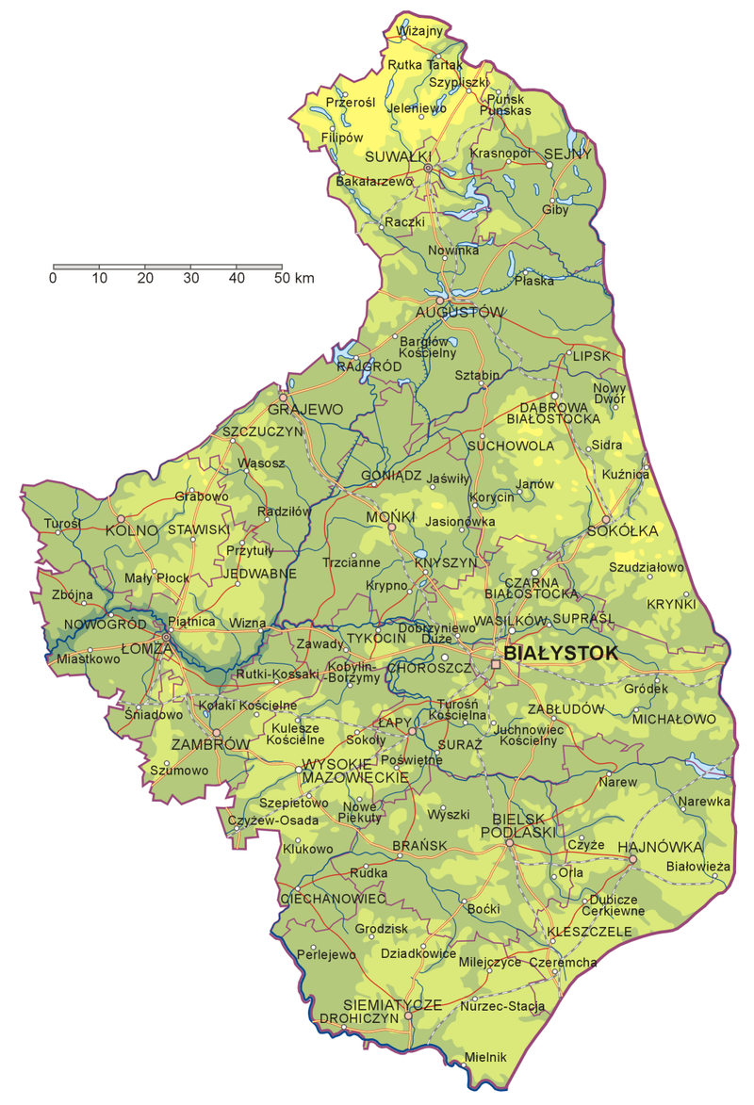

Our neighbours.
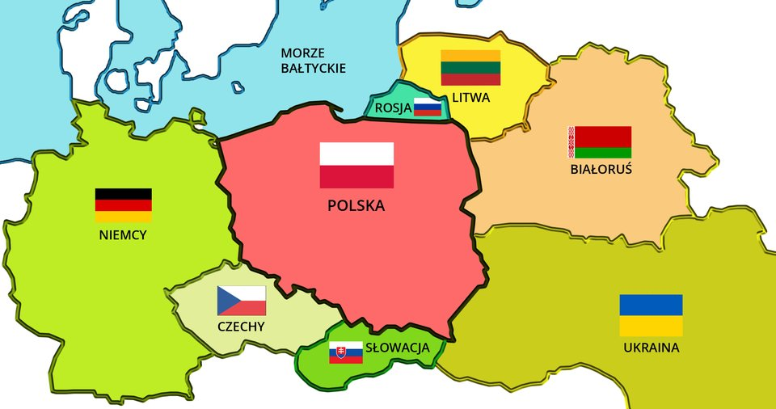
Taken from wikipedia.

