WHO WANTS TO BE A SCIENTIST  SCIENTIFIC OBJECTS  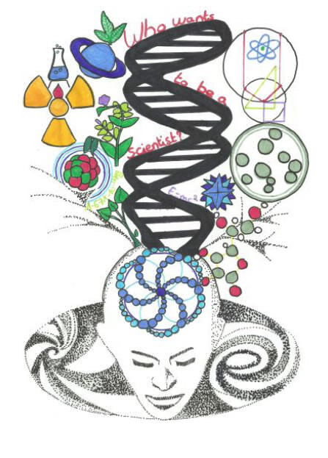 | WHO WANTS TO BE A SCIENTIST  SCIENTIFIC OBJECTS
WHO WANTS TO BE A SCIENTIST  SCIENTIFIC OBJECTS | WHO WANTS TO BE A SCIENTIST  SCIENTIFIC OBJECTS

SCIENTIFIC OBJECTS  DESCRIPTION  SOLUTION | SCIENTIFIC OBJECTS  DESCRIPTION  SOLUTION
SCIENTIFIC OBJECTS  DESCRIPTION  SOLUTION | SCIENTIFIC OBJECTS  DESCRIPTION  SOLUTION

WHO WANTS TO BE A SCIENTIST  SCIENTIFIC OBJECTS | WHO WANTS TO BE A SCIENTIST  SCIENTIFIC OBJECTS
WHO WANTS TO BE A SCIENTIST  SCIENTIFIC OBJECTS | WHO WANTS TO BE A SCIENTIST  SCIENTIFIC OBJECTS

SCIENTIFIC OBJECTS  DESCRIPTION  SOLUTION | SCIENTIFIC OBJECTS  DESCRIPTION  SOLUTION
SCIENTIFIC OBJECTS  DESCRIPTION  SOLUTION | SCIENTIFIC OBJECTS  DESCRIPTION  SOLUTION

WHO WANTS TO BE A SCIENTIST  SCIENTIFIC OBJECTS | WHO WANTS TO BE A SCIENTIST  SCIENTIFIC OBJECTS
WHO WANTS TO BE A SCIENTIST  SCIENTIFIC OBJECTS | WHO WANTS TO BE A SCIENTIST  SCIENTIFIC OBJECTS

SCIENTIFIC OBJECTS  DESCRIPTION  SOLUTION | SCIENTIFIC OBJECTS  DESCRIPTION  SOLUTION
SCIENTIFIC OBJECTS  DESCRIPTION  SOLUTION | SCIENTIFIC OBJECTS  DESCRIPTION  SOLUTION

WHO WANTS TO BE A SCIENTIST  SCIENTIFIC OBJECTS | WHO WANTS TO BE A SCIENTIST  SCIENTIFIC OBJECTS
WHO WANTS TO BE A SCIENTIST  SCIENTIFIC OBJECTS | WHO WANTS TO BE A SCIENTIST  SCIENTIFIC OBJECTS

SCIENTIFIC OBJECTS  DESCRIPTION  SOLUTION | SCIENTIFIC OBJECTS  DESCRIPTION  SOLUTION
SCIENTIFIC OBJECTS  DESCRIPTION  SOLUTION | SCIENTIFIC OBJECTS  DESCRIPTION  SOLUTION

WHO WANTS TO BE A SCIENTIST  SCIENTIFIC OBJECTS | WHO WANTS TO BE A SCIENTIST  SCIENTIFIC OBJECTS
WHO WANTS TO BE A SCIENTIST  SCIENTIFIC OBJECTS | WHO WANTS TO BE A SCIENTIST  SCIENTIFIC OBJECTS

SCIENTIFIC OBJECTS  DESCRIPTION  SOLUTION | SCIENTIFIC OBJECTS  DESCRIPTION  SOLUTION
SCIENTIFIC OBJECTS  DESCRIPTION  SOLUTION | SCIENTIFIC OBJECTS  DESCRIPTION  SOLUTION

WHO WANTS TO BE A SCIENTIST  SCIENTIFIC OBJECTS | WHO WANTS TO BE A SCIENTIST  SCIENTIFIC OBJECTS
WHO WANTS TO BE A SCIENTIST  SCIENTIFIC OBJECTS | WHO WANTS TO BE A SCIENTIST  SCIENTIFIC OBJECTS

SCIENTIFIC OBJECTS  DESCRIPTION  SOLUTION | SCIENTIFIC OBJECTS  DESCRIPTION  SOLUTION
SCIENTIFIC OBJECTS  DESCRIPTION  SOLUTION | SCIENTIFIC OBJECTS  DESCRIPTION  SOLUTION

WHO WANTS TO BE A SCIENTIST  SCIENTIFIC OBJECTS | WHO WANTS TO BE A SCIENTIST  SCIENTIFIC OBJECTS
WHO WANTS TO BE A SCIENTIST  SCIENTIFIC OBJECTS | WHO WANTS TO BE A SCIENTIST  SCIENTIFIC OBJECTS

SCIENTIFIC OBJECTS  DESCRIPTION  SOLUTION | SCIENTIFIC OBJECTS  DESCRIPTION  SOLUTION
SCIENTIFIC OBJECTS  DESCRIPTION  SOLUTION | SCIENTIFIC OBJECTS  DESCRIPTION  SOLUTION

WHO WANTS TO BE A SCIENTIST  SCIENTIFIC OBJECTS | WHO WANTS TO BE A SCIENTIST  SCIENTIFIC OBJECTS
WHO WANTS TO BE A SCIENTIST  SCIENTIFIC OBJECTS | WHO WANTS TO BE A SCIENTIST  SCIENTIFIC OBJECTS

SCIENTIFIC OBJECTS  DESCRIPTION  SOLUTION | SCIENTIFIC OBJECTS  DESCRIPTION  SOLUTION
SCIENTIFIC OBJECTS  DESCRIPTION  SOLUTION | SCIENTIFIC OBJECTS  DESCRIPTION  SOLUTION

V
WHO WANTS TO BE A SCIENTIST  SCIENTIFIC OBJECTS | WHO WANTS TO BE A SCIENTIST  SCIENTIFIC OBJECTS
WHO WANTS TO BE A SCIENTIST  SCIENTIFIC OBJECTS | WHO WANTS TO BE A SCIENTIST  SCIENTIFIC OBJECTS

SCIENTIFIC OBJECTS  DESCRIPTION  SOLUTION | SCIENTIFIC OBJECTS  DESCRIPTION  SOLUTION
SCIENTIFIC OBJECTS  DESCRIPTION  SOLUTION | SCIENTIFIC OBJECTS  DESCRIPTION  SOLUTION

WHO WANTS TO BE A SCIENTIST  SCIENTIFIC OBJECTS | WHO WANTS TO BE A SCIENTIST  SCIENTIFIC OBJECTS
WHO WANTS TO BE A SCIENTIST  SCIENTIFIC OBJECTS | WHO WANTS TO BE A SCIENTIST  SCIENTIFIC OBJECTS

SCIENTIFIC OBJECTS  DESCRIPTION  SOLUTION | SCIENTIFIC OBJECTS  DESCRIPTION  SOLUTION
SCIENTIFIC OBJECTS  DESCRIPTION  SOLUTION | SCIENTIFIC OBJECTS  DESCRIPTION  SOLUTION

