WHO WANTS TO BE A SCIENTIST  EUROPE  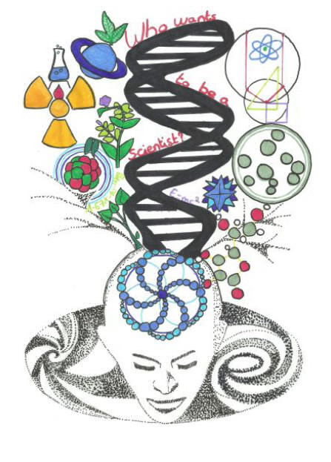 | WHO WANTS TO BE A SCIENTIST  EUROPE
WHO WANTS TO BE A SCIENTIST  EUROPE | WHO WANTS TO BE A SCIENTIST  EUROPE

EUROPE  QUESTION  SOLUTION | EUROPE  QUESTION  SOLUTION
EUROPE  QUESTION  SOLUTION | EUROPE  QUESTION  SOLUTION

WHO WANTS TO BE A SCIENTIST  EUROPE | WHO WANTS TO BE A SCIENTIST  EUROPE
WHO WANTS TO BE A SCIENTIST  EUROPE | WHO WANTS TO BE A SCIENTIST  EUROPE

EUROPE  QUESTION  SOLUTION | EUROPE  QUESTION  SOLUTION
EUROPE  QUESTION  SOLUTION | EUROPE  QUESTION  SOLUTION

WHO WANTS TO BE A SCIENTIST  EUROPE | WHO WANTS TO BE A SCIENTIST  EUROPE
WHO WANTS TO BE A SCIENTIST  EUROPE | WHO WANTS TO BE A SCIENTIST  EUROPE

EUROPE  QUESTION  SOLUTION | EUROPE  QUESTION  SOLUTION
EUROPE  QUESTION  SOLUTION | EUROPE  QUESTION  SOLUTION

WHO WANTS TO BE A SCIENTIST  EUROPE | WHO WANTS TO BE A SCIENTIST  EUROPE
WHO WANTS TO BE A SCIENTIST  EUROPE | WHO WANTS TO BE A SCIENTIST  EUROPE

EUROPE  QUESTION  SOLUTION | EUROPE  QUESTION  SOLUTION
EUROPE  QUESTION  SOLUTION | EUROPE  QUESTION  SOLUTION

WHO WANTS TO BE A SCIENTIST  EUROPE | WHO WANTS TO BE A SCIENTIST  EUROPE
WHO WANTS TO BE A SCIENTIST  EUROPE | WHO WANTS TO BE A SCIENTIST  EUROPE

EUROPE  QUESTION  SOLUTION | EUROPE  QUESTION  SOLUTION
EUROPE  QUESTION  SOLUTION | EUROPE  QUESTION  SOLUTION

WHO WANTS TO BE A SCIENTIST  EUROPE | WHO WANTS TO BE A SCIENTIST  EUROPE
WHO WANTS TO BE A SCIENTIST  EUROPE | WHO WANTS TO BE A SCIENTIST  EUROPE

EUROPE  QUESTION  SOLUTION | EUROPE  QUESTION  SOLUTION
EUROPE  QUESTION  SOLUTION | EUROPE  QUESTION  SOLUTION

WHO WANTS TO BE A SCIENTIST  EUROPE | WHO WANTS TO BE A SCIENTIST  EUROPE
WHO WANTS TO BE A SCIENTIST  EUROPE | WHO WANTS TO BE A SCIENTIST  EUROPE

EUROPE  QUESTION  SOLUTION | EUROPE  QUESTION  SOLUTION
EUROPE  QUESTION  SOLUTION | EUROPE  QUESTION  SOLUTION

WHO WANTS TO BE A SCIENTIST  EUROPE | WHO WANTS TO BE A SCIENTIST  EUROPE
WHO WANTS TO BE A SCIENTIST  EUROPE | WHO WANTS TO BE A SCIENTIST  EUROPE

EUROPE  QUESTION  SOLUTION | EUROPE  QUESTION  SOLUTION
EUROPE  QUESTION  SOLUTION | EUROPE  QUESTION  SOLUTION

WHO WANTS TO BE A SCIENTIST  EUROPE | WHO WANTS TO BE A SCIENTIST  EUROPE
WHO WANTS TO BE A SCIENTIST  EUROPE | WHO WANTS TO BE A SCIENTIST  EUROPE

EUROPE  QUESTION  SOLUTION | EUROPE  QUESTION  SOLUTION
EUROPE  QUESTION  SOLUTION | EUROPE  QUESTION  SOLUTION

WHO WANTS TO BE A SCIENTIST  EUROPE | WHO WANTS TO BE A SCIENTIST  EUROPE
WHO WANTS TO BE A SCIENTIST  EUROPE | WHO WANTS TO BE A SCIENTIST  EUROPE

EUROPE  QUESTION  SOLUTION | EUROPE  QUESTION  SOLUTION
EUROPE  QUESTION  SOLUTION | EUROPE  QUESTION  SOLUTION

WHO WANTS TO BE A SCIENTIST  EUROPE | WHO WANTS TO BE A SCIENTIST  EUROPE
WHO WANTS TO BE A SCIENTIST  EUROPE | WHO WANTS TO BE A SCIENTIST  EUROPE

EUROPE  QUESTION  SOLUTION | EUROPE  QUESTION  SOLUTION
EUROPE  QUESTION  SOLUTION | EUROPE  QUESTION  SOLUTION

