WHO WANTS TO BE A SCIENTIST  GREAT SCIENTISTS  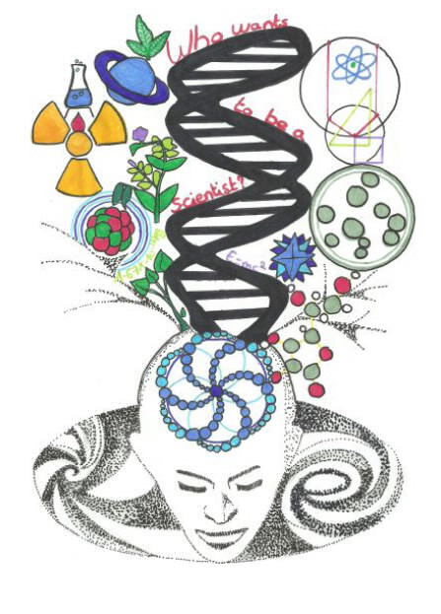 | WHO WANTS TO BE A SCIENTIST  GREAT SCIENTISTS
WHO WANTS TO BE A SCIENTIST  GREAT SCIENTISTS | WHO WANTS TO BE A SCIENTIST  GREAT SCIENTISTS

GREAT SCIENTISTS  CLUE 1  CLUE 2  CLUE 3  CLUE 4  CLUE 5  SOLUTION | GREAT SCIENTISTS  CLUE 1  CLUE 2  CLUE 3  CLUE 4  CLUE 5  SOLUTION
GREAT SCIENTISTS  CLUE 1  CLUE 2  CLUE 3  CLUE 4  CLUE 5  SOLUTION | GREAT SCIENTISTS  CLUE 1  CLUE 2  CLUE 3  CLUE 4  CLUE 5  SOLUTION

WHO WANTS TO BE A SCIENTIST  GREAT SCIENTISTS | WHO WANTS TO BE A SCIENTIST  GREAT SCIENTISTS
WHO WANTS TO BE A SCIENTIST  GREAT SCIENTISTS | WHO WANTS TO BE A SCIENTIST  GREAT SCIENTISTS

GREAT SCIENTISTS  CLUE 1  CLUE 2  CLUE 3  CLUE 4  CLUE 5  SOLUTION | GREAT SCIENTISTS  CLUE 1  CLUE 2  CLUE 3  CLUE 4  CLUE 5  SOLUTION
GREAT SCIENTISTS  CLUE 1  CLUE 2  CLUE 3  CLUE 4  CLUE 5  SOLUTION | GREAT SCIENTISTS  CLUE 1  CLUE 2  CLUE 3  CLUE 4  CLUE 5  SOLUTION

WHO WANTS TO BE A SCIENTIST  GREAT SCIENTISTS | WHO WANTS TO BE A SCIENTIST  GREAT SCIENTISTS
WHO WANTS TO BE A SCIENTIST  GREAT SCIENTISTS | WHO WANTS TO BE A SCIENTIST  GREAT SCIENTISTS

GREAT SCIENTISTS  CLUE 1  CLUE 2  CLUE 3  CLUE 4  CLUE 5  SOLUTION | GREAT SCIENTISTS  CLUE 1  CLUE 2  CLUE 3  CLUE 4  CLUE 5  SOLUTION
GREAT SCIENTISTS  CLUE 1  CLUE 2  CLUE 3  CLUE 4  CLUE 5  SOLUTION | GREAT SCIENTISTS  CLUE 1  CLUE 2  CLUE 3  CLUE 4  CLUE 5  SOLUTION

WHO WANTS TO BE A SCIENTIST  GREAT SCIENTISTS | WHO WANTS TO BE A SCIENTIST  GREAT SCIENTISTS
WHO WANTS TO BE A SCIENTIST  GREAT SCIENTISTS | WHO WANTS TO BE A SCIENTIST  GREAT SCIENTISTS

GREAT SCIENTISTS  CLUE 1  CLUE 2  CLUE 3  CLUE 4  CLUE 5  SOLUTION | GREAT SCIENTISTS  CLUE 1  CLUE 2  CLUE 3  CLUE 4  CLUE 5  SOLUTION
GREAT SCIENTISTS  CLUE 1  CLUE 2  CLUE 3  CLUE 4  CLUE 5  SOLUTION | GREAT SCIENTISTS  CLUE 1  CLUE 2  CLUE 3  CLUE 4  CLUE 5  SOLUTION

WHO WANTS TO BE A SCIENTIST  GREAT SCIENTISTS | WHO WANTS TO BE A SCIENTIST  GREAT SCIENTISTS
WHO WANTS TO BE A SCIENTIST  GREAT SCIENTISTS | WHO WANTS TO BE A SCIENTIST  GREAT SCIENTISTS

GREAT SCIENTISTS  CLUE 1  CLUE 2  CLUE 3  CLUE 4  CLUE 5  SOLUTION | GREAT SCIENTISTS  CLUE 1  CLUE 2  CLUE 3  CLUE 4  CLUE 5  SOLUTION
GREAT SCIENTISTS  CLUE 1  CLUE 2  CLUE 3  CLUE 4  CLUE 5  SOLUTION | GREAT SCIENTISTS  CLUE 1  CLUE 2  CLUE 3  CLUE 4  CLUE 5  SOLUTION

WHO WANTS TO BE A SCIENTIST  GREAT SCIENTISTS | WHO WANTS TO BE A SCIENTIST  GREAT SCIENTISTS
WHO WANTS TO BE A SCIENTIST  GREAT SCIENTISTS | WHO WANTS TO BE A SCIENTIST  GREAT SCIENTISTS

GREAT SCIENTISTS  CLUE 1  CLUE 2  CLUE 3  CLUE 4  CLUE 5  SOLUTION | GREAT SCIENTISTS  CLUE 1  CLUE 2  CLUE 3  CLUE 4  CLUE 5  SOLUTION
GREAT SCIENTISTS  CLUE 1  CLUE 2  CLUE 3  CLUE 4  CLUE 5  SOLUTION | GREAT SCIENTISTS  CLUE 1  CLUE 2  CLUE 3  CLUE 4  CLUE 5  SOLUTION

