Sissi - Empress Elisabeth (1837 - 1898)

Sisi was born as daughter of Duke Maximilian and Duchess Ludovika in Bavaria. In 1853, she got to know her cousin Emporer Franz Joseph, who was going to marry Sisi's sister Helene. Franz Joseph fell in love with Sisi immediately and decided to marry her instead of her sister. They married, Elisabeth being 15 years old. The love marriage did not work out: Sisi was an independent girl and totally unprepared for the strict protocol at court, an ambitious stepmother and a busy husband who struggled to fight revolutionary and separatist tendencies in the Habsburg empire…
The Viennese aristocracy was making fun of her and her mother in law Sophie took over the control of her life. Her children were taken from her and Sisi was barely allowed to see them, putting her in deep depression and illness. After two year of cure and lodging in Madeira, Korfu and Bavaria, Sisi returned with new confidence to Vienna.
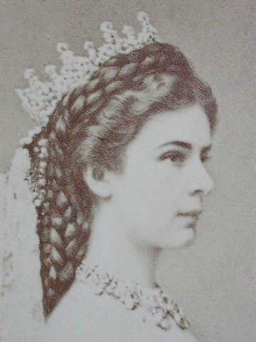
During her first trip to Hungary with her husband, Sisi fell in love with this nation that exhibited so much independence. She felt strong ties with the people. The feeling was mutual. While Sisi did not delve much into politics, she played an instrumental role in the negotiations that resulted in the Dual Monarchy of 1867 and made sure that Hungary obtained equal rights. That year Emperor Franz Joseph was declared King of Hungary while Sisi was proclaimed the nation’s queen. She learned Hungarian, too.
Sisi was obsessed with her beauty and her perfect figure and taking care of her body, resulting in anorexia. Her very liberal ideas, her call for a republic structure and her effort for the poor and troublesome made her very popular with the Austrian people.
In 1870, she decided to withdraw from public life and tried to live the life of a private person. On the 10th of September, while she was walking through Geneva, she was assassinated by a young Italian anarchist.
Text adapted from: http://www.aboutvienna.org/personalities/wittelsbach.php
Image: http://commons.wikimedia.org/wiki/Empress_Elisabeth_of_Austria#/media/File:Erszébet_királyné,_ebay.JPG

Open-cloze - fill in the missing gaps.
Sisi’s sister …………………………. was going to marry her cousin Emperor …………………………. but he fell in love with her younger sister, Sisi. They married but it didn’t work out well as Sisi wasn’t prepared for the strict court rules. Her mother in law, ……………………., was very bossy and took control over her life. She was hardly allowed to see her ……………………………. which led to a deep depression.
Sisi felt strong ties with ………………………… and its people. She even learned ………………………. . She was obsessed with beauty and she suffered from ……………………. . She was killed by an …………………………….. in Italy.

