MOBILITY in BORDEAUX

Monday, 9th May
After our arrival on Sunday we were picked up by French families. Next morning we came to school where the hesadmaster welcomed us. Then, all foreign students had to introduce themselves and to present their countries and the EU symbols. The television of Bordeaux came to make a shot about our project.
We all had lunch in a school canteen.
In the afternoon we had „ rallye de Bordeaux“. Firstly, we were divided into groups of different nationalities. Each group was given a map with some indications, our task was to find some monuments and take interesting photos of them. It was really funny and exciting experience. The winners of the rallye were announced on the final day of our stay. I liked this activity very much, because the city is full of history.

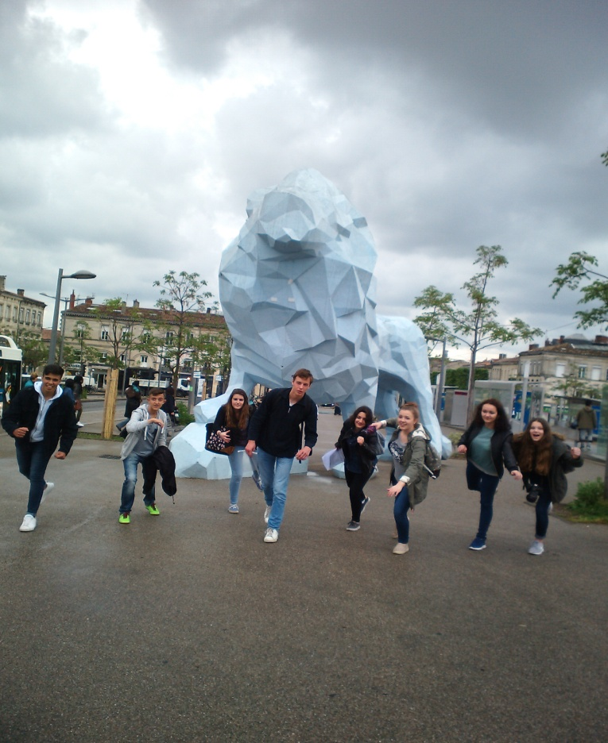

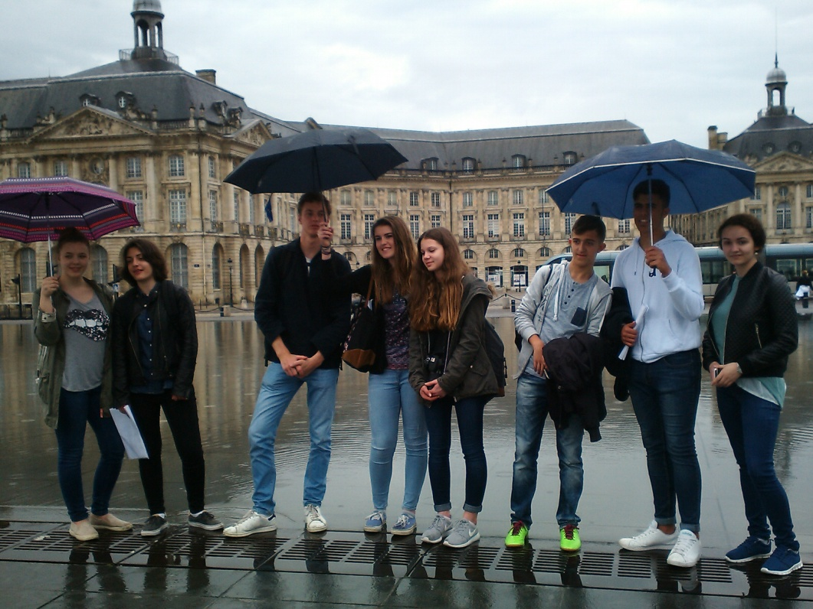
Natália Dundová, 4.B
Tuesday, 10th May
On Tuesday morning we travelled to The CAP Science. We were devided into groups. We saw very interesting exhibitions with sections of modern Technologies. The first part was devoted to economy, we could try interactive devices. It was useful because we learnt a lot of practical things about money, investments, work. Activity about buying and selling sheep was the most interesting for me.
The second was called FAB LAB. We could see 3D printer, robots, cutting and carving machines. We recieved small hearts made by these machines as a presents to remeber our project.
After lunch break we were in class with computers and we worked on e-twinning space. The tasks were about European symbols and women´s rights. We spent the evening with French families.
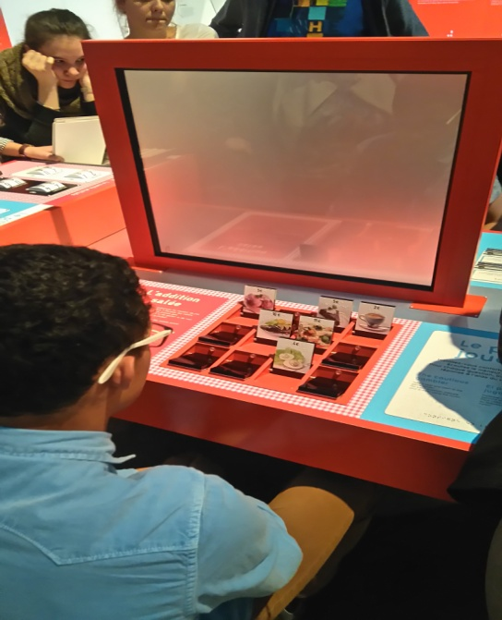
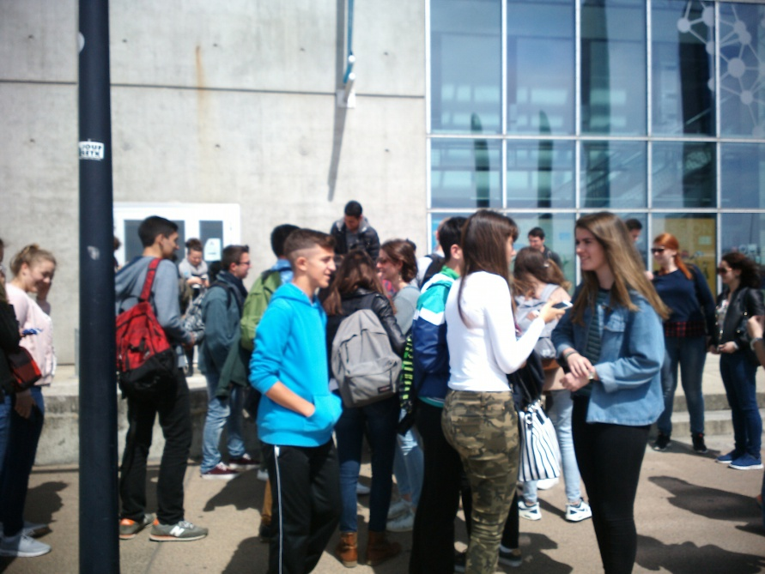
Kristína Kažiková, 4.A
Wednesday, 11th May
Wednesday was the most interesting day for me.
In the morning we stopped at oysters farm. It was unique experience to taste oysters and to learn about their manufacture.

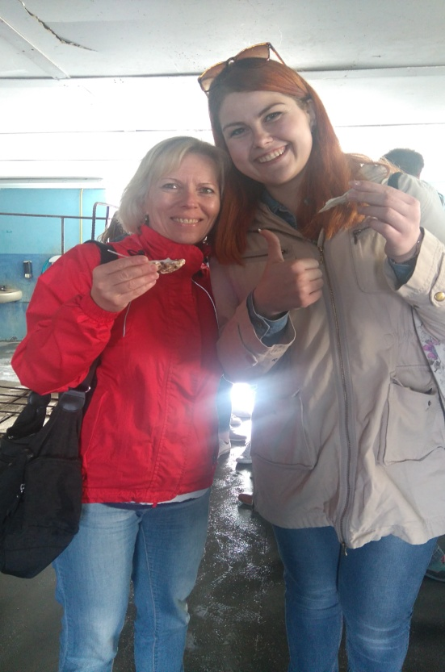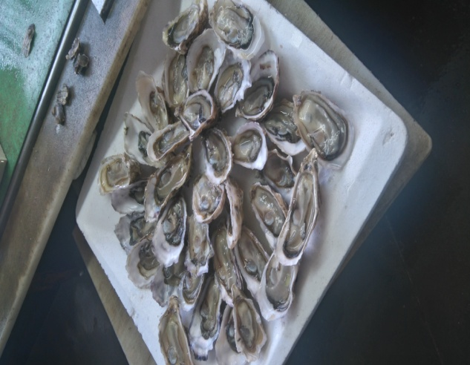

I was looking forward to go to dune. My expectations were fulfilled. The Dune du Pyla shone in the sun, tempted us to run, so we took off our shoes and walked to the sea and back. Despite windy weather, we enjoyed it.
After picnic lunch we went to Arcachon, an old town by the sea, where we had a beautiful view to places around. I admire France which is a country rich in history, different fauna and flora, but the most important are good people around you.

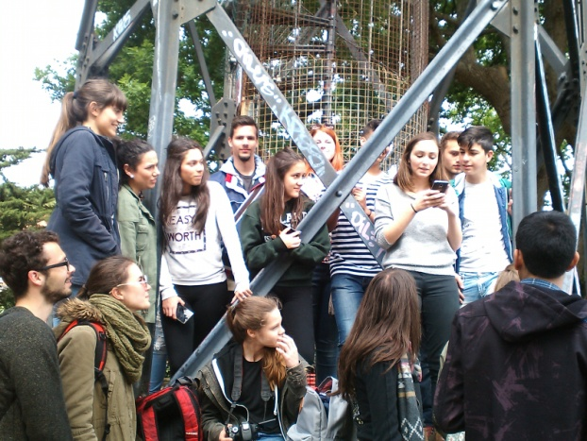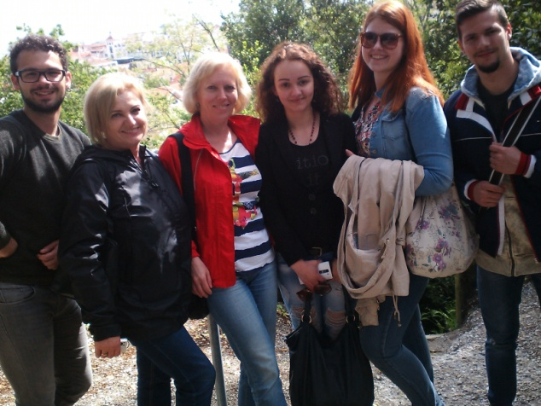

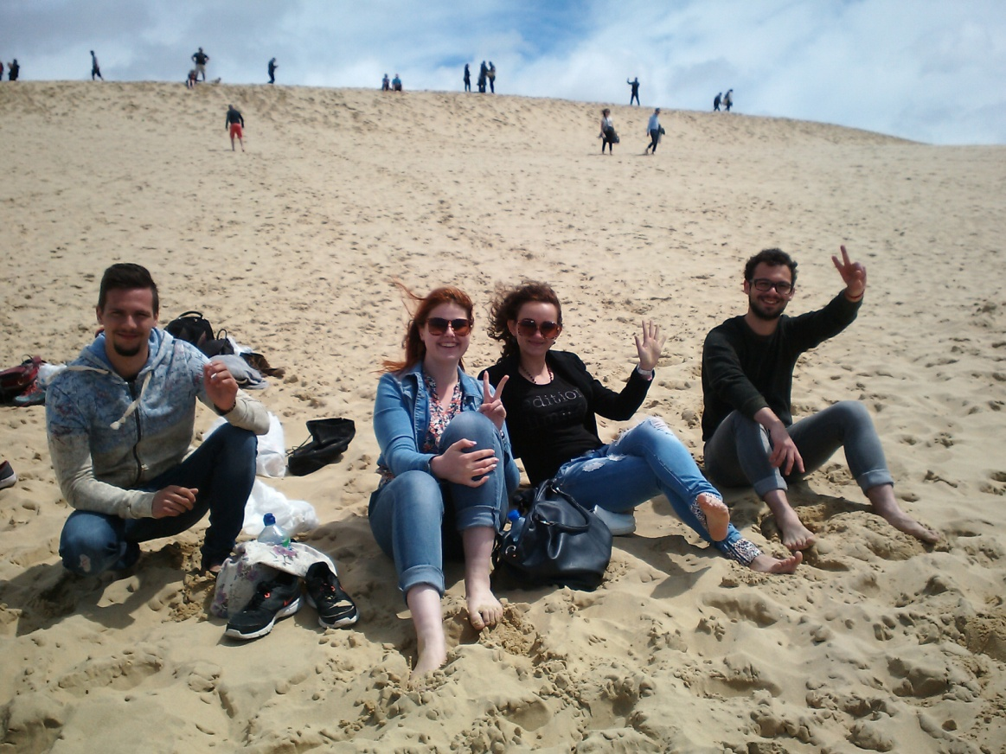
Jakub Leško, 4.B

Thursday, 12th May
On Thursday morning I was in classroom at Maths lesson. I noticed the students were disciplined, they could not use mobile phones, or borrow things. They all listened to teacher´s explanation and
seemed to be interested in the lesson. After a short break all students from project had a lecture and debate about refugees and immigrants. It was important, because the topic of imigration is urgent, nowadays.
After lunch we visited Côtes de Castillon, with wineyards .
The owners, Jerôme and Biatrice de Mointel explained 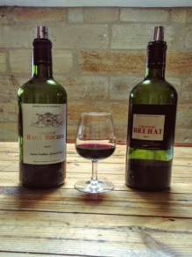
to us how wine is manufatured. We also had possibility to taste their delicious wine.
Later we stopped at St. Emilion, a small, but beautiful town. I bought presents for my family – a botlle of wine and typical French sweets –macarons.

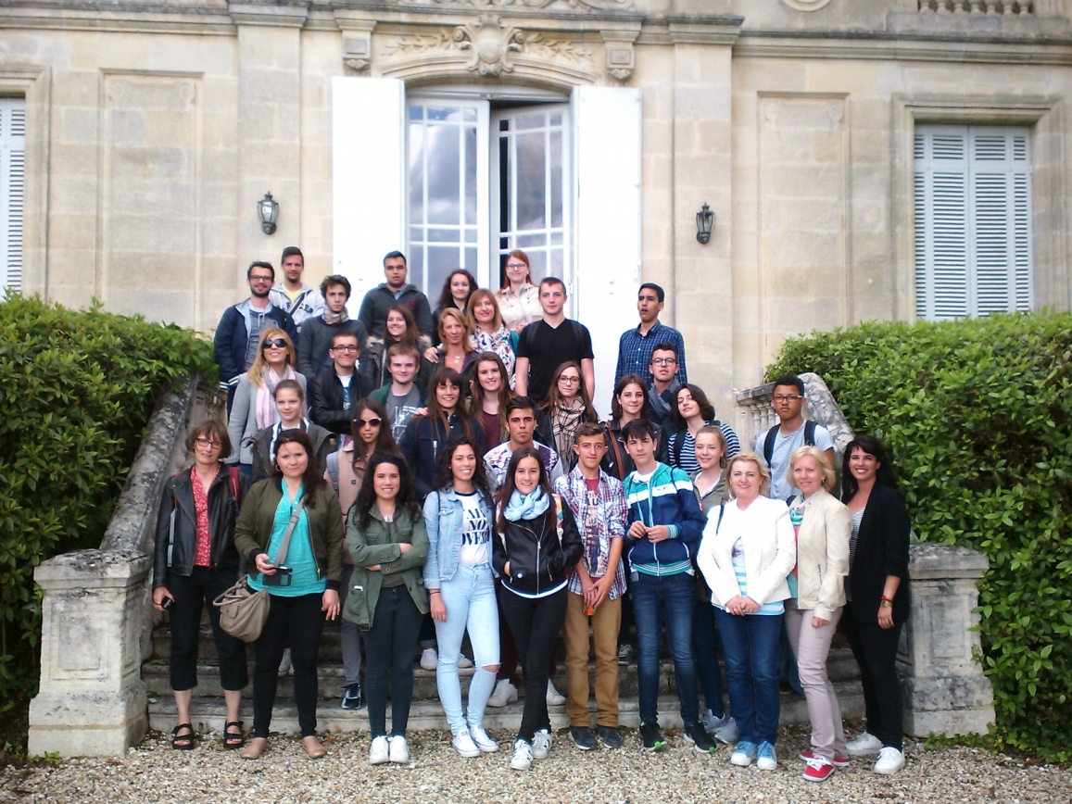
Dominik Kostrej, 4.A

Friday, 13th May
In the morning we had official meeting with representatives of the regional Council of d Aquitane Limousine Poitou Charentes. The first part was about new regions which were formed in France , what competences the regional Council has and its future plans. The second part was a debate about position of women in public life. It was interesting to learn that in France there is a law about equality of men and women in public institutions.
After lunch we met in Assembly hall because French students prepared a web radio programme about Erasmus+ projects. We participated actively in it, we were interviewed about our country, typical habits, traditions and our opinions about France and the project.
In the end there was a surprise, a party with the school dance group.
I liked the web radio programme the best, because students made it on their own and it was about school life.

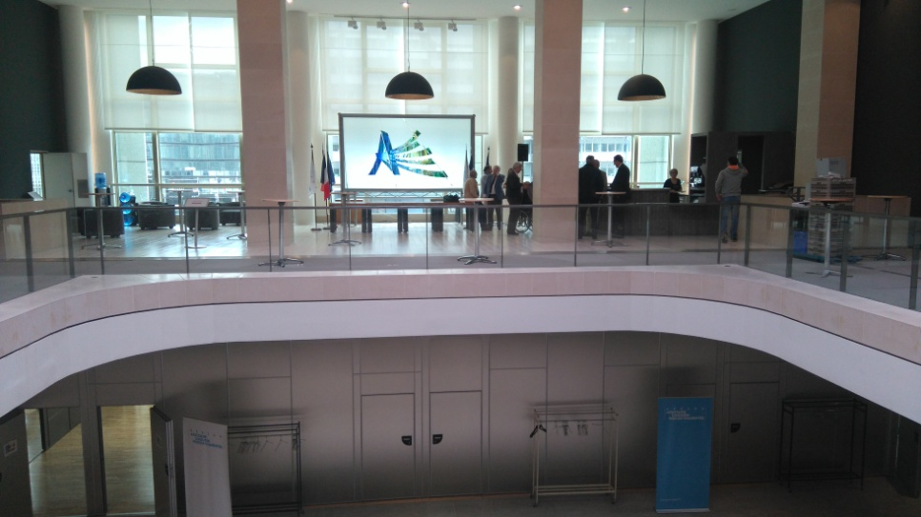
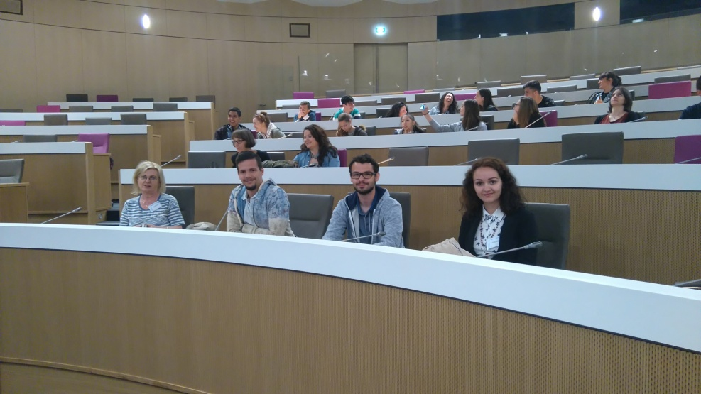

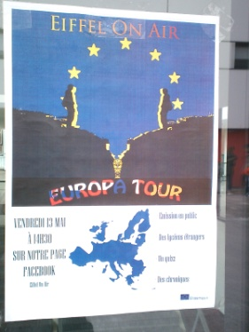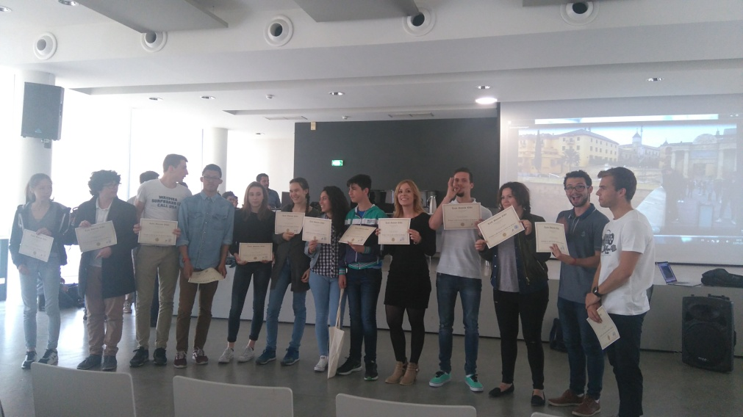
Kristína Kažiková, Natália Dundová

Thank you, French group, for all you made for us.

