Democracy

Democracy is a form of government in which citizens participate in power through elected representatives. To be exact, democracy is a form of state organisation in which collective decisions are adopted by people by means of mechanisms of direct or indirect participation. In broad terms, democracy is a form of social coexistence where the members are free and equal and social relationships are established in accordance with contractual mechanisms. The term democracy originated from the ancient Greek word “demokratía“ in Athens in the 5th century BC and it can be devided into two words “démos“ which means «people» and “kratos“ which means «power». In Ancient Greece, especially in Athens we can see the first forms of democracy. Classically democracy was divided into two big forms : direct and representative. Nowadays, the most extended mechanisms of democracy are the forms of representative democracy, in fact it deals with the government system which is used the most in the world.
Principles and characteristics of democracy :
• Constitution which limits different powers and controls the formal functioning of government and this way it forms the rule of law.
• Division of power.
• The right of general public to vote and to be voted in elections. (sufragio universal).
• Protection of property right and the existence of important private groups of power in economical activities.
• The existence of various political parties
• Freedom of expression.
• Freedom of the press and also access to alternative information sources of government which guarantee the right to information for citizens.
• Freedom of association.
• Validity of human rights which includes institutional frame of minority protection.

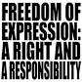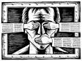

Human rights and citizents´ rights represent the whole group of civil, political and social rights which are on the basis of modern democracy.
Actually we can talk about progressive appearance of democratic countries since the 20th century, with the abolition of slavary, conquest of sufragio universal, the recognition of legal equality of women, the end of european colonialism, the recognition of working people rights and guarantees of no descrimination for racial and ethnic minorities.
Questionnaire :
- The word democracy comes from the Greek words démos y kratos :
yes / no / I don´t know
- Democracy appeared the first time in:
Ancient Rome/Ancient Greece/ France/ America
- There are two big forms of democracy: direct and indirect:
yes / no / I don´t know
- Nowadays, the most extended mechanisms of democracy are the forms of direct democracy :
yes / no / I don´t know
- Which of the following is the symbol of representative democracy?
right to freedom/ independence/ plurality
- Which principle of decision making exists in democracy?
decision of majority / decision of minority
- The citizens choose their representatives:
in elections/ in referendum

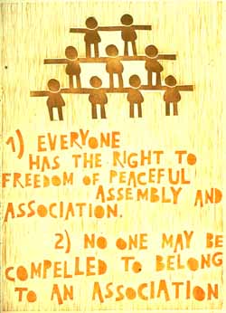

QUESTIONS:

What rights do we have as European citizens?

Where are these rights written down?

Which of these rights are the most important ones to live in a democratic society?

Are there any of these rights that sometimes are violated in your country?

How is your ideal society?

